# Blazor tutorial

* [Blazor Introduction](https://www.pragimtech.com/blog/blazor/what-is-blazor)
* [Blazor Hosting models](https://www.pragimtech.com/blog/blazor/blazor-hosting-models)
* [Blazor Project structure](https://www.pragimtech.com/blog/blazor/blazor-project-structure)
* [Blazor Razor components](https://www.pragimtech.com/blog/blazor/razor-components)
* [Blazor Split components](https://www.pragimtech.com/blog/blazor/Split-razor-component)
* [Blazor Model Classes](https://www.pragimtech.com/blog/blazor/blazor-model-classes)
* [EmployeeList Component](https://www.pragimtech.com/blog/blazor/blazor-component)
* [Blazor loading Indicator](https://www.pragimtech.com/blog/blazor/blazor-loading-indicator)
* [Blazor data access strategies](https://www.pragimtech.com/blog/blazor/blazor-data-access-strategies)
* [What are RESTful APIs](https://www.pragimtech.com/blog/blazor/what-are-restful-apis)
* [Create REST API](https://www.pragimtech.com/blog/blazor/create-asp.net-core-rest-api)
* [REST API DbContext](https://www.pragimtech.com/blog/blazor/asp.net-core-rest-api-dbcontext)
* [Repository Pattern in REST API](https://www.pragimtech.com/blog/blazor/rest-api-repository-pattern)
* [REST API Get List](https://www.pragimtech.com/blog/blazor/asp.net-core-rest-api-list-of-resources)
* [REST API Get By Id](https://www.pragimtech.com/blog/blazor/asp.net-core-rest-api-get-by-id)
* [Post in REST API](https://www.pragimtech.com/blog/blazor/post-in-aspnet-core-rest-api)
* [REST API Model Validation](https://www.pragimtech.com/blog/blazor/rest-api-model-validation)
* [Put in REST API](https://www.pragimtech.com/blog/blazor/put-in-asp.net-core-rest-api)
* [Delete in REST API](https://www.pragimtech.com/blog/blazor/delete-in-asp.net-core-rest-api)
* [Search in REST API](https://www.pragimtech.com/blog/blazor/search-in-asp.net-core-rest-api)
* [Call REST API from Blazor](https://www.pragimtech.com/blog/blazor/call-rest-api-from-blazor)
* [Blazor Route Parameters](https://www.pragimtech.com/blog/blazor/blazor-route-parameters)
* [Data from multiple tables](https://www.pragimtech.com/blog/blazor/data-from-two-tables-blazor)
* [Blazor event handling](https://www.pragimtech.com/blog/blazor/blazor-event-handling)
* [Blazor data binding](https://www.pragimtech.com/blog/blazor/blazor-data-binding)
* [Blazor two way binding](https://www.pragimtech.com/blog/blazor/blazor-two-way-data-binding-example)
* [Component Parameters](https://www.pragimtech.com/blog/blazor/blazor-component-parameters)
* [Blazor EventCallback](https://www.pragimtech.com/blog/blazor/blazor-eventcallback)
* [Building blazor form](https://www.pragimtech.com/blog/blazor/building-blazor-form)
* [Blazor Select List](https://www.pragimtech.com/blog/blazor/blazor-select-bind-database-data)
* [Custom Input Component](https://www.pragimtech.com/blog/blazor/inputselect-does-not-support-system.int32)
* [RCL Project](https://www.pragimtech.com/blog/blazor/razor-class-library-project)
* [Bind Enum to Select](https://www.pragimtech.com/blog/blazor/bind-input-select-element-to-enum-in-blazor)
* [Blazor DatePicker](https://www.pragimtech.com/blog/blazor/blazor-datepicker)
* [Blazor Form Validation](https://www.pragimtech.com/blog/blazor/blazor-form-validation)
* [Custom Form Validation](https://www.pragimtech.com/blog/blazor/blazor-custom-form-validation)
* [Compare Validation](https://www.pragimtech.com/blog/blazor/compare-validation-in-blazor)
* [Complex Model Validation](https://www.pragimtech.com/blog/blazor/validating-complex-models-in-blazor)
* [AutoMapper in ASP.NET Core](https://www.pragimtech.com/blog/blazor/using-automapper-in-asp.net-core)
* [Edit and Update](https://www.pragimtech.com/blog/blazor/edit-and-update-in-blazor)
* [Create Operation](https://www.pragimtech.com/blog/blazor/create-database-operation-blazor)
* [Force reload component](https://www.pragimtech.com/blog/blazor/force-reload-blazor-component)
* [Delete Operation](https://www.pragimtech.com/blog/blazor/delete-database-row-from-blazor)
* [Component Communication](https://www.pragimtech.com/blog/blazor/pass-data-from-child-to-parent-component-in-blazor)
* [Delete Confirmation](https://www.pragimtech.com/blog/blazor/delete-confirmation-dialog-in-blazor)
* [Attribute Splatting](https://www.pragimtech.com/blog/blazor/blazor-attribute-splatting)
* [Arbitrary Attributes](https://www.pragimtech.com/blog/blazor/blazor-arbitrary-attributes)
* [Cascading Values](https://www.pragimtech.com/blog/blazor/blazor-cascading-values-parameters)
* [Multiple Cascading Parameters](https://www.pragimtech.com/blog/blazor/blazor-multiple-cascading-parameters)
* [Cascading Values Performance](https://www.pragimtech.com/blog/blazor/blazor-cascading-values-performance)
* [Identity Setup in Blazor](https://www.pragimtech.com/blog/blazor/asp.net-core-identity-setup-in-blazor-application)
* [Cookie Authentication](https://www.pragimtech.com/blog/blazor/how-cookie-authentication-works)

<https://www.pragimtech.com/blog/blazor/what-is-blazor/>

# What is Blazor

In this article, we will discuss

* How we develop web applications today?
* What is Blazor, and why should we use it?
* Setup our local machine for Blazor application development by installing the software and tools required.
* How we develop web applications today?
* what is Blazor?

## How we develop web applications today?

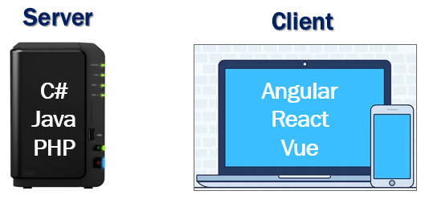

* For server-side development, we use programming languages like C#, Java, PHP etc. These are the server-side programming languages.
* For the client-side development we use JavaScript frameworks like Angular, React, Vue etc. There’s no doubt these JavaScript frameworks dominated client-side development up until recently.
* To stay in the business as a developer and remain competitive, it's inevitable we learn both a server-side programming language and a client-side programming language.
* But the question is, why should we learn and use 2 different sets of programming languages and frameworks.

## Can we use C# both for server-side and client-side development?

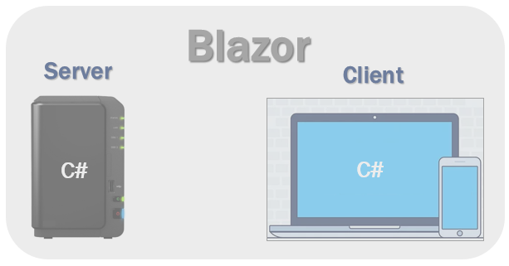

Well, we can and that's exactly why we use Blazor. With Blazor we can now build interactive web UIs using C# instead of JavaScript. C# code can be executed both on the server and in the client browser. This means existing .Net developers can reuse their c# skills rather than learning new JavaScript frameworks and their huge learning curve.

## How can a browser execute C# code?

Browsers understand and execute only JavaScript. How can we execute c# code in the client browser?

Well, the answer is WebAssembly.

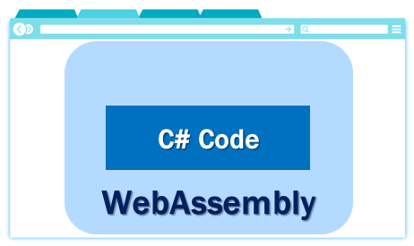

Blazor can run C# code directly in the browser, using WebAssembly. It runs in the same security sandbox as JavaScript frameworks like Angular, React, Vue etc. Not just C#, in fact, we can run any type of code in the browser using WebAssembly.

WebAssembly is based on open web standards. So it is a native part of all modern browsers including mobile browsers. This means for the blazor application to work, there is no need to install any special plugin like back in the days of silver light and flash.

## Blazor hosting models

Blazor offers 2 hosting models. Blazor WebAssembly and Blazor Server.

### Blazor WebAssembly

This is also called the client-side hosting model and in this model, the application runs directly in the browser on WebAssembly. So, everything the application needs i.e the compiled application code itself, it's dependencies and the .NET runtime are downloaded to the browser. We use the Blazor WebAssembly App template, to create a Blazor application with the client-side hosting model. We will see this in action in our upcoming videos.

### Blazor server

This is also called the server hosting model and in this model, the application is executed on the server from within an ASP.NET Core application. Between the client and the server, a SignalR connection is established. When an event occurs on the client such as a button click, for example, the information about the event is sent to the server over the SignalR connection. The server handles the event and for the generated HTML a diff (difference) is calculated. The entire HTML is not sent back again to the client, it's only the diff that is sent to the client over the established SignalR connection. The browser then updates the UI. Blazor embraces the single page application architecture which rewrites the same page dynamically in response to the user action. Since only the diff is applied to update the UI, the application feels faster and more responsive to the user.

We use the Blazor Server App template, to create a Blazor application with the server hosting model. We will create a blazor application with both the hosting models and discuss the pros and cons in detail in our upcoming videos.

## Machine setup for Blazor development

[Install .NET Core SDK 3.1 or later](https://dotnet.microsoft.com/download/)

To verify the list of .NET Core SDKs installed in your machine, run the following command from the command line.

dotnet --list-sdks

Copy

You can build blazor applications using Visual Studio 2019, Visual Studio Code or the .NET Core CLI.

You can download Visual Studio 2019 from the following URL

[Download visual studio 2019](https://visualstudio.microsoft.com/downloads/)

If you are using Visual Studio, make sure asp.net and web development workload is installed. To verify if you have this workload installed, click on Tools and then select Get Tools and Features.

### Blazor Prerequisites

* C#
* HTML
* CSS

Blazor is gaining great traction and it is here to stay. If you are a .Net developer, it’s invaluable to have Blazor in your tool belt.

### Slides



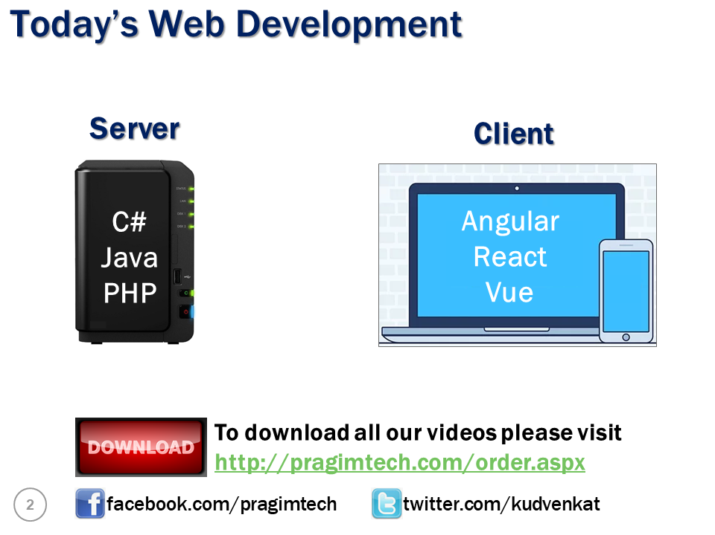

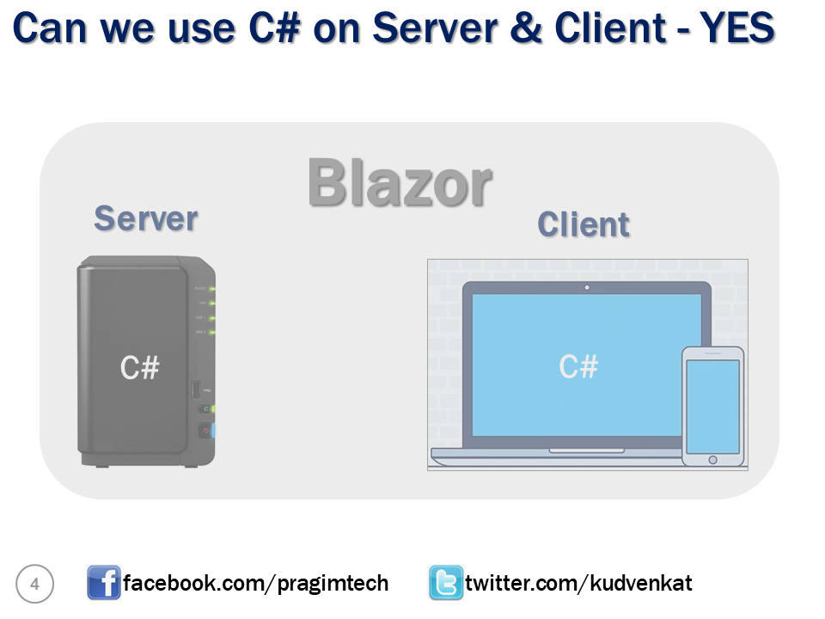

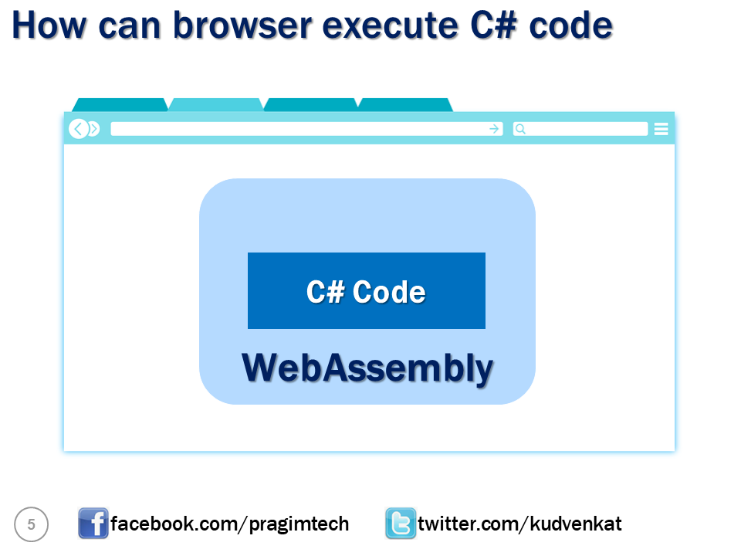

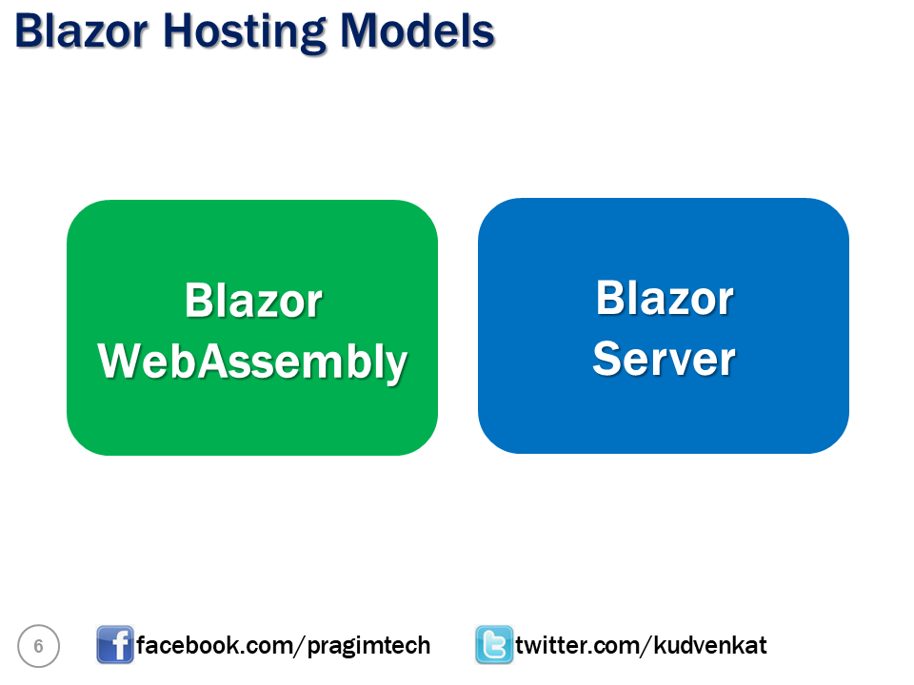

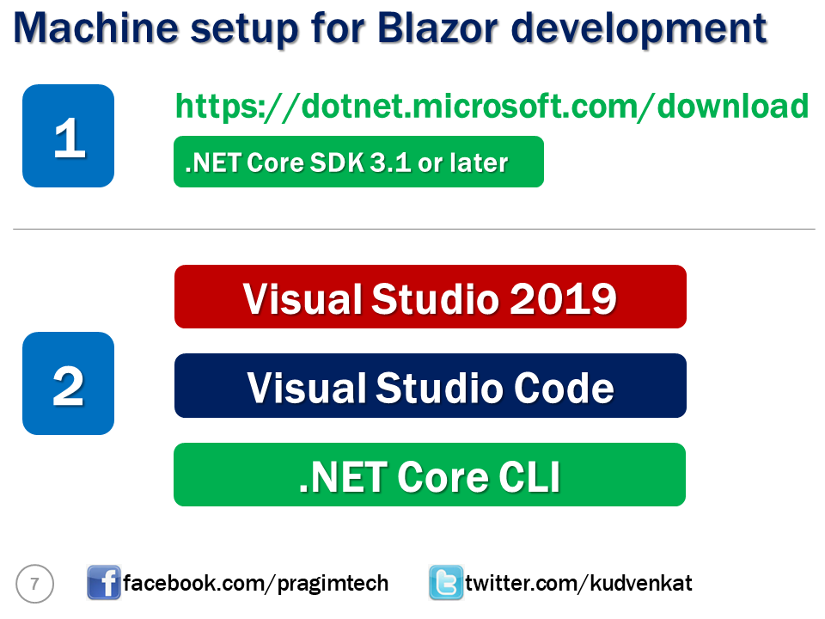

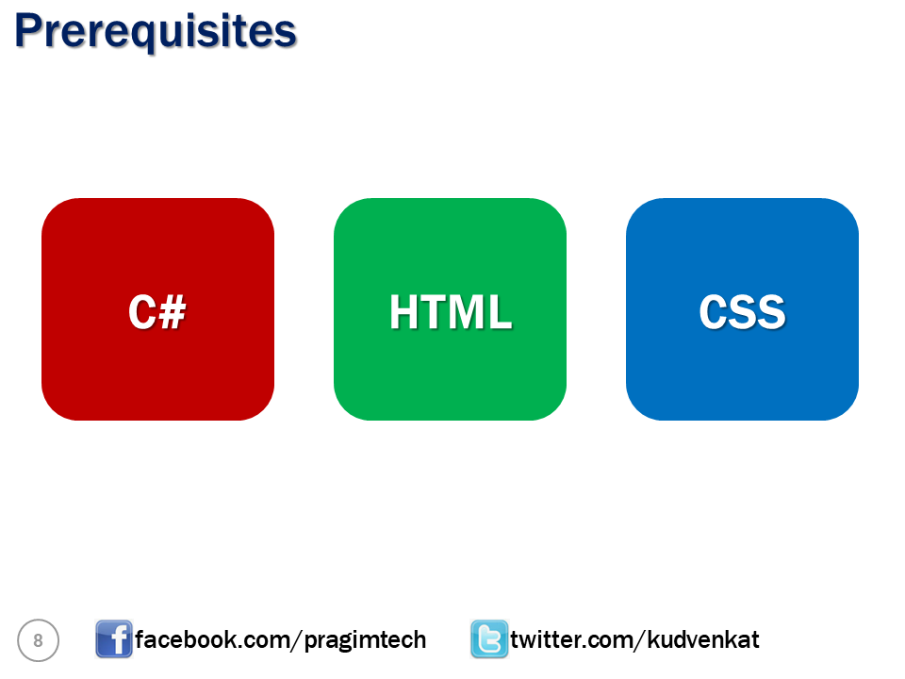

# Blazor hosting models

* We will create our first Blazor project. In fact, we will create 2 blazor projects. One with server-side hosting and the other with client-side hosting. We will then run both the projects and see the difference in where and how they execute.
* Along the way, we will understand the difference between the two hosting models and the pros and cons of each

## Blazor WebAssembly app template missing

Blazor WebAssembly (also called client-side blazor) is still in preview. So, if you try to create a Blazor project using Visual Studio 2019, you will only find **Blazor Server App** template and not **Blazor WebAssembly App** template.

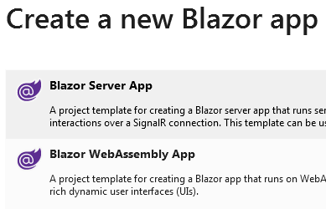

Execute the following command to install the **Blazor WebAssembly App** template

dotnet new --install Microsoft.AspNetCore.Blazor.Templates::3.1.0-preview4.19579.2

Copy

You can execute this command either from the Package Manager Console in Visual Studio or from the command prompt.

[Click here to get the latest Blazor WebAssembly App template](https://www.nuget.org/packages/Microsoft.AspNetCore.Blazor.Templates)

## Blazor hosting models

With Blazor we have two hosting models, **Blazor WebAssembly** (Client-side hosting model) and **Blazor Server** (Server-side hosting model)

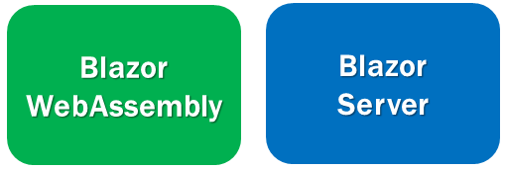

As the template names imply, use the Blazor Server App template to create a blazor application with server hosting model and Blazor WebAssembly template to create a blazor application with client hosting model.

## Blazor Server vs Blazor WebAssembly

The project structure and layout is not that different between the 2 project types.

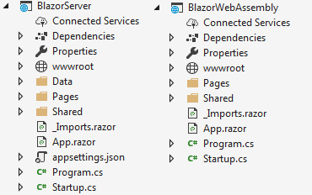

We will discuss the purpose of these different files and folders in detail in our next video.

## Configure multiple StartUp projects in Visual Studio

We can configure more than one project as a **StartUp project** in Visual Studio. The following are the steps.

Right click on the Solution Name in the Solution Explorer and select **Set StartUp Project**s option

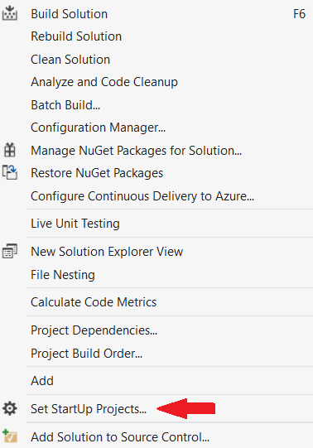

Select **Multiple startup projects** radio button. Select **Start** from the **Action** dropdownlist against each project that you want to setup as a startup project.

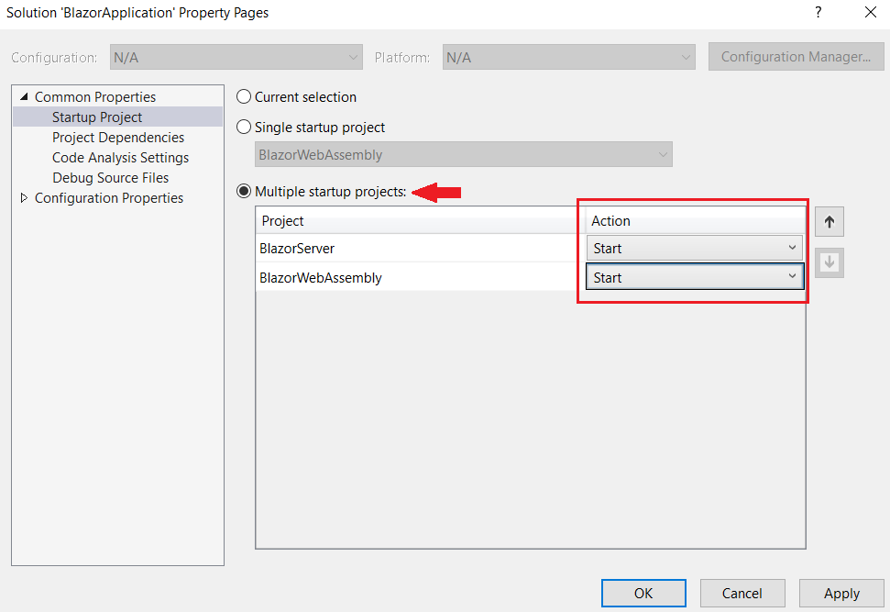

## Blazor WebAssembly hosting model

With this hosting model, the application runs directly in the browser on WebAssembly. So, everything the application needs i.e the compiled application, it's dependencies and the .NET runtime are downloaded to the client browser from the server. A Blazor WebAssembly app can run entirely on the client without a connection to the server or we can optionally configure it to interact with the server using web API calls or SignalR.

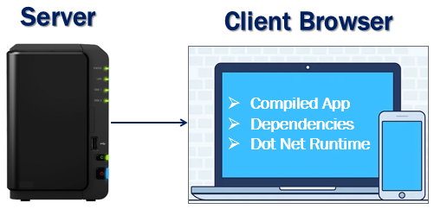

## Blazor WebAssembly hosting model benefits :

* A Blazor WebAssembly app can run entirely on the client machine. So, after the application is downloaded, a connection to the server is not required. This means there is no need for your server to be up and running 24X7.
* Work is offloaded from the server to the client. It is the client resources and capabilities that are being used.
* We do not need a full-blown ASP.NET Core web server to host the application. We just need a server somewhere, that can deliver the application to the client browser. This means we can host the application on our own server on the internet somewhere, in the cloud, on Azure as a static website or even on a CDN Content Delivery Network.

## Downsides of Blazor WebAssembly hosting :

* The very first request usually takes longer as the entire app, it's dependencies and the .NET runtime must be downloaded to the client browser. Keep in mind, it's only the first request that takes longer than usual. If that same client visits the application later, it usually starts fast because the browser caches the files.
* Since the app runs entirely on the client browser, it is restricted to the capabilities of the browser.
* Depending on the nature of the application, capable client hardware and software is required. From software standpoint, for example, at least a browser with WebAssembly support is required.

## Blazor Server hosting model

With this hosting model, the application is executed on the server. Between the client and the server a SignalR connection is established. When an event occurs on the client such as a button click for example, the information about the event is sent to the server over the SignalR connection. The server handles the event and for the generated HTML a diff (difference) is calculated. The entire HTML is not sent again to the client, it's only the diff that is sent to the client over the SignalR connection. The browser then updates the UI. Since only the diff is applied to update the UI, the application feels faster and more responsive to the user.

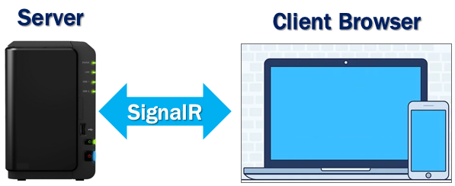

## Blazor Server hosting model benefits :

* The app loads much faster as the download size is significantly smaller than a Blazor WebAssembly app
* Since the app runs on the server, it can take full advantage of server capabilities, including use of any .NET Core compatible APIs.
* All the client needs, to use the app is a browser. Even browsers that don't support WebAssembly can be used.
* More secure because the app's .NET/C# code isn't served to clients.

## Downsides of Blazor Server hosting :

* A full-blown ASP.NET Core server is required to host the application. Serverless deployment scenarios such as serving the app from a CDN aren't possible.
* An active connection to the server is always required. This means there is a need to keep the server up and running 24X7. If the server is down, the application stops working.
* As every user interaction involves a round trip to the server a higher latency usually exists when compared with Blazor WebAssembly hosting.
* Scalability can be challenging especially for the apps that have many users as the server must manage multiple client connections and handle client state. However, we can overcome this scalability issue, by using Azure SignalR Service with a Blazor Server app. This service allows a Blazor Server app to scale really well by supporting a large number of concurrent SignalR connections.

## Slides



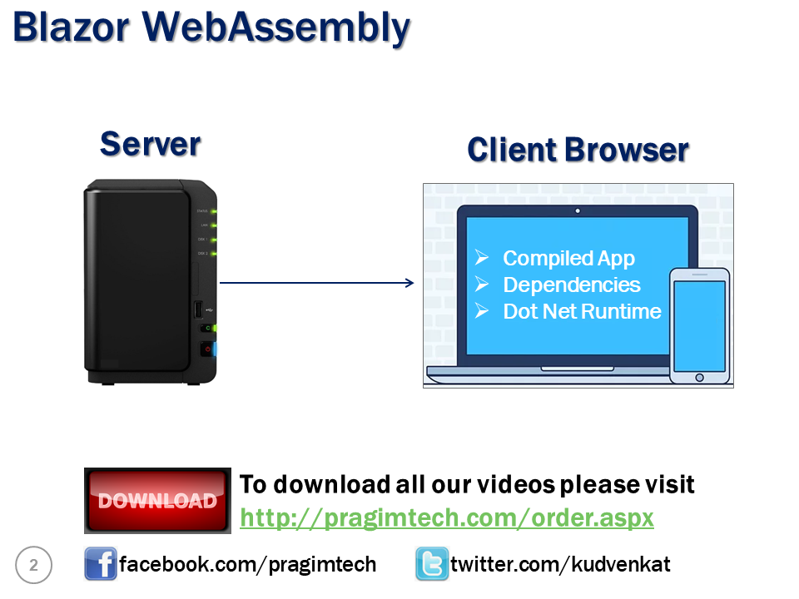

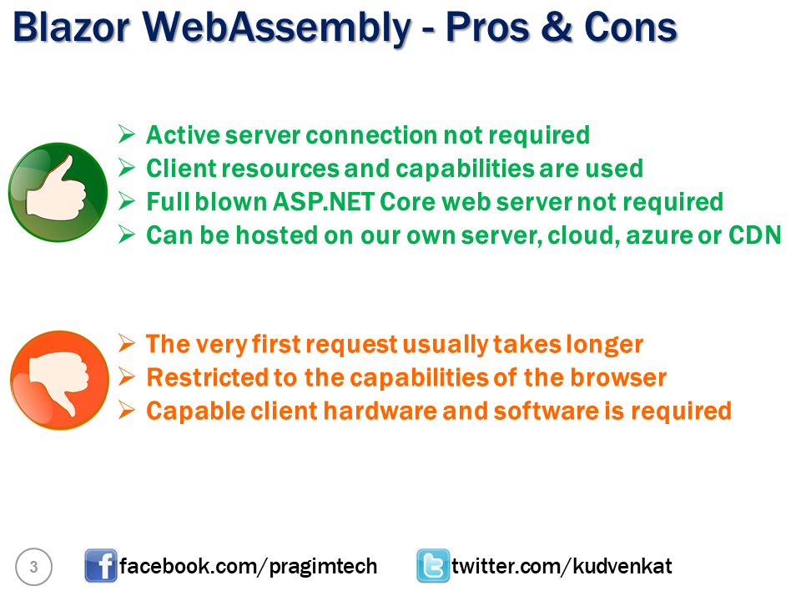

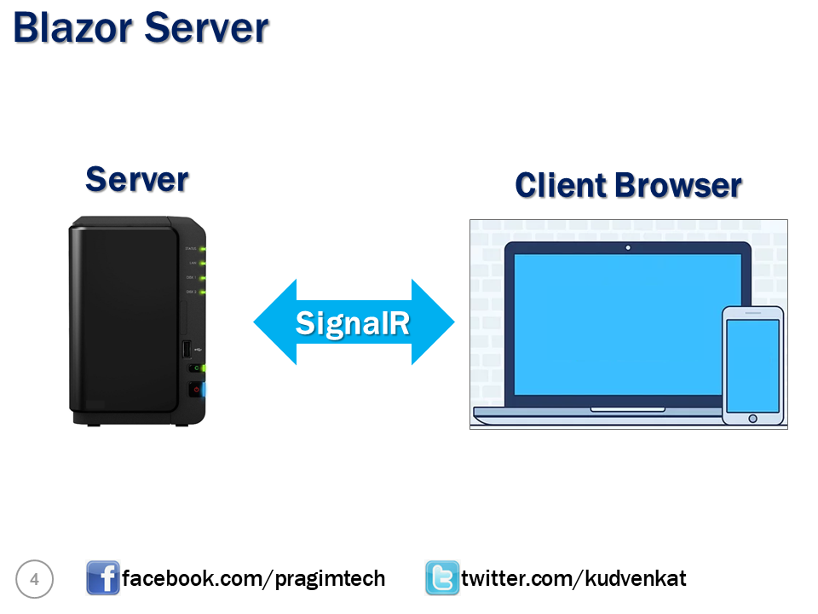

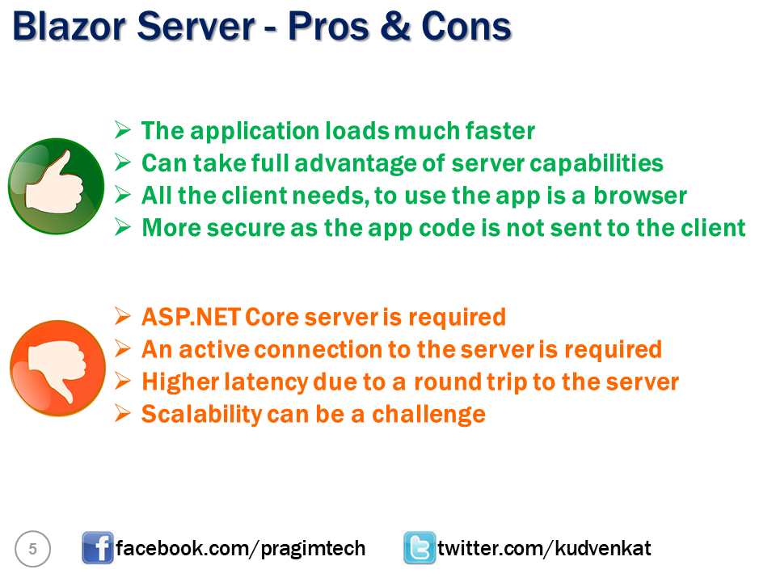Caption

# Blazor project structure

Files and folders in ASP.NET Core Blazor project

## Program.cs

This file contains the Main() method which is the entry point for both the project types (i.e Blazor WebAssembly and Blazor Server).

In a Blazor server project, the Main() method calls CreateHostBuilder() method which sets up the ASP.NET Core host.

In a Blazor WebAssembly project, the App component, which is the root component of the application, is specified in the Main method. This root component is present in the root project folder in App.razor file.

Components are the building blocks of a Blazor application. We will discuss everything you need to know build effective and reusable blazor components in our upcoming videos. For now, just understand the App component is the root component of the application.

## wwwroot

For both the project types, this folder contains the static files like images, stylesheets etc.

## App.razor

This is the root component of the application. It uses the built-in Router component and sets up client-side routing. It is this Router component that intercepts browser navigation and renders the page that matches the requested address. The Router uses the Found property to display the content when a match is found. If a match is not found, the NotFound property is used to display the  message - Sorry, there's nothing at this address.

## Pages folder

This folder contains the \_Host razor page and the routable components that make up the Blazor app. The components have the .razor extension.

* Index component (Index.razor) – Rendered when we navigate to the root application URL.
* Counter component (Counter.razor) – Rendered when we navigate to the path /counter.
* FetchData component (FetchData.razor) – Rendered when we navigate to the path /fetchdata.
* Error component (Error.razor) – Rendered when an unhandled exception occurs in the blazor app.

## Shared folder

As the name implies, contains the shared components

## MainLayout component (MainLayout.razor)

The application's main layout component

## NavMenu component (NavMenu.razor)

Implements the navigation menu on the sidebar. NavLink component, renders navigation links to other Razor components like the index, counter and fetchdata components. This NavLink component is intelligent enough to highlight the navigation menu item, if it's component is currently displayed.

## \_Imports.razor

This is like the \_ViewImports.cshtml file in an asp.net core MVC project. This file contains the common namespaces so we do not have to include them in every razor component.

## wwwroot/index.html

This is the root page in a Blazor WebAssembly project and is implemented as an html page. When a first request hits the application, it is this page, that is initially served. It has the standard HTML, HEAD and BODY tags. It specifies where the root application component App.razor should be rendered. You can find this App.razor root component in the root project folder. It is included on the page as an HTML element <app>. We will discuss razor components in detail in our upcoming videos.

This index.html page also loads the blazor WebAssembly JavaScript file (\_framework/blazor.webassembly.js). It is this file that is responsible for downloading

* The compiled blazor application, it's dependencies and the .NET runtime
* It also initializes the runtime to run the blazor app in the browser

## Startup.cs

This file is present only in the Blazor Server project. As the name implies it contains the applications's startup logic. The Startup class contains the following two methods.

**ConfigureServices** - Configures the applications DI i.e dependency injection services. For example AddServerSideBlazor() method adds Blazor server side services. On the IServiceCollection interface there are several methods that start with the word Add. These methods add different services for the Blazor application. We can even add our own services to the DI container. We will see this in action in our upcoming videos.

**Configure** - Configures the app's request processing pipeline. Depending on what we want the Blazor application to be capable of doing we add or remove the respective middleware components from request processing pipeline. For example, UseStaticFiles() method adds the middleware component that can server static files like images, css etc.

If you have any experience with ASP.NET core, then you already know what middleware components are. We discussed them in detail in [Part 10](https://youtu.be/ALu4jtvjSYw) of our [ASP.NET Core MVC tutorial for beginners](https://www.pragimtech.com/courses/asp-net-core-mvc-tutorial-for-beginners/) course.

MapBlazorHub sets up the endpoint for the SignalR connection with the client browser.

## Pages/\_Host.cshtml

This is the root page of the application and is specified by calling MapFallbackToPage("/\_Host") method. It is implemented as a razor page.

It is this page, that is initially served when a first request hits the application. It has the standard HTML, HEAD and BODY tags. It also specifies where the root application component, App component (App.razor) must be rendered. Finally, it also loads the blazor.server.js JavaScript file, which sets up the real-time SignalR connection between the server and the client browser. This connection is used to exchange information between the client and the server. SignalR, is a great framework for adding real-time web functionality to apps.

## Data folder (Blazor Server)

Contains code files related to the sample WeatherForecast service

## appsettings.json (Blazor Server)

Just like an asp.net core mvc project, a blazor project also uses this file to store the Configuration settings.

## Conclusion

One very important point to keep in mind is, Blazor Server and Blazor WebAssembly are just 2 different ways we can host a Blazor application. Remember everything in a Blazor application is a razor component. Components are the fundamental building blocks of a Blazor application. The way we build these components is the same for a Blazor server app as well as for a Blazor WebAssembly app. So, the point that I am trying to make is, there is just one Blazor framework and the way we build, the Blazor server app and the Blazor WebAssembly app is very similar. The only difference is in the way the app is hosted. If implemented properly, it is easy to convert a Blazor server app to a Blazor WebAssembly app and vice-versa.

Blazor WebAssembly is still in preview and not yet officially released. So, as part of this course we will be building a Blazor server app.

# ASP.NET core razor components

In this video and in our upcoming videos, we will discuss everything you need to know to create effective and reusable asp.net core razor components.

* Blazor is a component-driven framework, meaning components are the fundamental building blocks of a Blazor application.
* They can be nested, reused, and if implemented properly, can even be shared across multiple projects.
* Component files have the extension .razor

## Blazor component example

The following is the Counter component that we get when we create a new Blazor project.

##### **Counter.razor**

@page "/counter"

<h1>Counter</h1>

<p>Current count: @currentCount</p>

<button class="btn btn-primary" @onclick="IncrementCount">Click me</button>

@code

{

private int currentCount = 0;

private void IncrementCount()

{

currentCount++;

}

}

Copy

It is a combination of two things

* HTML markup which defines the user interface of the component i.e the look and feel.
* C# code which defines the processing logic

In this example

1. The c# code increments the currentCount variable value by 1 every time the button is clicked.
2. When the button is clicked IncrementCount() function must be called. This is wired up using the onclick attribute.
3. In the HTML, to access the private variable currentCount value, use @ character.
4. C# code is in @code block. It's also possible to have more than one @code blocks.

When the application is compiled, the HTML and C# code converted into a component class. The name of the generated class matches the name of the component file. A component file name must start with an uppercase character. If you add a component file that starts with a lower case character, the code will fail to compile and you get the following compiler error.

**Component names cannot start with a lowercase character**

Remember, blazor server project runs on the server.

* A SignalR connection is established between the server and the client browser. After the counter component is initially rendered and when the user clicks the button.
* The information about the click event is sent to the server over the SignalR connection.
* In response to the event, the component is regenerated, but the entire HTML is not sent back to the client. It's only the diff, i.e the difference in the render tree, in this case, the new counter value that is sent to the client browser.
* Since only the changed part of the page is updated instead of reloading and updating the entire page, the application feels faster and more responsive to the user.

## Nesting razor components

One way to have the Counter component rendered is by navigating to /counter in the browser. This path is specified by the @page directive at the top of the component.

@page "/counter"

Copy

A component can also be nested inside another component using HTML syntax. For example, use **<Counter />** to nest the Counter component in the Index component.

## Where to place components

Components can be placed anywhere within a blazor project. It's a good practice to place components that produce webpages in the Pages folder and reusable non-page components in the Shared folder. If you want to, you can also place them in a completely different custom folder within your project.

## Split component HTML and C# code

In this example, both the HTML and C# are in a single file. This is fine for a simple component like this counter, but it is usually a good practice to separate HTML and C# code into their own files. It is not only good from maintenance standpoint, but it is also easy to unit test. There are 2 approaches, to split component HTML and C# code into their own separate files.

1. Partial files approach
2. Base class approach

We will discuss these 2 approaches in our next video.

## Slides



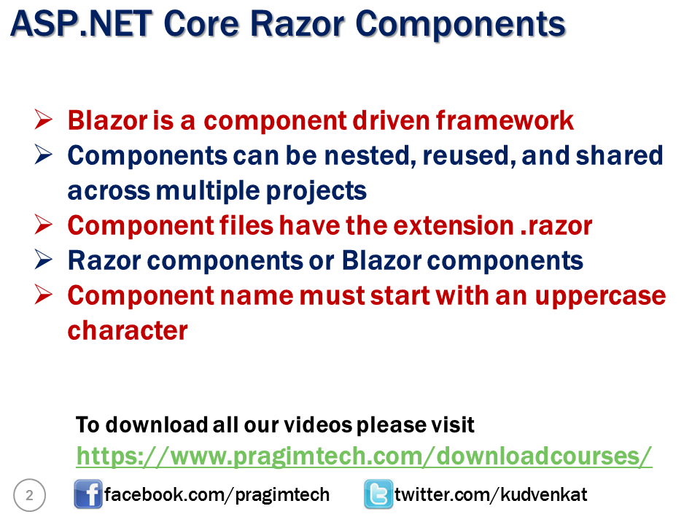

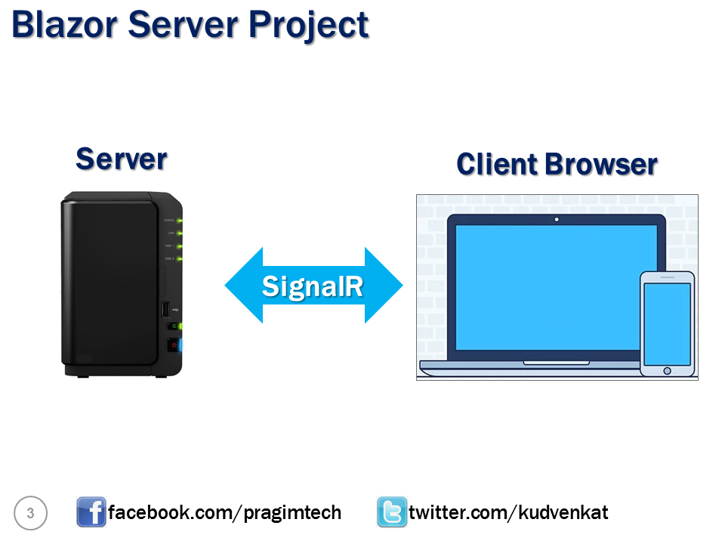

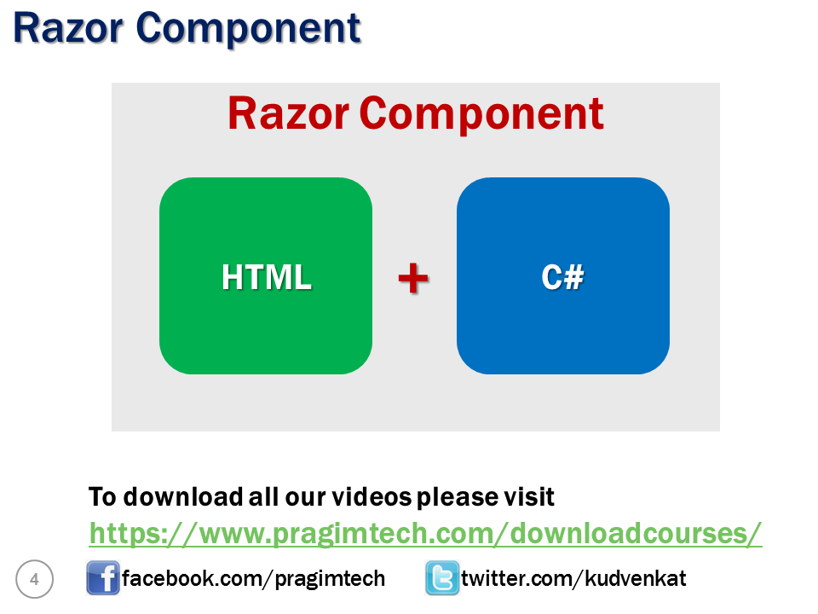

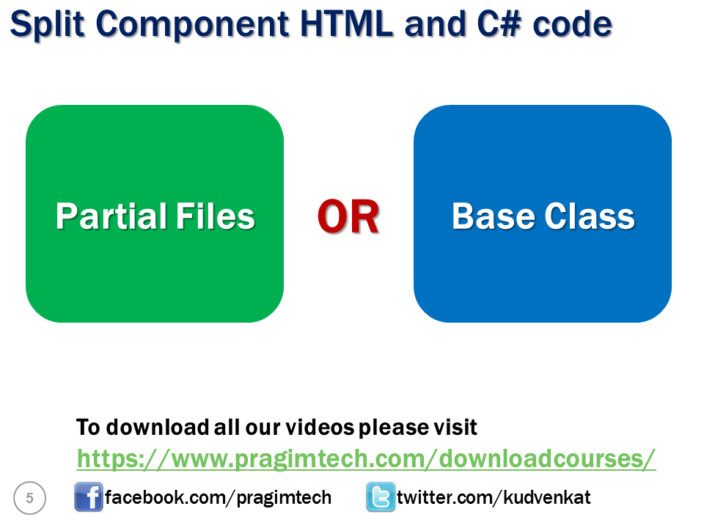

# Split razor component

There are 2 approaches, to split component HTML and C# code into their own separate files.

1. Partial files approach
2. Base class approach

## Single file or Mixed file approach

Both the HTML markup and C# code are in a single file.

// Counter.razor

@page "/counter"

<h1>Counter</h1>

<p>Current count: @currentCount</p>

<button class="btn btn-primary" @onclick="IncrementCount">Click me</button>

@code {

private int currentCount = 0;

private void IncrementCount()

{

currentCount++;

}

}

Copy

## Partial files approach

The HTML markup remains in Counter.razor file.

// Counter.razor

@page "/counter"

<h1>Counter</h1>

<p>Current count: @currentCount</p>

<button class="btn btn-primary" @onclick="IncrementCount">Click me</button>

Copy

Remember, when the component is compiled a class with the same name as the component file is generated. Create another class file with name Counter.razor.cs and include the following code in it. Notice the class in this file is implemented as a partial class.

// Counter.razor.cs

public partial class Counter

{

private int currentCount = 0;

private void IncrementCount()

{

currentCount++;

}

}

Copy

You can toggle file nesting, using the File nesting button on the Solution Explorer.

## Base class approach

Just like the partial class approach, even with the base class approach, the HTML markup remains in Counter.razor file.

// Counter.razor

@page "/counter"

<h1>Counter</h1>

<p>Current count: @currentCount</p>

<button class="btn btn-primary" @onclick="IncrementCount">Click me</button>

Copy

Move the C# code to a separate class. I named it CounterBase. You can name the class anything you want, but it is a common convention to have the same name as the component but suffixed with the word Base.

In this example, the component name is Counter. So the class that contains the c# code is named CounterBase. The class has to inherit from the built-in ComponentBase class. This class is in Microsoft.AspNetCore.Components namespace.

The access modifier must be at least protected if you wish to access the class member from the HTML.

// CounterBase.cs

public class CounterBase : ComponentBase

{

protected int currentCount = 0;

protected void IncrementCount()

{

currentCount++;

}

}

Copy

Finally, in Counter.razor file do not forget to include the following inherits directive.

@inherits CounterBase

Copy

## Slides



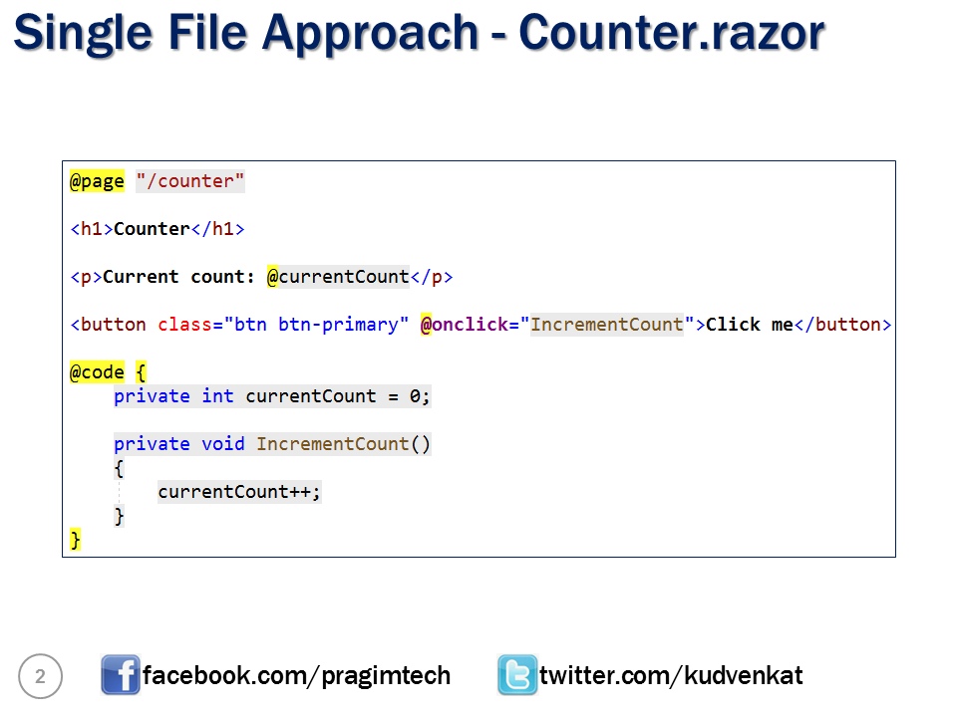

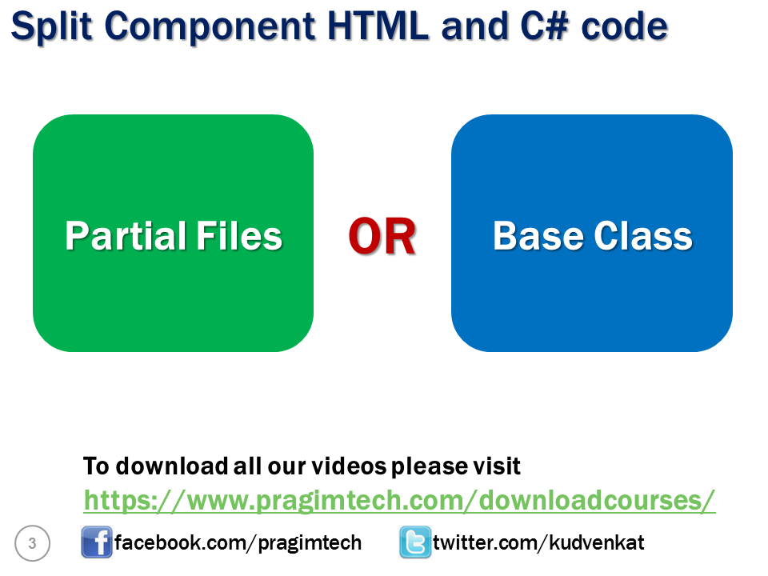

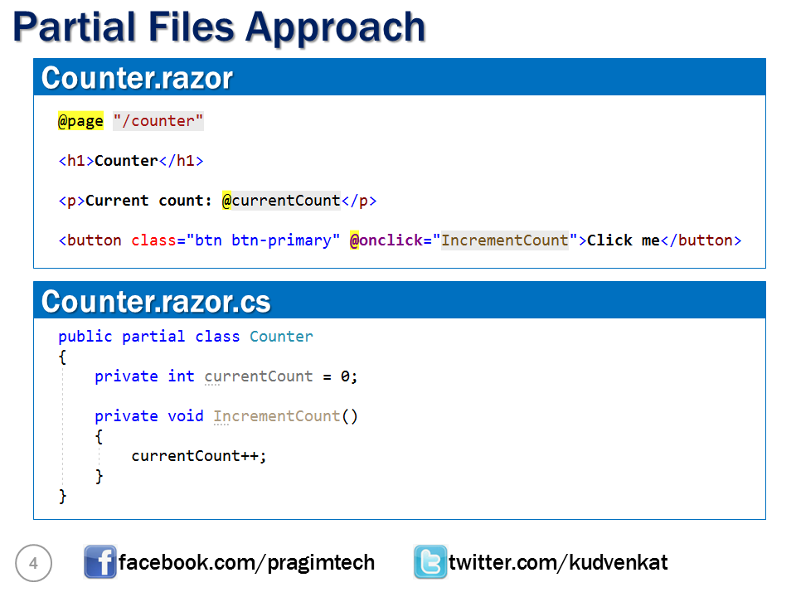

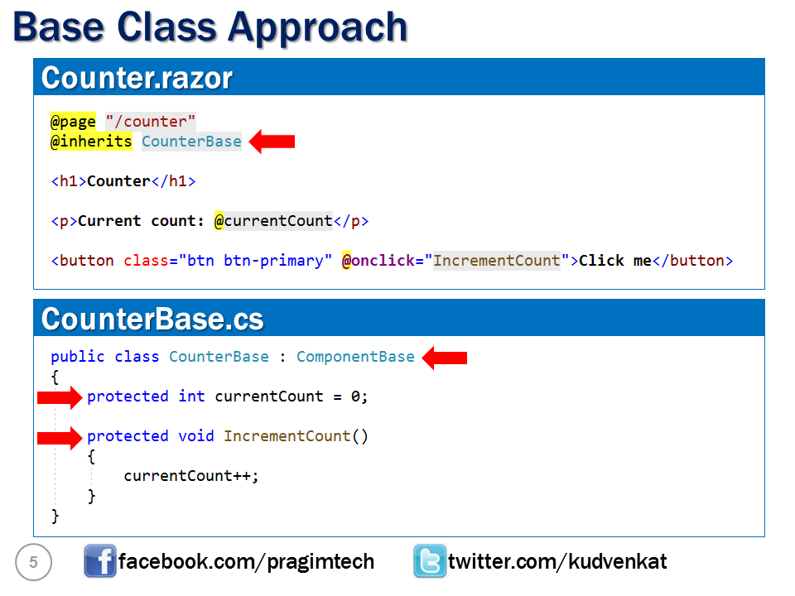

# Creating blazor model classes

As we progress through this course we will be building Employee management system that allows us to Create, Read, Update and Delete employees. The following are the model classes we need.

1. Employee
2. Department
3. Gender

// Employee class

public class Employee

{

public int EmployeeId { get; set; }

public string FirstName { get; set; }

public string LastName { get; set; }

public string Email { get; set; }

public DateTime DateOfBrith { get; set; }

public Gender Gender { get; set; }

public Department Department { get; set; }

public string PhotoPath { get; set; }

}

// Gender Enum

public enum Gender

{

Male,

Female,

Other

}

// Department Class

public class Department

{

public int DepartmentId { get; set; }

public string DepartmentName { get; set; }

}

Copy

## Create Blazor Model classes

Create a new .NET Standard Class Library project. Name the project EmployeeManagement.Models. Name the solution BlazorTutorial.

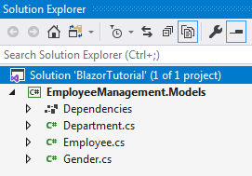

If you are wondering why we chose a .NET standard class library project. Well, it allows us to reuse these models in many different project types across the .NET ecosystem.

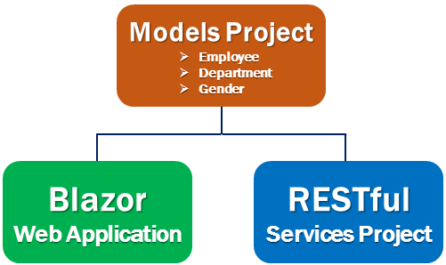

We will be using these models in a Blazor web application project. As we progress through this course we will be creating ASP.NET core RESTful services. These services provide the data our Blazor project needs. Even in the RESTful services project we will be using these model classes.

## Create Blazor Web Project

Add a new Blazor server project, to the BlazorTutorial solution Name it EmployeeManagement.Web. This is the web application project that allows us to Create, Read, Update and Delete employees.

This project needs the model classes we created above. So add a reference to EmployeeManagement.Models project from EmployeeManagement.Web project.

Right click and make EmployeeManagement.Web the startup project if it is not the start up project already.

Delete the following files and folders from EmployeeManagement.Web project.

* Data folder
* Pages/Counter.razor
* Pages/FetchData.razor
* Pages/Index.razor
* Shared/SurveyPrompt.razor

#### **Changes in Startup.cs**

Rmove the following using statement

using EmployeeManagement.Web.Data;

Copy

Remove the following line from ConfigureServices() method

services.AddSingleton<WeatherForecastService>();

Copy

If you are following along, at this point your project should look as below

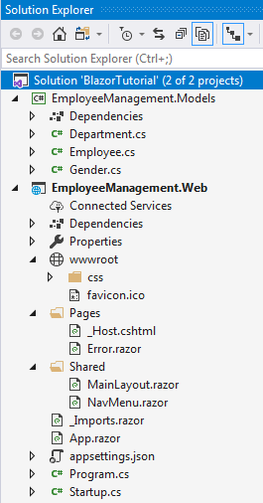

## Create EmployeeList component

In EmployeeManagement.Web project, right click on the Pages folder and add a new razor component. Name it EmployeeList.razor. It is this component that we will use to display the list of Employees.

Include the following @page directive in EmployeeList.razor file. This tells Blazor to render this component when we navigate to the root application URL.

@page "/"

Copy

## Changes in NavMenu.razor

Remove the following 2 navigation menu items.

<li class="nav-item px-3">

<NavLink class="nav-link" href="counter">

<span class="oi oi-plus" aria-hidden="true"></span> Counter

</NavLink>

</li>

<li class="nav-item px-3">

<NavLink class="nav-link" href="fetchdata">

<span class="oi oi-list-rich" aria-hidden="true"></span> Fetch data

</NavLink>

</li>

Copy

## Slides



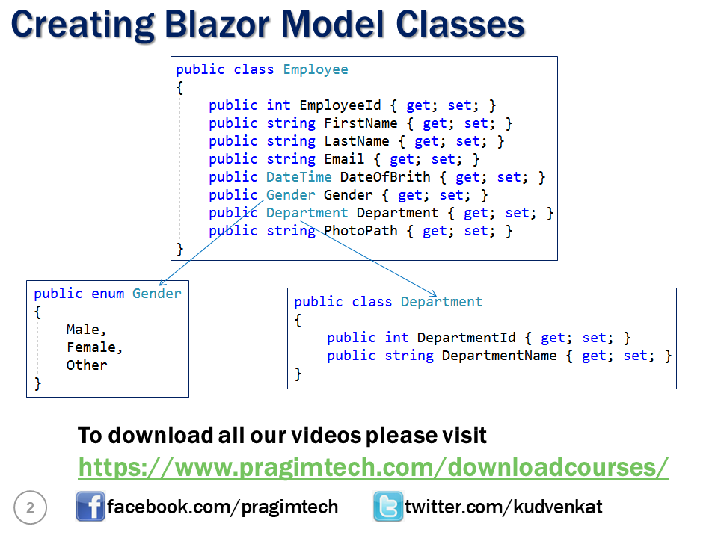

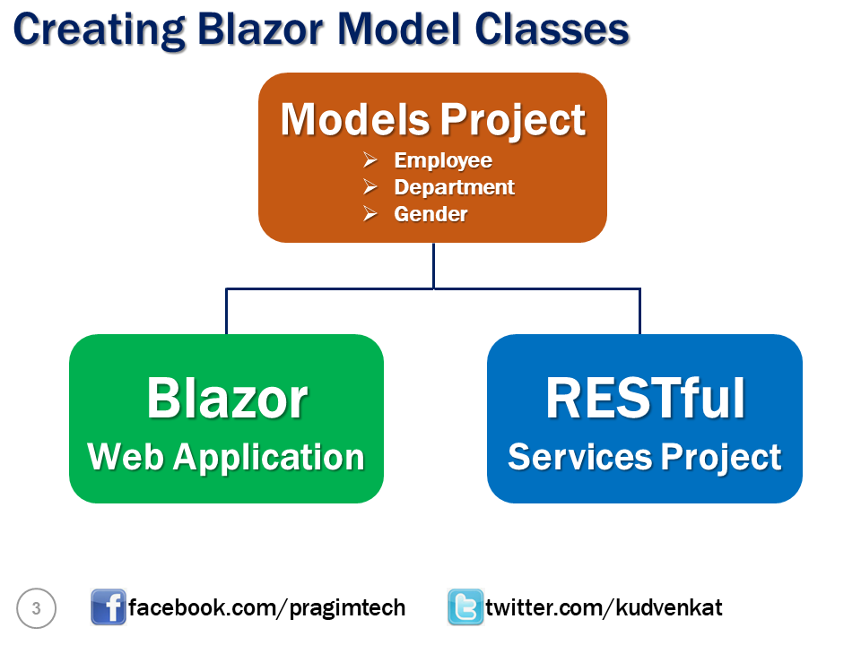

# Employee list blazor component

In this video we will discuss implementing our first **blazor component** - EmployeeList component. We want this component to display list of employees as in the image below.

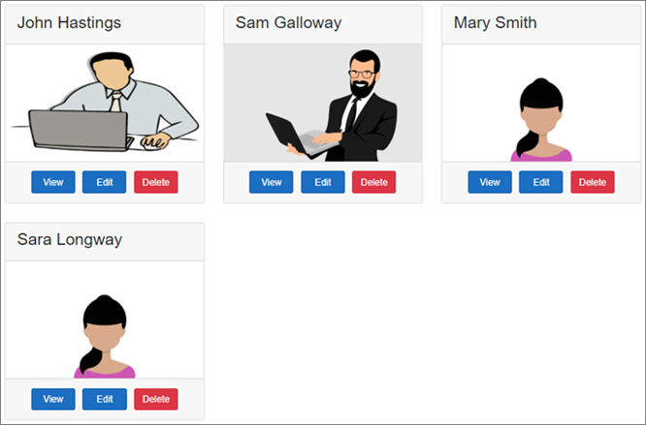

// EmployeeList.razor

@page "/"

@inherits EmployeeListBase

<h3>Employee List</h3>

<div class="card-deck">

@foreach (var employee in Employees)

{

<div class="card m-3" style="min-width: 18rem; max-width:30.5%;">

<div class="card-header">

<h3>@employee.FirstName @employee.LastName</h3>

</div>

<img class="card-img-top imageThumbnail" src="@employee.PhotoPath" />

<div class="card-footer text-center">

<a href="#" class="btn btn-primary m-1">View</a>

<a href="#" class="btn btn-primary m-1">Edit</a>

<a href="#" class="btn btn-danger m-1">Delete</a>

</div>

</div>

}

</div>

Copy

## Code explanation

@page "/"

@inherits EmployeeListBase

The single forward slash in the page directive specifies to render this component when we navigate to the root application URL.

@inherits attribute specifies the base class for this component.

Copy

<div class="card-deck">

@foreach (var employee in Employees)

{

<div class="card m-3" style="min-width: 18rem; max-width:30.5%;">

<div class="card-header">

<h3>@employee.FirstName @employee.LastName</h3>

</div>

<img class="card-img-top imageThumbnail" src="@employee.PhotoPath" />

<div class="card-footer text-center">

<a href="#" class="btn btn-primary m-1">View</a>

<a href="#" class="btn btn-primary m-1">Edit</a>

<a href="#" class="btn btn-danger m-1">Delete</a>

</div>

</div>

}

</div>

Copy

Each employee is displayed using a Bootstrap card. To loop through the list of employees we are using a foreach loop

Copy

// EmployeeListBase.cs

using EmployeeManagement.Models;

using Microsoft.AspNetCore.Components;

using System;

using System.Collections.Generic;

using System.Threading.Tasks;

namespace EmployeeManagement.Web.Pages

{

public class EmployeeListBase : ComponentBase

{

public IEnumerable<Employee> Employees { get; set; }

protected override Task OnInitializedAsync()

{

LoadEmployees();

return base.OnInitializedAsync();

}

private void LoadEmployees()

{

Employee e1 = new Employee

{

EmployeeId = 1,

FirstName = "John",

LastName = "Hastings",

Email = "David@pragimtech.com",

DateOfBrith = new DateTime(1980, 10, 5),

Gender = Gender.Male,

Department = new Department { DepartmentId = 1, DepartmentName = "IT" },

PhotoPath = "images/john.png"

};

Employee e2 = new Employee

{

EmployeeId = 2,

FirstName = "Sam",

LastName = "Galloway",

Email = "Sam@pragimtech.com",

DateOfBrith = new DateTime(1981, 12, 22),

Gender = Gender.Male,

Department = new Department { DepartmentId = 2, DepartmentName = "HR" },

PhotoPath = "images/sam.jpg"

};

Employee e3 = new Employee

{

EmployeeId = 3,

FirstName = "Mary",

LastName = "Smith",

Email = "mary@pragimtech.com",

DateOfBrith = new DateTime(1979, 11, 11),

Gender = Gender.Female,

Department = new Department { DepartmentId = 1, DepartmentName = "IT" },

PhotoPath = "images/mary.png"

};

Employee e4 = new Employee

{

EmployeeId = 3,

FirstName = "Sara",

LastName = "Longway",

Email = "sara@pragimtech.com",

DateOfBrith = new DateTime(1982, 9, 23),

Gender = Gender.Female,

Department = new Department { DepartmentId = 3, DepartmentName = "Payroll" },

PhotoPath = "images/sara.png"

};

Employees = new List<Employee> { e1, e2, e3, e4 };

}

}

}

Copy

Blazor components have several life cycle methods. OnInitializedAsync is the most common life cycle method. We are overriding this method to retrieve Employees data.

At the moment we have Employees data hard-coded in the component. As we progress through this course we will discuss how to retrieve this data from a database by calling a RESTful service.

// MainLayout.razor

For styling, include Boostrap container class on the <div> element that contains @Body

@inherits LayoutComponentBase

<div class="sidebar">

<NavMenu />

</div>

<div class="main">

<div class="content px-4 container">

@Body

</div>

</div>

Copy

// Site.css

.imageThumbnail {

height: 200px;

width: auto;

}

Copy

Download and include the following 4 images in wwwroot/images folder.









# Display loading indicator in blazor

In this video we will discuss how to display a loading indicator, if there is a delay in retrieving the data a blazor component needs. You can see the loading spinner in action below.



## Employee List Component

A component like EmployeeList component retrieves data from a server asynchronously. Employees property in the base class holds the list of employees. We typically retrieve employees from a database by calling a server side service which is an asynchronous operation. By the time the component is rendered, this asynchronous operation might not have completed. This means Employees property could be null and can result in NullReference exceptions.

// EmployeeListBase.cs

public class EmployeeListBase : ComponentBase

{

public IEnumerable<Employee> Employees { get; set; }

protected override async Task OnInitializedAsync()

{

await Task.Run(LoadEmployees);

}

private void LoadEmployees()

{

System.Threading.Thread.Sleep(2000);

// Retrieve data from the server and initialize

// Employees property which the View will bind

}

}

Copy

While Employees property is null we see the loading spinner. As soon as the asynchronous operation is complete and Employees property is populated we see the list of Employees.

// EmployeeList.razor

@if (Employees == null)

{

<div class="spinner"></div>

}

else

{

<div class="card-deck">

@foreach (var employee in Employees)

{

<div class="card m-3">

<div class="card-header">

<h3>@employee.FirstName @employee.LastName</h3>

</div>

<img class="card-img-top imageThumbnail"

src="@employee.PhotoPath" />

</div>

}

</div>

}

Copy

We are using CSS animations to get the effect of a loading spinner. Place the following CSS in wwwroot/css/site.css file. To match the look and feel of the spinner with your application pages, you can change the css properties accordingly in the spinner class.

For example to change the spinner color to Red, set border-top property to 16px solid red.

.spinner {

border: 16px solid silver;

border-top: 16px solid #337AB7;

border-radius: 50%;

width: 80px;

height: 80px;

animation: spin 700ms linear infinite;

top: 40%;

left: 55%;

position: absolute;

}

@keyframes spin {

0% {

transform: rotate(0deg)

}

100% {

transform: rotate(360deg)

}

}

Copy

## Slides



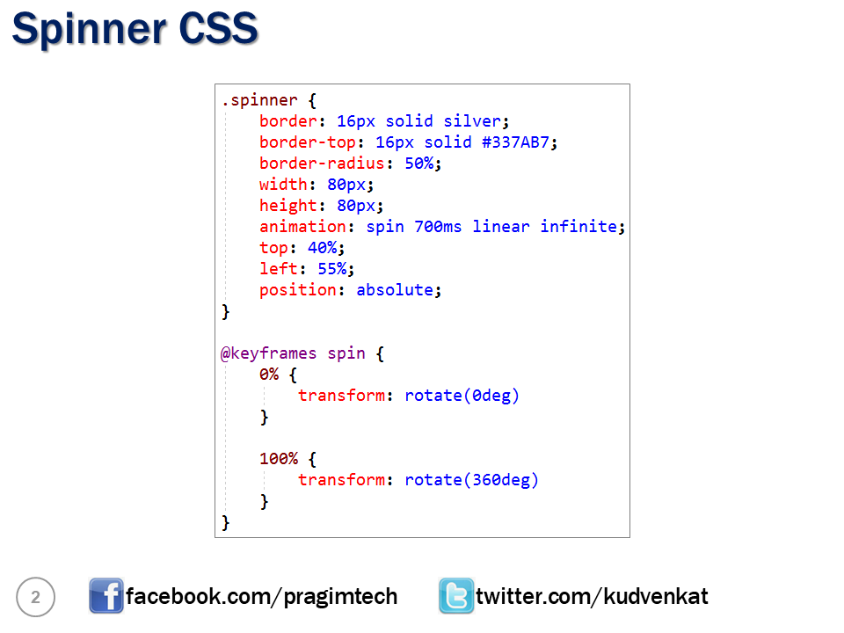

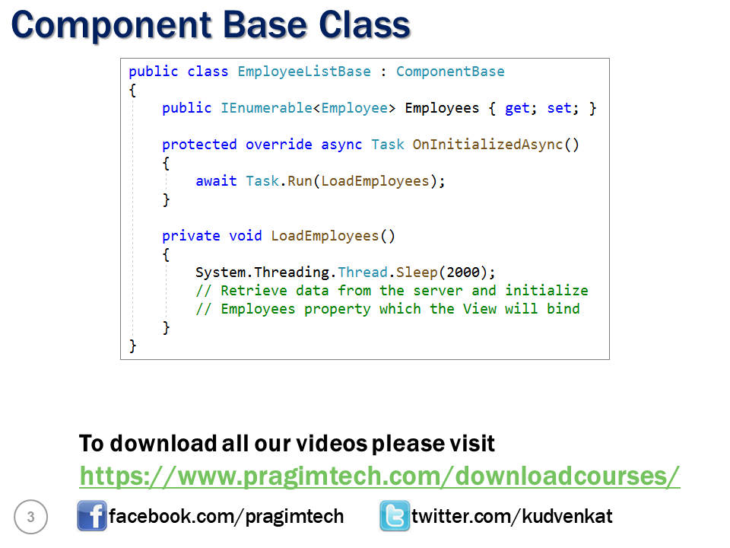

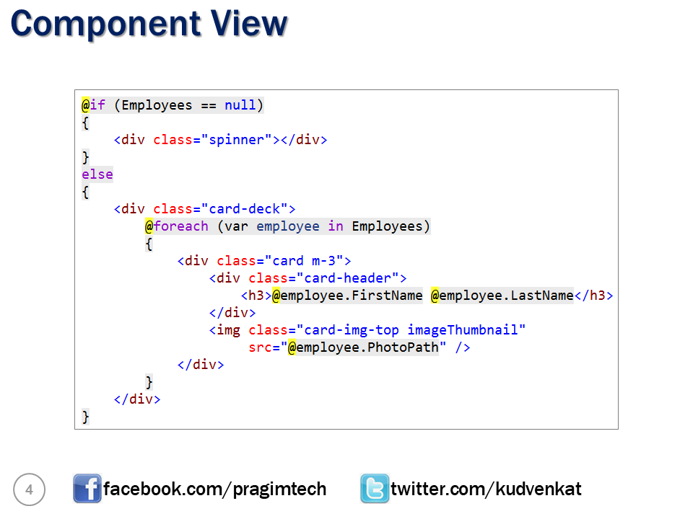

# Blazor data access strategies

In this video we will discuss the options we have to access server-side data from a Blazor application.

One way to build a data driven blazor application is by using the following architecture. With this architecture, the client which is usually the browser calls the Blazor server application. Blazor server application runs on the server. A SignalR connection is established between the client and the blazor application for exchanging information.

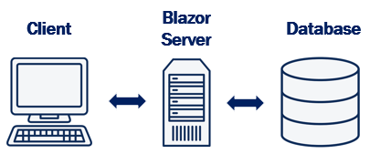

For data, the Blazor application can talk directly to a database server by using entity framework core or some other data access framework. However, use this approach only when you know the Blazor application will always be running on the server and in the future there is no need to convert the Blazor server application to Blazor WebAssembly application. This is because EF core cannot run on the client browser. So if you want to convert this Blazor server application to a Blazor WebAssembly application a lot of rework and code chnage is required.

However, this is an option if you know your Blazor application will always be running on the server.

In this course we will be using a different approach. For the application that we will be building we will use the following architecture.

With this architecture we have a RESTful service between the Blazor application and the Database. **REST**stands for **RE**presentational **S**tate **T**ransfer and it is based on open standards. If you are new to REST, we will discuss what it is in our upcoming videos. So, Blazor application calls the RESTful service. The RESTful service calls the Database using Entity Framework Core.

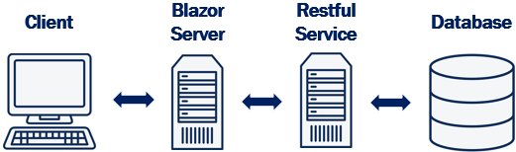

We will be building the RESTful service using ASP.NET Core MVC. Since the RESTful service will be running server-side on a .NET core enabled server we will have access to all server-side resources and data including the capability to run Entity Framework Core code.

The obvious benefit of this approach is, the blazor code we write to consume a RESTful service can be used with both the hosting models i.e Blazor Server and Blazor WebAssembly. It is easy (ie. with minimal changes) we can convert a Blazor server project to Blazor WebAssembly project and vice-versa.

In our next video, we will discuss What is REST.

## Slides



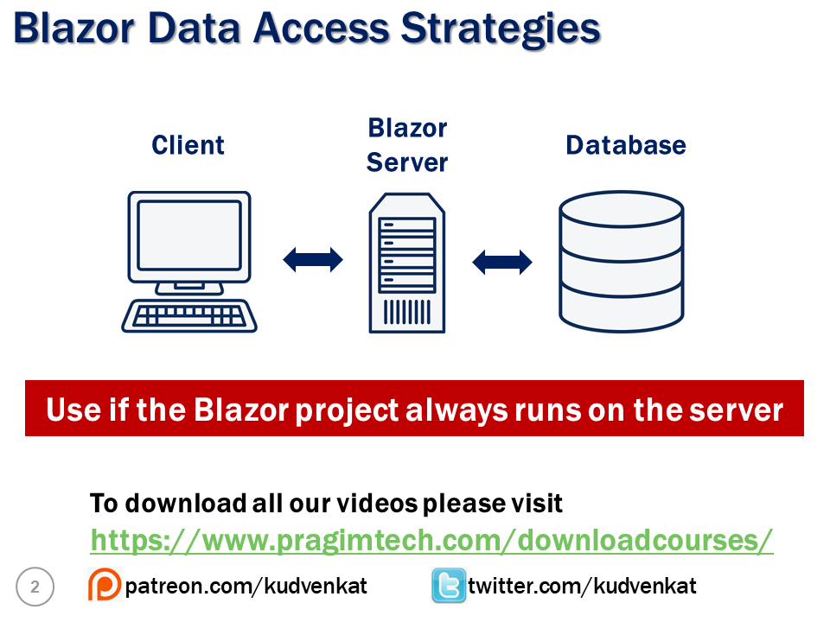

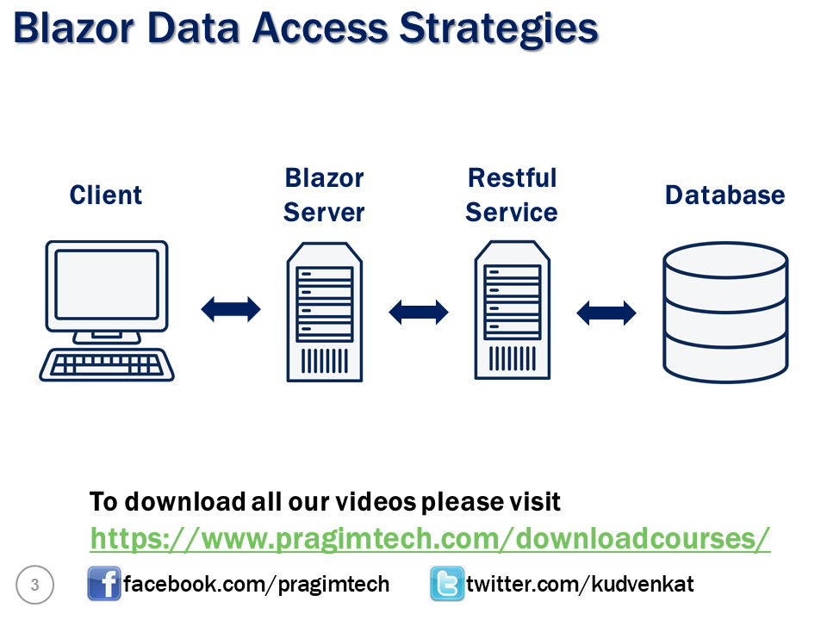

https://www.pragimtech.com/blog/blazor/what-are-restful-apis/

What are RESTful APIs

The word **REST**stands for **RE**presentational **S**tate **T**ransfer. In simple terms it's a pattern for creating an **API**. **API** stands for **A**pplication **P**rogramming **I**nterface.

What is the use of REST API

In simple terms a REST API allows applications to interact with each other and exchange data. For example, let's say you are building a mobile application or a web application. In that application you want to display weather data like temperature, humidity, wind speed etc.

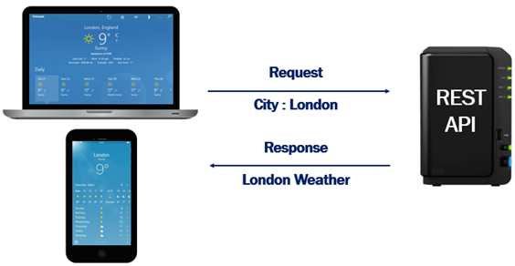

The problem is our application does not have this weather data. It is provided by a third party REST API service. Your application sends the city name for which you want weather data. The third party REST API sends weather data like temperature, humidity, wind speed etc back to your application.

Another REST API Example

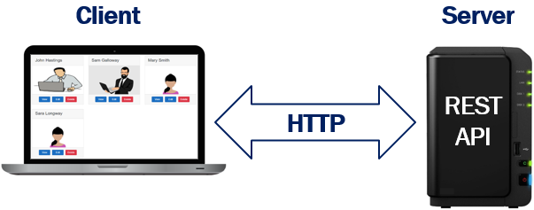

Let's say we are building an Employee portal. Employee data is provided to our application by a REST API. So here the employee portal is the client and the REST API that provides the employee data is the server. The communication between the client and the server happens over HTTP. If you want a more secure option you can also use HTTPS.

In this example, the client is a web application. Since REST is based on open standards, REST APIs can be consumed by a broad range of clients like

* Web Browsers
* Mobile applications
* Desktop applications
* IOTs i.e Internet Of Things.

REST Constraints

When building a REST API, we have to follow a set of rules. These are commonly called as REST Constraints. The following are some of the common REST constraints.

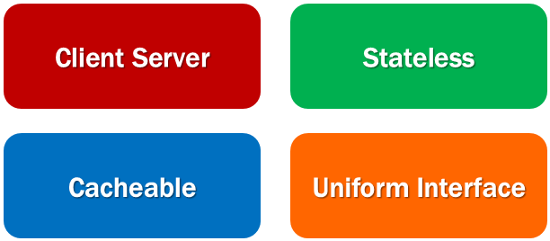

Client Server constraint

This is the first constraint. Client sends a request and the server sends a response. In our case Client is the Employee portal which sends a request for employee data and the server, the REST API, responds with employee data. This separation of concerns supports the independent evolution of the client-side logic and server-side logic.

Stateless constraint

The communication between the client and the server must be stateless between requests. This means we should not be storing anything on the server related to the client. The request from the client should contain all the necessary information for the server to process that request. This ensures that each request can be treated independently by the server.

Cacheable constraint

Some data provided by the server like list of products, or list of departments in a company does not change that often. This constraint says that let the client know how long this data is good for, so that the client does not have to come back to the server for that data over and over again.

Uniform Interface

As the name implies, this constraint defines the interface between the client and the server. This constraint helps us understand how a REST API actually works.

In the context of a REST API, a resource is a data entity like Product, Employee, Customer, Order etc. For example, a REST API that provides employee data makes the list of employees available at the following URI (Uniform Resource Identifier).

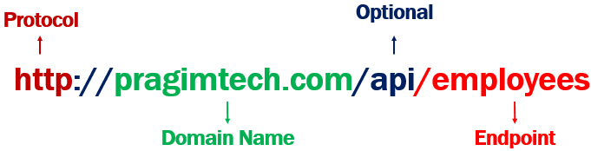

* The protocol that is used here is http. We can also use HTTPS to be a bit more secure.
* pragimtech.com is the domain.
* The path /api in the URI indicates that this is an API. This is just a convention that most people follow. With this convention just by looking at the URL, we can say this is a REST API URL.
* Finally /employees is the endpoint at which we have the resource i.e list of employees in this case.

If you have another resource like a product. Then the list of products might be available at the following end point

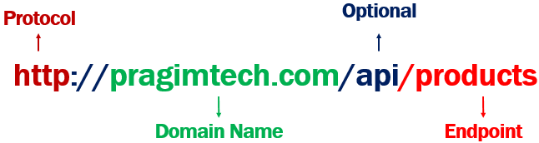

So, each resource, is identified by a specific URI. For example, the list of employees are available at the URI http://pragimtech.com/api/employees. Similarly, the list of products are available at the URI http://pragimtech.com/api/products.

Along with the URI, we also need to send an HTTP verb to the server. The following are the common HTTP verbs.

* GET
* POST
* PUT
* PATCH
* DELETE

It is this HTTP verb that tells the API what to do with the resource. The following are the 4 common operations that we do on any resource. For example, we create a new employee. EDIT, UPDATE or DELETE an existing employee.

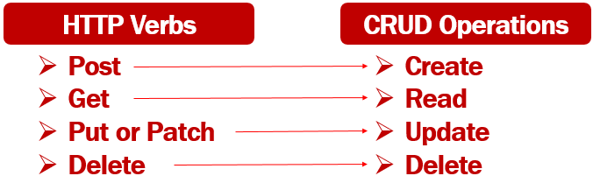

So the combination of the URI and the HTTP verb, that is sent with each request tells the server (i.e the REST API) what to do with the resource. For example,

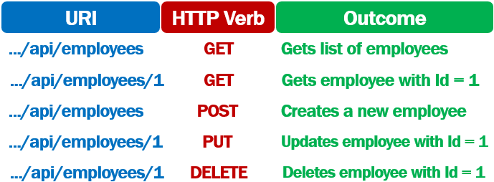

Remember a REST API must adhere to Stateless constraint. According to this constraint, the communication between the client and the server must be stateless i.e the request from the client must contain all the required information for the server to process that request.

So, when creating a new employee, the request

1. Contains the URI .../api/employees
2. The HTTP Verb - POST
3. The employee object itself in the body of the request

Similarly to update an existing employee, the request

1. Contains the URI .../api/employees/1. The id of the employee whose data we want to update is 1.
2. The HTTP Verb - PUT
3. The employee object that contains the changes is sent in the body of the request

PUT V/S PATCH

PUT updates the entire object i.e FirstName, LastName, DOB, Gender, Email etc of an employee. Basically all the properties of the object are updated.

PATCH is used when you want to do a partial update i.e only a subset of the properties. May be just FirstName and Gender of an employee object.

Slides

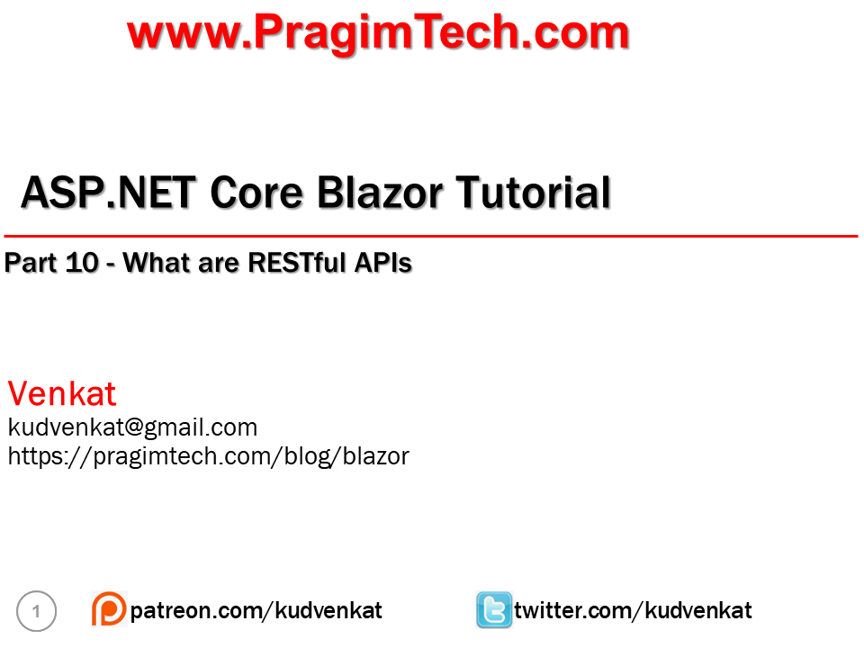

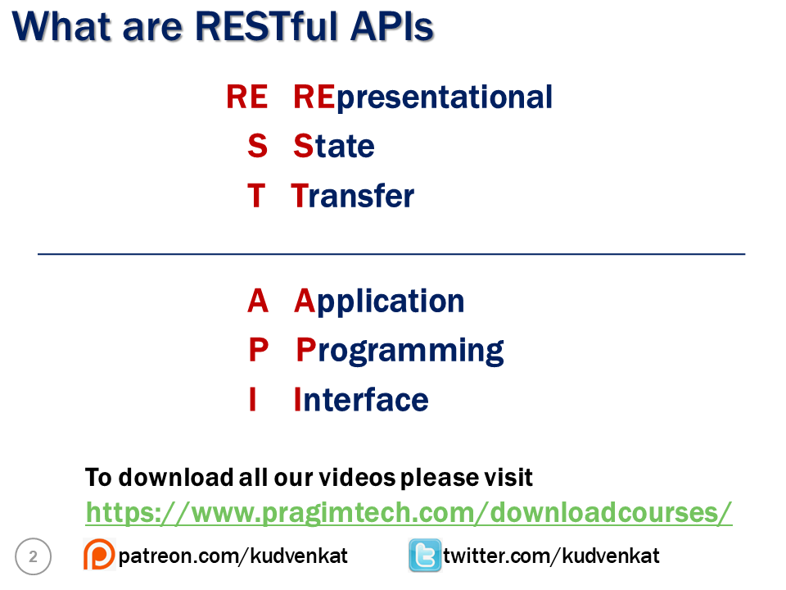

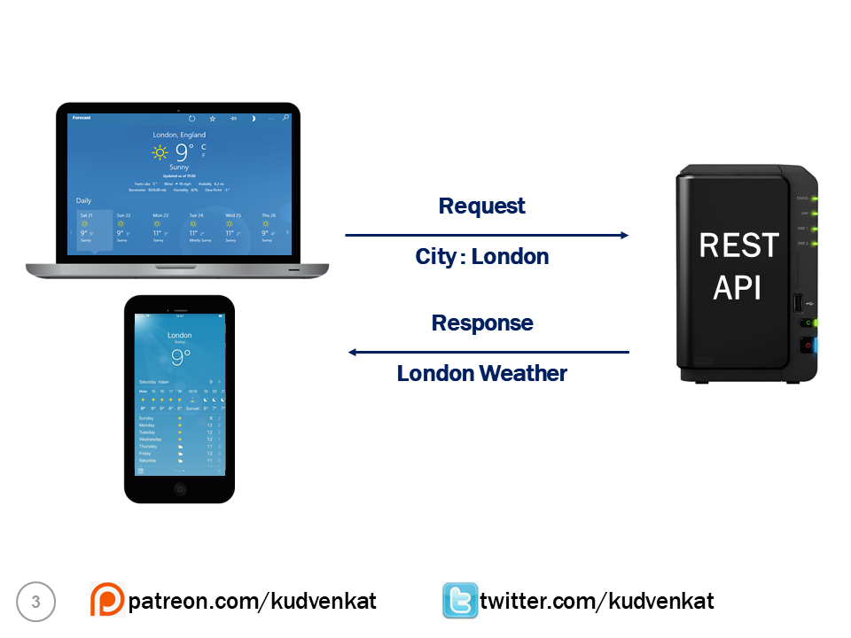

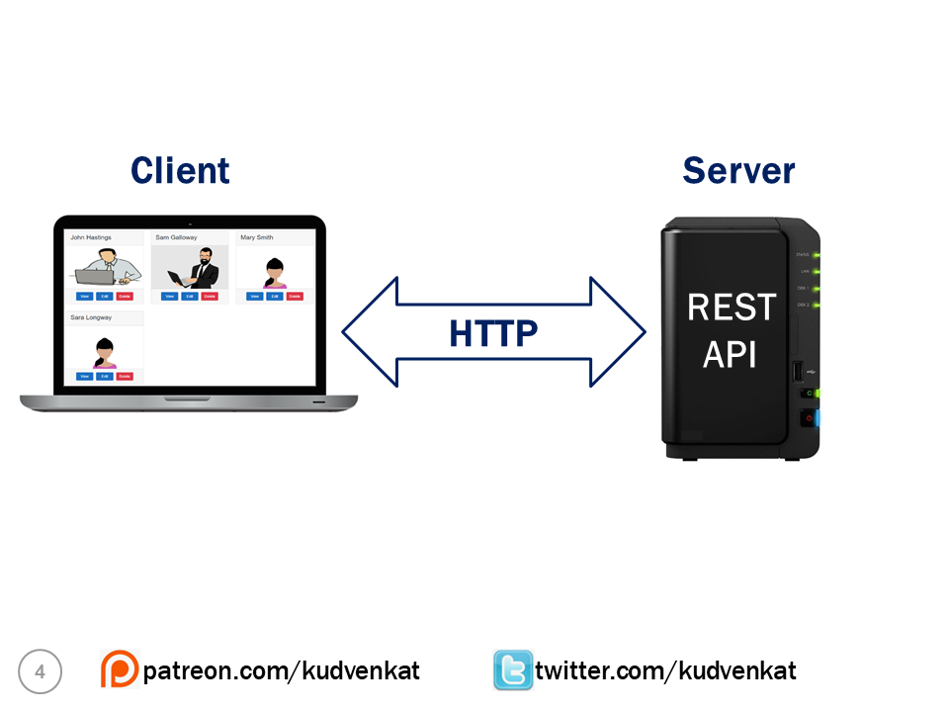

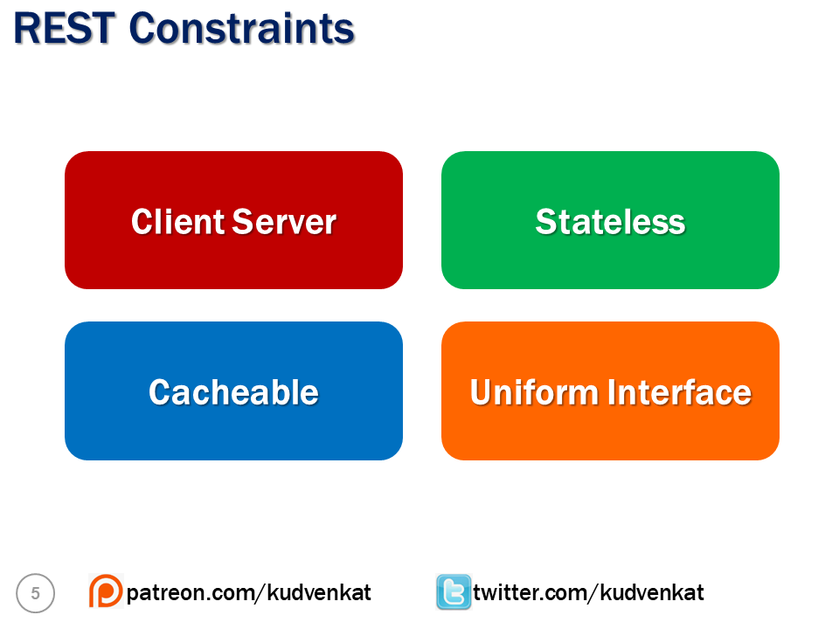

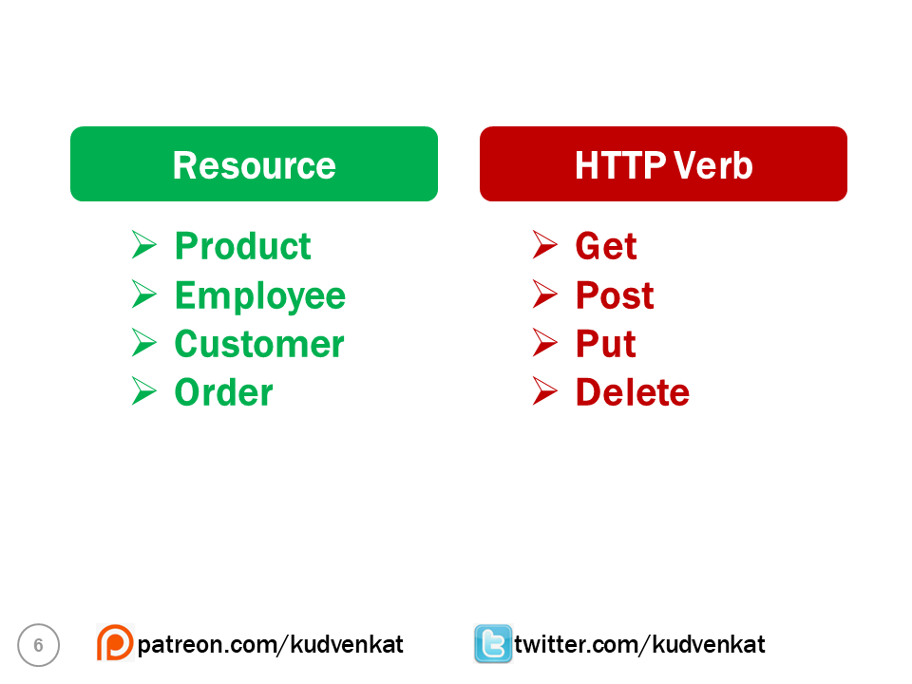

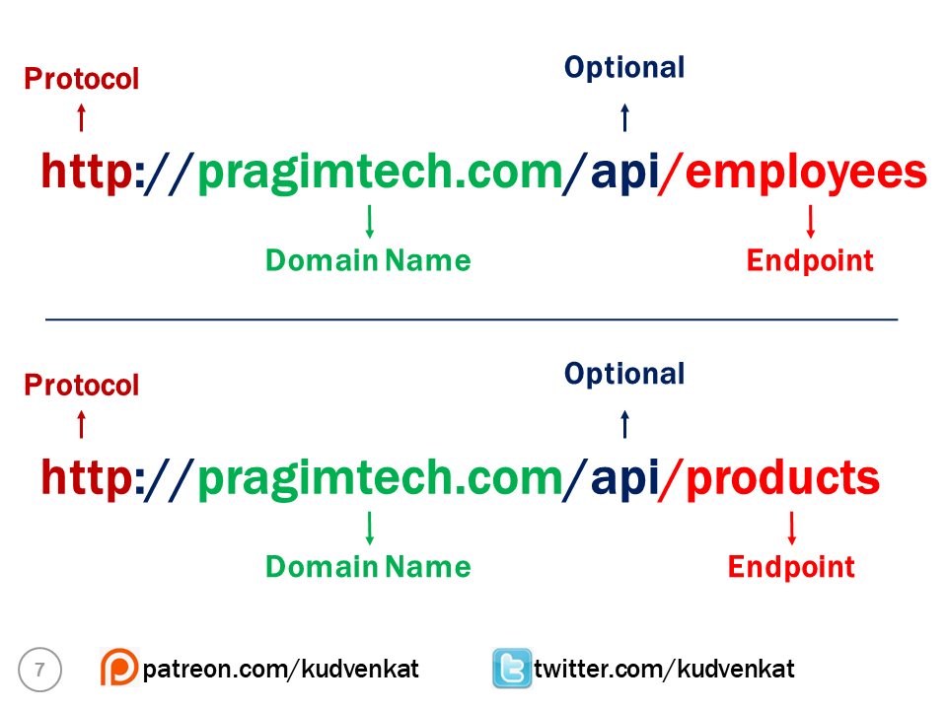

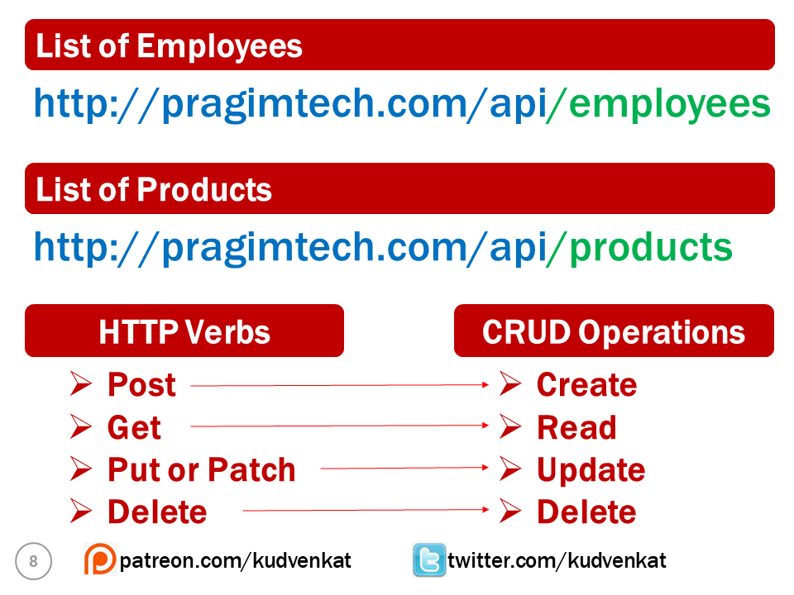

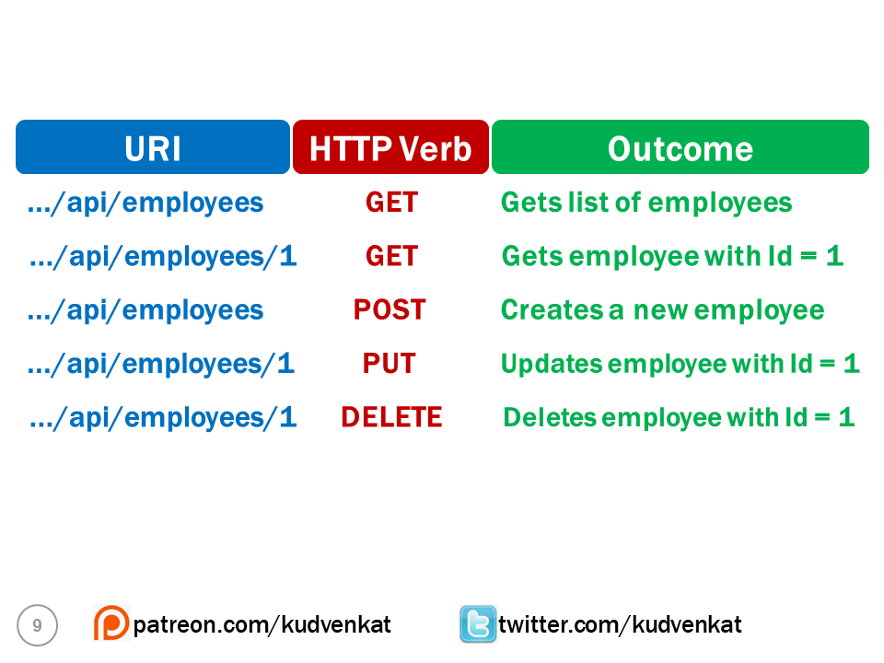

Create asp.net core web api from scratch

In this video and in our next few videos in this series, we will discuss creating a RESTful API from scratch using ASP.NET Core MVC. If you already know, how to create RESTful services using ASP.NET Core MVC, you may skip these videos.

Create ASP.NET Core REST API Project

Use the API project template to create a REST API Project. In our case we want to add the REST API project to the BlazorTutorial solution. Here are the steps.

1. Right click on the solution in the Solution Explorer and select Add - New Project.
2. In the Add a new project window, select ASP.NET Core Web Application and click Next
3. Name the project EmployeeManagement.Api and then click Create

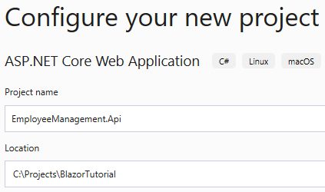

4. On the next screen, select API project template and click Create

EmployeeManagement.Models.Employee class changes

In the Employees database table, we will be storing DepartmentId. So to keep the Employee model class simple, remove Department property and include DepartmentId property. The Employee class must be as shown now.

public class Employee

{

public int EmployeeId { get; set; }

public string FirstName { get; set; }

public string LastName { get; set; }

public string Email { get; set; }

public DateTime DateOfBrith { get; set; }

public Gender Gender { get; set; }

public int DepartmentId { get; set; }

public string PhotoPath { get; set; }

}

Copy

Add reference to EmployeeManagement.Models project

We need the model classes (i.e Employee and Department) defined in EmployeeManagement.Models project in EmployeeManagement.Api project . So add a project reference.

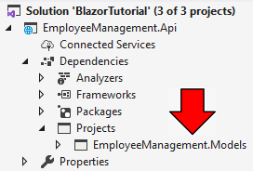

<https://www.pragimtech.com/blog/blazor/asp.net-core-rest-api-dbcontext/>

# ASP.NET Core REST API DbContext

# . ASP.NET Core REST API DbContext

In this video we will discuss adding database support for ASP.NET Core REST API service. For this we are going to use Entity Framework Core.

## What is Entity Framework Core

Entity Framework Core is an ORM (i.e an Object-Relational Mapper). It's a complete rewrite from the ground up. If you have any experience with previous versions of Entity Framework, you will find lot of familiar features.

EF core is lightweight, extensible, and open source software. Like .NET Core, EF Core is also cross platform. It works on windows, Mac OS, and Linux. EF core is Microsoft’s official data access platform.

## Entity Framework Core DbContext class

One of the very important classes in Entity Framework Core is the DbContext class. This is the class that we use in our application code to interact with the underlying database. It is this class that manages the database connection and is used to retrieve and save data in the database.

To use the DbContext class in our application

1. We create a class that derives from the DbContext class.
2. DbContext class is in Microsoft.EntityFrameworkCore namespace.

public class AppDbContext : DbContext

{ }

Copy

## DbContextOptions in Entity Framework Core

For the DbContext class to be able to do any useful work, it needs an instance of the DbContextOptions class.

The DbContextOptions instance carries configuration information such as the connection string, database provider to use etc.

We pass the DbContextOptions to the base DbContext class constructor using the base keyword as shown below.

public class AppDbContext : DbContext

{

public AppDbContext(DbContextOptions<AppDbContext> options)

: base(options)

{

}

}

Copy

## Entity Framework Core DbSet

* The DbContext class includes a DbSet<TEntity> property for each entity in the model.
* At the moment in our application we have, 2 entity classes - Employee and Department.
* So in our AppDbContext class we have 2 corresponding DbSet properties.

DbSet<Employee>

DbSet<Department>

Copy

* We will use these DbSet properties to query and save instances of Employee and Department classes.
* The LINQ queries against the DbSet properties will be translated into queries against the underlying database.

public class AppDbContext : DbContext

{

public AppDbContext(DbContextOptions<AppDbContext> options)

: base(options)

{

}

public DbSet<Employee> Employees { get; set; }

public DbSet<Department> Employees { get; set; }

}

Copy

## Seeding Data

Override OnModelCreating method to seed Employee and Department data.

protected override void OnModelCreating(ModelBuilder modelBuilder)

{

base.OnModelCreating(modelBuilder);

// Code to seed data

}

Copy

## AppDbContext class complete code

Create Models folder and include the following AppDbContext class in it.

using EmployeeManagement.Models;

using Microsoft.EntityFrameworkCore;

using System;

namespace EmployeeManagement.Api.Models

{

public class AppDbContext : DbContext

{

public AppDbContext(DbContextOptions<AppDbContext> options)

: base(options)

{

}

public DbSet<Employee> Employees { get; set; }

public DbSet<Department> Departments { get; set; }

protected override void OnModelCreating(ModelBuilder modelBuilder)

{

base.OnModelCreating(modelBuilder);

//Seed Departments Table

modelBuilder.Entity<Department>().HasData(

new Department { DepartmentId = 1, DepartmentName = "IT" });

modelBuilder.Entity<Department>().HasData(

new Department { DepartmentId = 2, DepartmentName = "HR" });

modelBuilder.Entity<Department>().HasData(

new Department { DepartmentId = 3, DepartmentName = "Payroll" });

modelBuilder.Entity<Department>().HasData(

new Department { DepartmentId = 4, DepartmentName = "Admin" });

// Seed Employee Table

modelBuilder.Entity<Employee>().HasData(new Employee

{

EmployeeId = 1,

FirstName = "John",

LastName = "Hastings",

Email = "David@pragimtech.com",

DateOfBrith = new DateTime(1980, 10, 5),

Gender = Gender.Male,

DepartmentId = 1,

PhotoPath = "images/john.png"

});

modelBuilder.Entity<Employee>().HasData(new Employee

{

EmployeeId = 2,

FirstName = "Sam",

LastName = "Galloway",

Email = "Sam@pragimtech.com",

DateOfBrith = new DateTime(1981, 12, 22),

Gender = Gender.Male,

DepartmentId = 2,

PhotoPath = "images/sam.jpg"

});

modelBuilder.Entity<Employee>().HasData(new Employee

{

EmployeeId = 3,

FirstName = "Mary",

LastName = "Smith",

Email = "mary@pragimtech.com",

DateOfBrith = new DateTime(1979, 11, 11),

Gender = Gender.Female,

DepartmentId = 1,

PhotoPath = "images/mary.png"

});

modelBuilder.Entity<Employee>().HasData(new Employee

{

EmployeeId = 4,

FirstName = "Sara",

LastName = "Longway",

Email = "sara@pragimtech.com",

DateOfBrith = new DateTime(1982, 9, 23),

Gender = Gender.Female,

DepartmentId = 3,

PhotoPath = "images/sara.png"

});

}

}

}

Copy

## Install required NuGet packages

Install the following 2 NuGet packages.

* Microsoft.EntityFrameworkCore.SqlServer
* Microsoft.EntityFrameworkCore.Tools

## Database Connection String

Include the following database connection string in appsettings.json file of the REST API project.

"ConnectionStrings": {

"DBConnection": "server=(localdb)\\MSSQLLocalDB;database=EmployeeDB;Trusted\_Connection=true"

}

Copy

## ConfigureServices in API project Startup class

Read the connection string from appsettings.json file

public void ConfigureServices(IServiceCollection services)

{

services.AddDbContext<AppDbContext>(options =>

options.UseSqlServer(Configuration.GetConnectionString("DBConnection")));

services.AddControllers();

}

Copy

## Create and execute database migrations

Use the following 2 commands to create and execute the initial database migration

* Add-Migration InitialCreate
* Update-Database

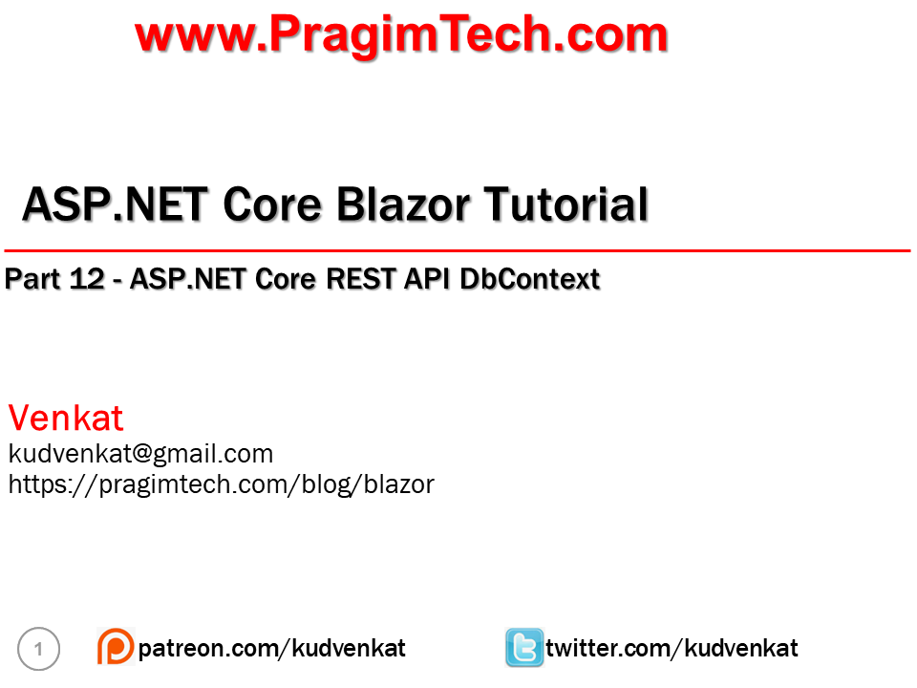

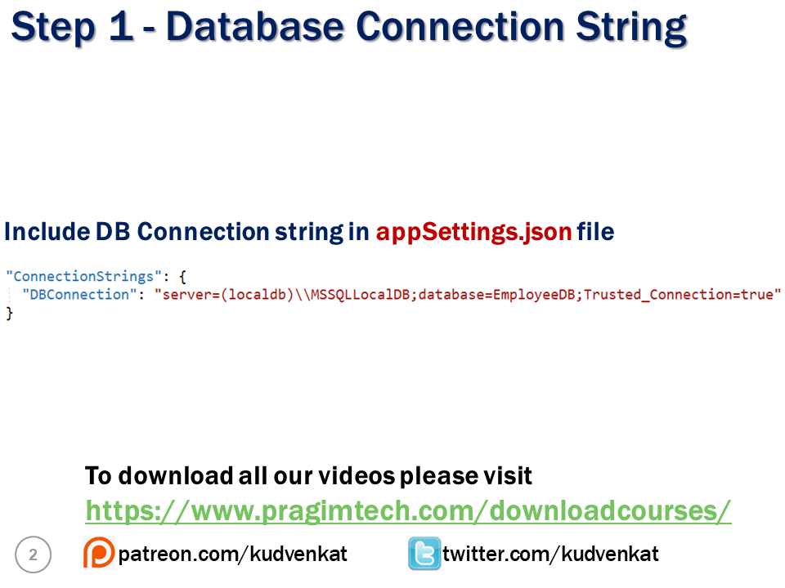

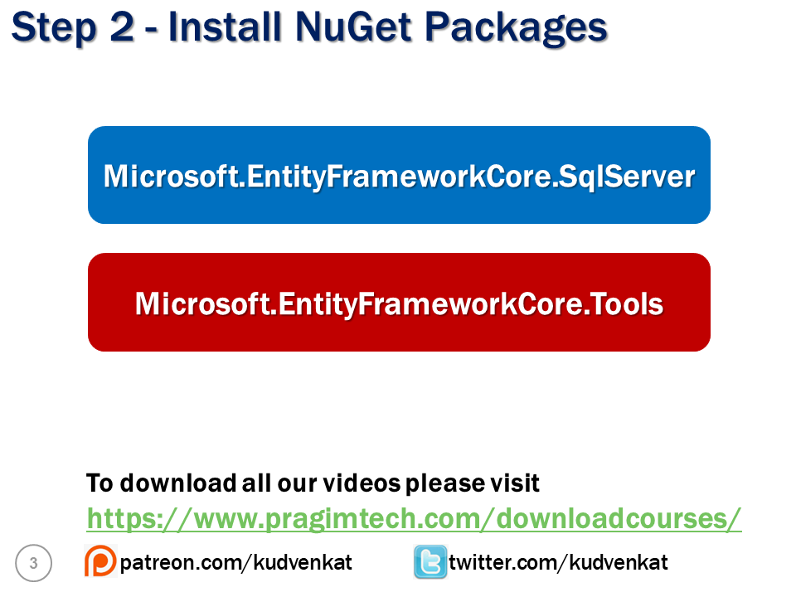

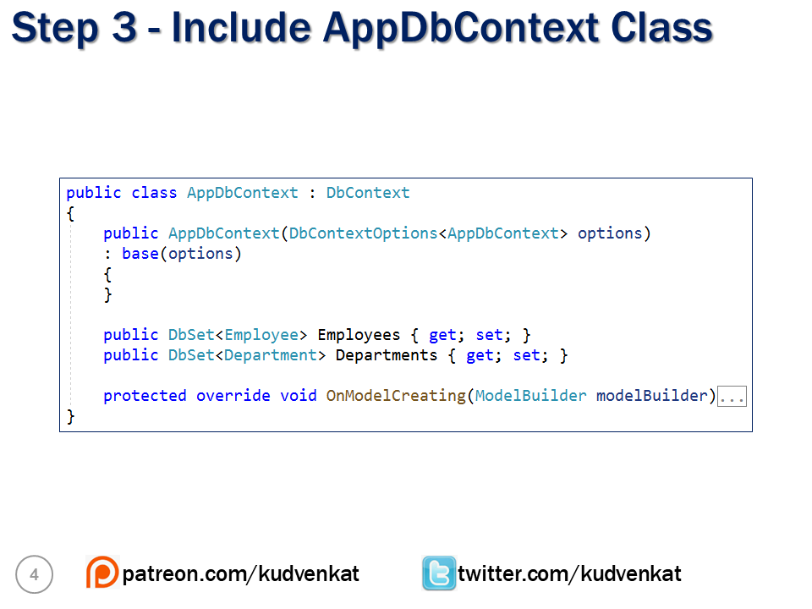

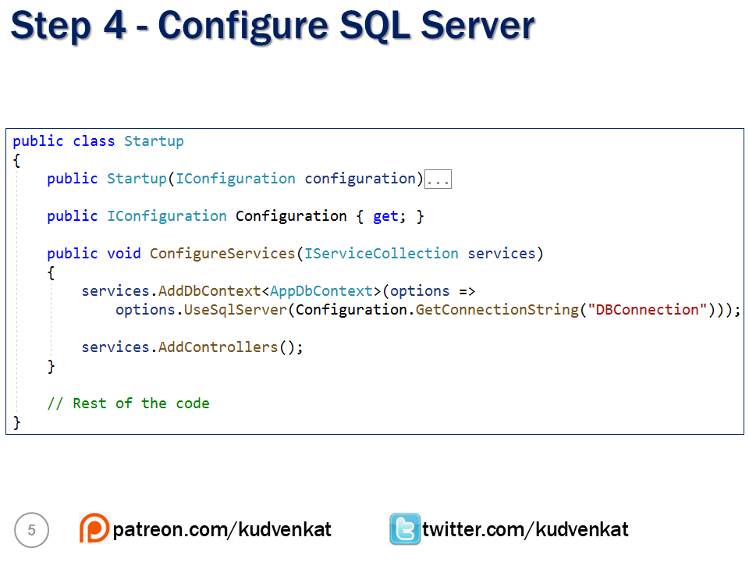

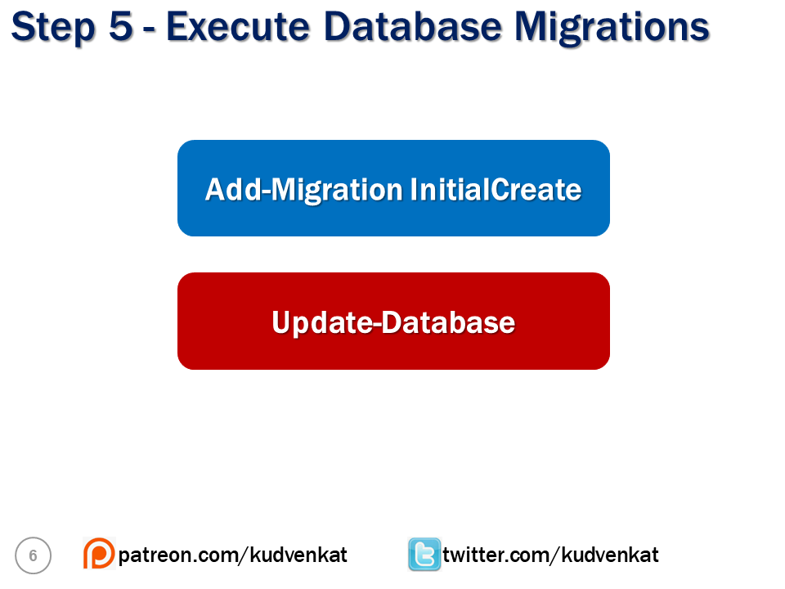

.

# . Repository Pattern in ASP.NET Core REST API

In this video, we will learn

1. What is Repository Pattern
2. Benefits of Repository Pattern
3. An example that uses repository pattern to store and retrieve data from sql server database

## What is Repository Pattern

Repository Pattern is an abstraction of the Data Access Layer. It hides the details of how exactly the data is saved or retrieved from the underlying data source. The details of how the data is stored and retrieved is in the respective repository. For example, you may have a repository that stores and retrieves data from an in-memory collection. You may have another repository that stores and retrieves data from a database like SQL Server. Yet another repository that stores and retrieves data from an XML file.

## Repository Pattern Interface

The interface in the repository pattern specifies

* What operations (i.e methods) are supported by the repository
* The data required for each of the operations i.e the parameters that need to be passed to the method and the data the method returns
* The repository interface contains what it can do, but not, how it does, what it can do
* The implementation details are in the respective repository class that implements the repository Interface

public interface IEmployeeRepository

{

Task<IEnumerable<Employee>> GetEmployees();

Task<Employee> GetEmployee(int employeeId);

Task<Employee> AddEmployee(Employee employee);

Task<Employee> UpdateEmployee(Employee employee);

void DeleteEmployee(int employeeId);

}

Copy

IEmployeeRepository interface supports the following operations

* Get all the employees
* Get a single employee by id
* Add a new employee
* Updat an employee
* Delete an employee

The details of how these operations are implmented are in the repository class that implments this IEmployeeRepository interface.

## Repository Pattern - SQL Server Implementation

The following EmployeeRepository class provides an implementation for IEmployeeRepository. This specific implementation stores and retrieves employees from a sql server database.

using EmployeeManagement.Models;

using Microsoft.EntityFrameworkCore;

using System.Collections.Generic;

using System.Threading.Tasks;

namespace EmployeeManagement.Api.Models

{

public class EmployeeRepository : IEmployeeRepository

{

private readonly AppDbContext appDbContext;

public EmployeeRepository(AppDbContext appDbContext)

{

this.appDbContext = appDbContext;

}

public async Task<IEnumerable<Employee>> GetEmployees()

{

return await appDbContext.Employees.ToListAsync();

}

public async Task<Employee> GetEmployee(int employeeId)

{

return await appDbContext.Employees

.FirstOrDefaultAsync(e => e.EmployeeId == employeeId);

}

public async Task<Employee> AddEmployee(Employee employee)

{

var result = await appDbContext.Employees.AddAsync(employee);

await appDbContext.SaveChangesAsync();

return result.Entity;

}

public async Task<Employee> UpdateEmployee(Employee employee)

{

var result = await appDbContext.Employees

.FirstOrDefaultAsync(e => e.EmployeeId == employee.EmployeeId);

if (result != null)

{

result.FirstName = employee.FirstName;

result.LastName = employee.LastName;

result.Email = employee.Email;

result.DateOfBrith = employee.DateOfBrith;

result.Gender = employee.Gender;

result.DepartmentId = employee.DepartmentId;

result.PhotoPath = employee.PhotoPath;

await appDbContext.SaveChangesAsync();

return result;

}

return null;

}

public async void DeleteEmployee(int employeeId)

{

var result = await appDbContext.Employees

.FirstOrDefaultAsync(e => e.EmployeeId == employeeId);

if (result != null)

{

appDbContext.Employees.Remove(result);

await appDbContext.SaveChangesAsync();

}

}

}

}

Copy

## DepartmentRepository Interface

public interface IDepartmentRepository

{

IEnumerable<Department> GetDepartments();

Department GetDepartment(int departmentId);

}

Copy

## DepartmentRepository Implementation

using EmployeeManagement.Models;

using System.Collections.Generic;

using System.Linq;

namespace EmployeeManagement.Api.Models

{

public class DepartmentRepository : IDepartmentRepository

{

private readonly AppDbContext appDbContext;

public DepartmentRepository(AppDbContext appDbContext)

{

this.appDbContext = appDbContext;

}

public Department GetDepartment(int departmentId)

{

return appDbContext.Departments

.FirstOrDefault(d => d.DepartmentId == departmentId);

}

public IEnumerable<Department> GetDepartments()

{

return appDbContext.Departments;

}

}

}

Copy

## Which implementation to use

With the following 2 lines of code, ASP.NET Core provides an instance of EmployeeRepository class when an instance of IEmployeeRepository is requested. Similarly an instance of DepartmentRepository class is provided when an instance of IDepartmentRepository is requested.

public void ConfigureServices(IServiceCollection services)

{

// Rest of the code

services.AddScoped<IDepartmentRepository, DepartmentRepository>();

services.AddScoped<IEmployeeRepository, EmployeeRepository>();

}

Copy

We are using AddScoped() method because we want the instance to be alive and available for the entire scope of the given HTTP request. For another new HTTP request, a new instance of EmployeeRepository class will be provided and it will be available throughout the entire scope of that HTTP request.

We discussed the difference between AddSingleton(), AddScoped() and AddTransient() methods in detail in [Part 44](https://youtu.be/v6Nr7Zman_Y) of [ASP.NET Core Tutorial](https://www.pragimtech.com/courses/asp-net-core-mvc-tutorial-for-beginners/).

Throughout our entire application, in all the places where IEmployeeRepository is injected an instance of EmployeeRepository is provided. If you want your application to use a different implementation instead, all you need to change is the following one line of code.

services.AddScoped<IEmployeeRepository, EmployeeRepository>();

Copy

## Benefits of Repository Pattern

* The code is cleaner, and easier to reuse and maintain.
* Enables us to create loosely coupled systems. For example, if we want our application to work with oracle instead of sql server, implement an OracleRepository that knows how to read and write to Oracle database and register OracleRepository with the dependency injection system.
* In an unit testing project, it is easy to replace a real repository with a fake implementation for testing.

## Slides

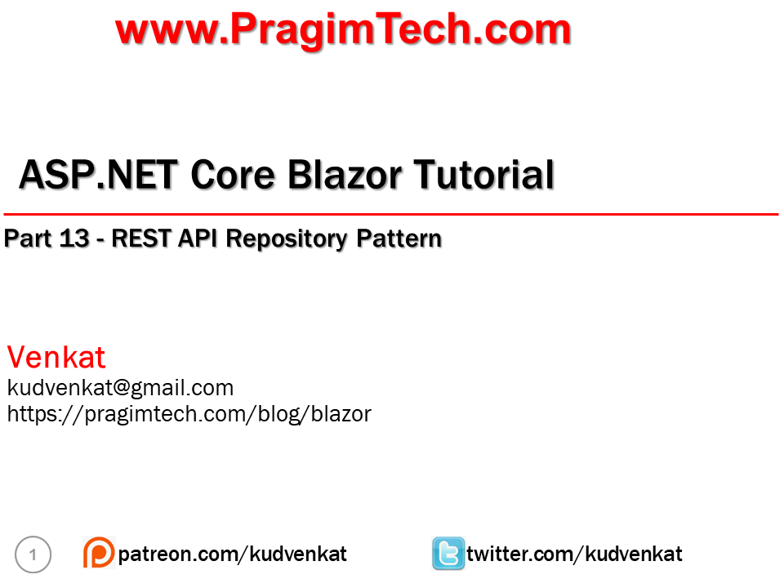

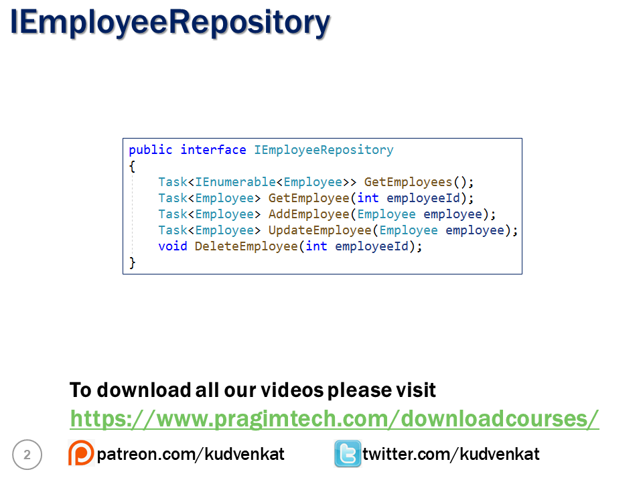

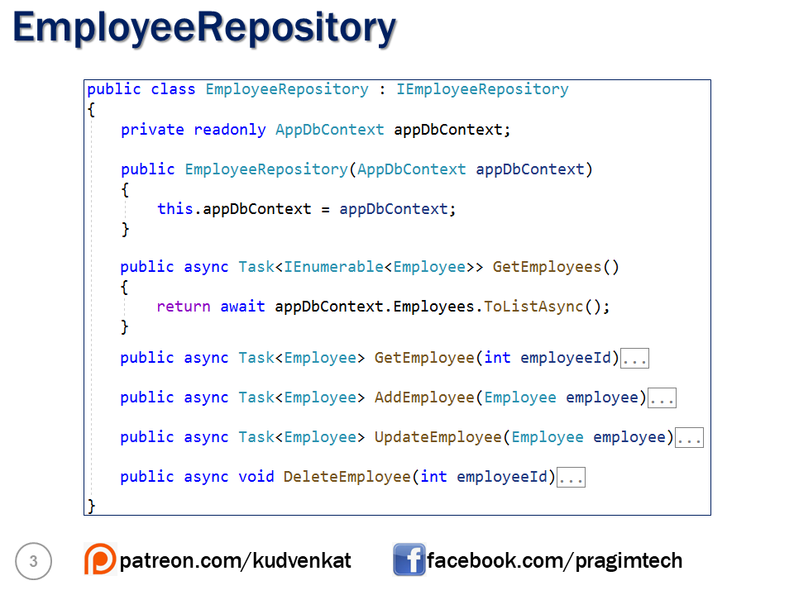

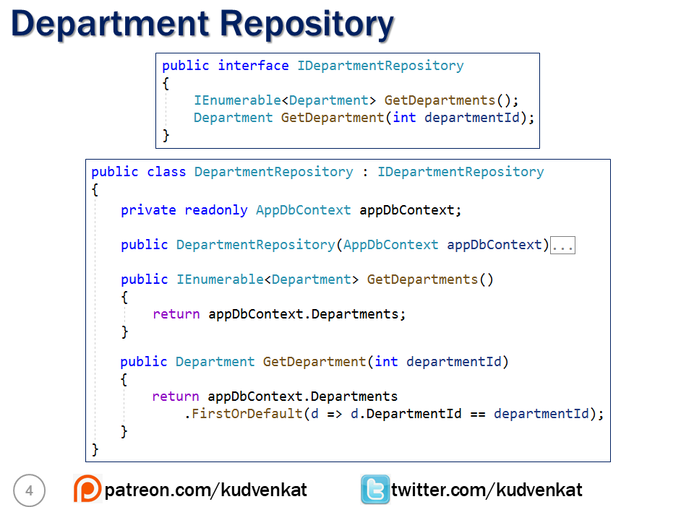

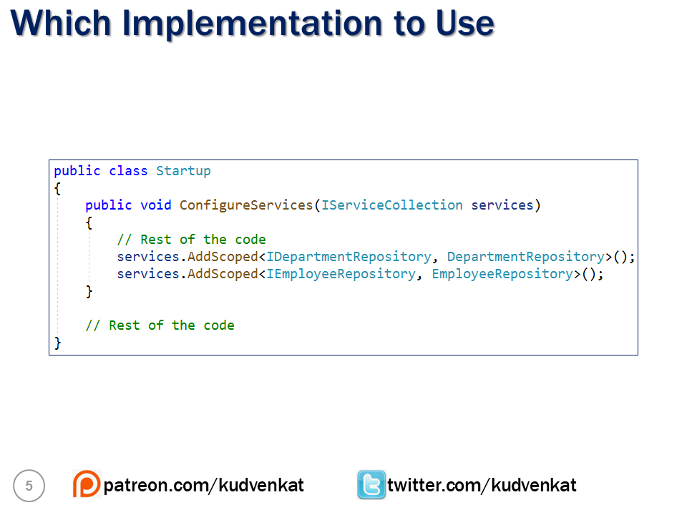

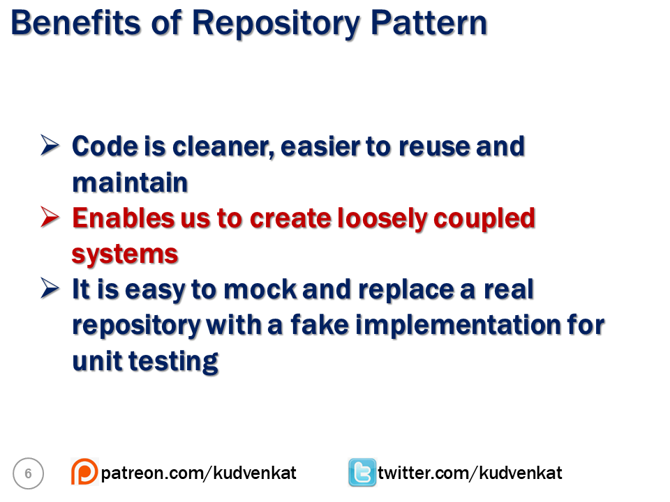

# Get list of resources using ASP.NET Core REST API

In this video we will learn

* Creating a REST API using ASP.NET Core
* Return a list of resources i.e a list of employees from the REST API

## Create REST API using ASP.NET Core

To create a REST API using ASP.NET core, create a controller class that derives from the built-in ControllerBase class. ControllerBase is in Microsoft.AspNetCore.Mvc namespace.

## Controller vs ControllerBase in ASP.NET Core

If you are creating a REST API, make your Controller class derive from ControllerBase and not Controller class. Controller derives from ControllerBase and adds support for MVC views.

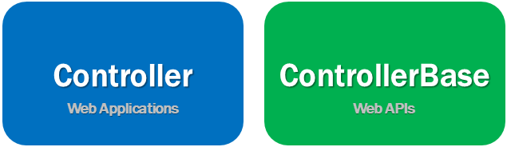

So create a controller that derives from Controller class if you are building an MVC web application. On the other hand, if you are creating a Web API, create a controller class that derives from ControllerBase class. So in short, Controller is for MVC web applications and ControllerBase is for MVC Web APIs.

If you are planning to use the controller both for a web application and for a web api, then derive it from the Controller class.

## ASP.NET Core API Controller Example

* EmployeesController is an API Controller so decorate it with [ApiController] attribute
* As the name implies, [Route] attribute specifies the route. The word [controller] in square brackets specifies we just use the name of the Controller in the URL to get the EmployeesController.
* IEmployeeRepository is injected into the Controller class using the standrad constructor injection. It is this IEmployeeRepository that retrieves employee data from the underlying SQL Server database. We implemented this repository class in our previous videos in this series.
* [HttpGet] attribute specifies that this method should respond to http GET request.
* The return type of Task<ActionResult> allows us to return status code 200 OK along with the list of employees or status code 500 if there is a server error retrieving data from the database.

using EmployeeManagement.Api.Models;

using Microsoft.AspNetCore.Http;

using Microsoft.AspNetCore.Mvc;

using System;

using System.Threading.Tasks;

namespace EmployeeManagement.Api.Controllers

{

[Route("api/[controller]")]

[ApiController]

public class EmployeesController : ControllerBase

{

private readonly IEmployeeRepository employeeRepository;

public EmployeesController(IEmployeeRepository employeeRepository)

{

this.employeeRepository = employeeRepository;

}

[HttpGet]

public async Task<ActionResult> GetEmployees()

{

try

{

return Ok(await employeeRepository.GetEmployees());

}

catch (Exception)

{

return StatusCode(StatusCodes.Status500InternalServerError,

"Error retrieving data from the database");

}

}

}

}

Copy

## Http Status codes

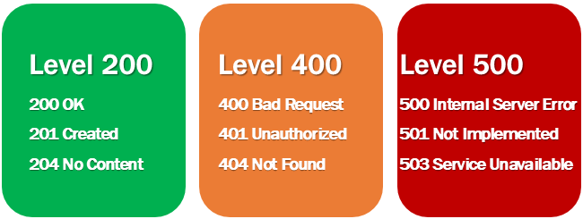

Provides the caller i.e the client of the API know the status of the request. Some of the common status codes are 200/OK, 404/Not Found, 204/No Content. For the complete list of HTTP status codes and what they mean, please visit <https://en.wikipedia.org/wiki/List_of_HTTP_status_codes>.

ASP.NET core provides the following helper methods to return HTTP Status Codes.

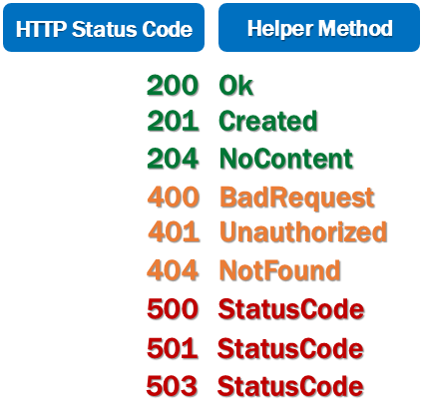

# ASP.NET Core REST API get by id

In this video we will learn how to retrieve a resource by id. For example, retrieve Employee by Id. In our previous video we discussed how to retrieve the list of all employees. In this video we want to retrieve a specific Employee i.e Employee by ID.

## REST API URLs

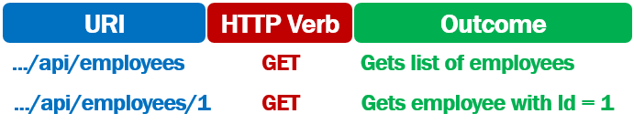

* A GET request to the URI /api/employees returns the list of Employees
* A GET request to the URI /api/employees/1 should return the Employee whose ID is 1

## ASP.NET Core REST API Get by Id Example

using EmployeeManagement.Api.Models;

using EmployeeManagement.Models;

using Microsoft.AspNetCore.Http;

using Microsoft.AspNetCore.Mvc;

using System;

using System.Collections.Generic;

using System.Linq;

using System.Threading.Tasks;

namespace EmployeeManagement.Api.Controllers

{

[Route("api/[controller]")]

[ApiController]

public class EmployeesController : ControllerBase

{

private readonly IEmployeeRepository employeeRepository;

public EmployeesController(IEmployeeRepository employeeRepository)

{

this.employeeRepository = employeeRepository;

}

[HttpGet]

public async Task<ActionResult<IEnumerable<Employee>>> GetEmployees()

{

try

{

return (await employeeRepository.GetEmployees()).ToList();

}

catch (Exception)

{

return StatusCode(StatusCodes.Status500InternalServerError,

"Error retrieving data from the database");

}

}

[HttpGet("{id:int}")]

public async Task<ActionResult<Employee>> GetEmployee(int id)

{

try

{

var result = await employeeRepository.GetEmployee(id);

if (result == null) return NotFound();

return result;

}

catch (Exception)

{

return StatusCode(StatusCodes.Status500InternalServerError,

"Error retrieving data from the database");

}

}

}

}

Copy

A method decorated with HttpGet attribute specifies, that amethod should handle HTTP GET request. Both GetEmployees() and GetEmployee() are decorated with the HttpGet attribute. The difference is, HttpGet attribute on GetEmployee() method also has a route template. The id of the employee will be appended to the URL /api/employees.

[HttpGet("{id:int}")]

public async Task<ActionResult<Employee>> GetEmployee(int id)

Copy

* So if the URL is /api/employees then it is handled by GetEmployees() method. If the URL is /api/employees/1 then it is handled by GetEmployee(int id) method.
* The employee id value in the URL is automatically mapped to the id parameter on the GetEmployee(int id) method.
* As we are using the int route constraint on the id route parameter, the id value in the URL is mapped to the method parameter, only if the value is an integer.
* The employee id is then passed to employeeRepository.GetEmployee(id) method which retrieves the respective employee from the database.
* If the employee is found, ASP.NET Core automatically serializes the employee object to JSON and writes it into the response body. This response body along with the http status code 200 OK is returned to the client. If the employee is not found, then http status code 404 NotFound is returned.

# Post in ASP.NET Core REST API

In this video we will discuss, how to create a new item, i.e implement **http post in ASP.NET Core REST API**.

To create a new item, issue an HTTP POST request to the URI /api/employees. Posting to the collection /api/employees makes sense because, to the collection of employees we want to add a new employee.

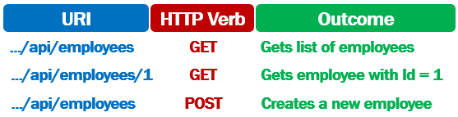

## ASP.NET Core REST API - HTTP POST Example

[Route("api/[controller]")]

[ApiController]

public class EmployeesController : ControllerBase

{

private readonly IEmployeeRepository employeeRepository;

public EmployeesController(IEmployeeRepository employeeRepository)

{

this.employeeRepository = employeeRepository;

}

[HttpPost]

public async Task<ActionResult<Employee>> CreateEmployee(Employee employee)

{

try

{

if (employee == null)

return BadRequest();

var createdEmployee = await employeeRepository.AddEmployee(employee);

return CreatedAtAction(nameof(GetEmployee),

new { id = createdEmployee.EmployeeId }, createdEmployee);

}

catch (Exception)

{

return StatusCode(StatusCodes.Status500InternalServerError,

"Error creating new employee record");

}

}

}

Copy

## Code Explanation

It is the POST request that is used to create a new resource, in our case a new employee. This is the reason CreateEmployee() method is decorated with the HttpPost attribute.

EmployeesController class is decorated with ApiController attribute. This attribute allows the data from the request to be mapped to the employee parameter on CreateEmployee() method.

Either this ApiController attribute is required or the method parameter must be decorated with [FromBody] attribute. Otherwise, model binding will not work as expected and the employee data from the request will not be mapped to the employee parameter on the CreateEmployee method.

[HttpPost]

public async Task<IActionResult> CreateEmployee([FromBody]Employee employee)

{

}

Copy

The injected EmployeeRepository instance adds the new employee to the SQL Server database.

var createdEmployee = await employeeRepository.AddEmployee(employee);

Copy

When a new resource is created the following 3 things usually happen

1. Return the http status code 201 to indicate that the resource is successfully created.
2. Return the newly created resource. In our case, the newly created employee.
3. Add a Location header to the response. The Location header specifies the URI of the newly created employee object.

CreatedAtAction method helps us achieve all the above three things. We are using the nameof operator instead of including the method name (GetEmployee) in a string. This is a good a practice, because if we later change the name of the method and forget to change it here, the compiler will generate an error.

return CreatedAtAction(nameof(GetEmployee),

new { id = createdEmployee.EmployeeId }, createdEmployee);

Copy

In the request body, if we do not include a value for a specific property of the employee. That property will be set to null or default value depending on the datatype.

In the request body, if we include a property that does not exist on the employee object, it will be lost. This is the behaviour we want. If the request includes unnecessary or additional data, simply ignore it.

## Complete REST API Controller Code

using EmployeeManagement.Api.Models;

using EmployeeManagement.Models;

using Microsoft.AspNetCore.Http;

using Microsoft.AspNetCore.Mvc;

using System;

using System.Threading.Tasks;

namespace EmployeeManagement.Api.Controllers

{

[Route("api/[controller]")]

[ApiController]

public class EmployeesController : ControllerBase

{

private readonly IEmployeeRepository employeeRepository;

public EmployeesController(IEmployeeRepository employeeRepository)

{

this.employeeRepository = employeeRepository;

}

[HttpGet]

public async Task<ActionResult> GetEmployees()

{

try

{

return Ok(await employeeRepository.GetEmployees());

}

catch (Exception)

{

return StatusCode(StatusCodes.Status500InternalServerError,

"Error retrieving data from the database");

}

}

[HttpGet("{id:int}")]

public async Task<ActionResult<Employee>> GetEmployee(int id)

{

try

{

var result = await employeeRepository.GetEmployee(id);

if (result == null)

{

return NotFound();

}

return result;

}

catch (Exception)

{

return StatusCode(StatusCodes.Status500InternalServerError,

"Error retrieving data from the database");

}

}

[HttpPost]

public async Task<ActionResult<Employee>>

CreateEmployee([FromBody]Employee employee)

{

try

{

if (employee == null)

return BadRequest();

var createdEmployee = await employeeRepository.AddEmployee(employee);

return CreatedAtAction(nameof(GetEmployee),

new { id = createdEmployee.EmployeeId }, createdEmployee);

}

catch (Exception)

{

return StatusCode(StatusCodes.Status500InternalServerError,

"Error creating new employee record");

}

}

}

}

Copy

# ASP.NET Core REST API Model Validation

In this video we will discuss **model validation in ASP.NET Core REST API**.

## ASP.NET Core built-in model validation attributes

ASP.NET Core provides several built-in attributes for model validation. The following is the complete list.

* Required - Specifies the field is required
* Range - Specifies the minimum and maximum value allowed
* MinLength - Specifies the minimum length of a string
* MaxLength - Specifies the maximum length of a string
* Compare - Compares 2 properties of a model. For example compare Email and ConfirmEmail properties
* RegularExpression - Validates if the provided value matches the pattern specified by the regular expression

These validation attributes are in System.ComponentModel.DataAnnotations namespace. Also do not forget to install the following Nuget package.

Install-Package System.ComponentModel.Annotations

Copy

## Model Validation in ASP.NET Core REST API

To implement model validation in an ASP.NET Core REST API, decorate the respective properties with the validation attributes. In the following example, FirstName is a required property. Should contain a minimum of 2 characters and must not exceed 100 characters.

public class Employee

{

public int EmployeeId { get; set; }

[Required]

[StringLength(100, MinimumLength = 2)]

public string FirstName { get; set; }

[Required]

public string LastName { get; set; }

[Required]

public string Email { get; set; }

public DateTime DateOfBrith { get; set; }

public Gender Gender { get; set; }

public int DepartmentId { get; set; }

public string PhotoPath { get; set; }

}

Copy

## Custom model validation errors in ASP.NET Core REST API

To add a custom model validation error, use AddModelError() method of the ModelState object.

[HttpPost]

public async Task<ActionResult<Employee>> CreateEmployee(Employee employee)

{

try

{

if(employee == null)

{

return BadRequest();

}

// Add custom model validation error

var emp = employeeRepository.GetEmployeeByEmail(employee.Email);

if(emp != null)

{

ModelState.AddModelError("email", "Employee email already in use");

return BadRequest(ModelState);

}

var createdEmployee = await employeeRepository.AddEmployee(employee);

return CreatedAtAction(nameof(GetEmployee), new { id = createdEmployee.EmployeeId },

createdEmployee);

}

catch (Exception)

{

return StatusCode(StatusCodes.Status500InternalServerError,

"Error retrieving data from the database");

}

}

Copy

## ASP.NET Core REST API and ModelState.IsValid check

In an ASP.NET Core REST API, there is no need to explicitly check if the model state is Valid. Since the controller class is decorated with the [ApiController] attribute, it takes care of checking if the model state is valid and automatically returns 400 response along the validation errors.

[Route("api/[controller]")]

[ApiController]

public class EmployeesController : ControllerBase

{

}

Copy

The following is the response we get when the model validation fails

{

"type": "https://tools.ietf.org/html/rfc7231#section-6.5.1",

"title": "One or more validation errors occurred.",

"status": 400,

"traceId": "|65b7c07c-4323622998dd3b3a.",

"errors": {

"Email": [

"The Email field is required."

],

"FirstName": [

"The field FirstName must be a string with a minimum length of 2 and a maximum length of 100."

]

}

}

Copy

## EmployeeRepository GetEmployeeByEmail

public interface IEmployeeRepository

{

// Other interface methods

Task<Employee> GetEmployeeByEmail(string email);

}

public class EmployeeRepository : IEmployeeRepository

{

private readonly AppDbContext appDbContext;

public EmployeeRepository(AppDbContext appDbContext)

{

this.appDbContext = appDbContext;

}

public async Task<Employee> GetEmployeeByEmail(string email)

{

return await appDbContext.Employees

.FirstOrDefaultAsync(e => e.Email == email);

}

}

Copy

# Put in ASP.NET Core REST API

In this video we will discuss, how to update an existing resource, i.e **implement HTTP PUT in ASP.NET Core REST API**.

To update an existing item, issue an HTTP PUT request to the URI /api/employees/ID. The ID of the employee to update must be passed in the URI.

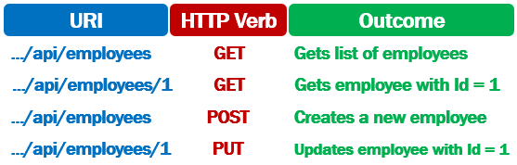

## ASP.NET Core REST API - HTTP PUT Example

[Route("api/[controller]")]

[ApiController]

public class EmployeesController : ControllerBase

{

private readonly IEmployeeRepository employeeRepository;

public EmployeesController(IEmployeeRepository employeeRepository)

{

this.employeeRepository = employeeRepository;

}

[HttpPut("{id:int}")]

public async Task<ActionResult<Employee>> UpdateEmployee(int id, Employee employee)

{

try

{

if (id != employee.EmployeeId)

return BadRequest("Employee ID mismatch");

var employeeToUpdate = await employeeRepository.GetEmployee(id);

if (employeeToUpdate == null)

return NotFound($"Employee with Id = {id} not found");

return await employeeRepository.UpdateEmployee(employee);

}

catch (Exception)

{

return StatusCode(StatusCodes.Status500InternalServerError,

"Error updating data");

}

}

}

Copy

## Code Explanation

It is the PUT request that is used to update an existing employee. This is the reason UpdateEmployee() method is decorated with the HttpPut attribute.

EmployeesController class is decorated with ApiController attribute. This attribute allows the data from the request to be mapped to the employee parameter on UpdateEmployee() method.

Either this ApiController attribute is required or the method parameter must be decorated with [FromBody] attribute. Otherwise, model binding will not work as expected and the employee data from the request will not be mapped to the employee parameter on the UpdateEmployee method.

[HttpPut]

public async Task<IActionResult> UpdateEmployee(int id, [FromBody]Employee employee)

{

}

Copy

HttpPut attribute on UpdateEmployee() method also has a route template. The id of the employee will be appended to the URL /api/employees. So the URL becomes /api/employees/5

[HttpPut("{id:int}")]

public async Task<ActionResult<Employee>> UpdateEmployee(int id, Employee employee)

Copy

The employee id value in the URL is automatically mapped to the id parameter on the UpdateEmployee(int id, Employee employee) method.

As we are using the int route constraint on the id route parameter, the id value in the URL is mapped to the method parameter, only if the value is an integer.

## Complete EmployeeController Code

using EmployeeManagement.Api.Models;

using EmployeeManagement.Models;

using Microsoft.AspNetCore.Http;

using Microsoft.AspNetCore.Mvc;

using System;

using System.Threading.Tasks;

namespace EmployeeManagement.Api.Controllers

{

[Route("api/[controller]")]

[ApiController]

public class EmployeesController : ControllerBase

{

private readonly IEmployeeRepository employeeRepository;

public EmployeesController(IEmployeeRepository employeeRepository)

{

this.employeeRepository = employeeRepository;

}

[HttpGet]

public async Task<ActionResult> GetEmployees()

{

try

{

return Ok(await employeeRepository.GetEmployees());

}

catch (Exception)

{

return StatusCode(StatusCodes.Status500InternalServerError,

"Error retrieving data from the database");

}

}

[HttpGet("{id:int}")]

public async Task<ActionResult<Employee>> GetEmployee(int id)

{

try

{

var result = await employeeRepository.GetEmployee(id);

if (result == null)

{

return NotFound();

}

return result;

}

catch (Exception)

{

return StatusCode(StatusCodes.Status500InternalServerError,

"Error retrieving data from the database");

}

}

[HttpPost]

public async Task<ActionResult<Employee>> CreateEmployee(Employee employee)

{

try

{

if (employee == null)

{

return BadRequest();

}

var emp = employeeRepository.GetEmployeeByEmail(employee.Email);

if (emp != null)

{

ModelState.AddModelError("email", "Employee email already in use");

return BadRequest(ModelState);

}

var createdEmployee = await employeeRepository.AddEmployee(employee);

return CreatedAtAction(nameof(GetEmployee), new { id = createdEmployee.EmployeeId },

createdEmployee);

}

catch (Exception)

{

return StatusCode(StatusCodes.Status500InternalServerError,

"Error creating employee");

}

}

[HttpPut("{id}")]

public async Task<ActionResult<Employee>> UpdateEmployee(int id, Employee employee)

{

try

{

if (id != employee.EmployeeId)

return BadRequest("Employee ID mismatch");

var employeeToUpdate = await employeeRepository.GetEmployee(id);

if (employeeToUpdate == null)

return NotFound($"Employee with Id = {id} not found");

return await employeeRepository.UpdateEmployee(employee);

}

catch (Exception)

{

return StatusCode(StatusCodes.Status500InternalServerError,

"Error updating data");

}

}

}

}

# Delete in ASP.NET Core REST API

In this video we will discuss, how to delete a resource, i.e implement **HTTP DELETE in ASP.NET Core REST API**.

To delete a resource, issue an HTTP DELETE request to the URI /api/employees/ID. The ID of the employee to delete must be passed in the URI.

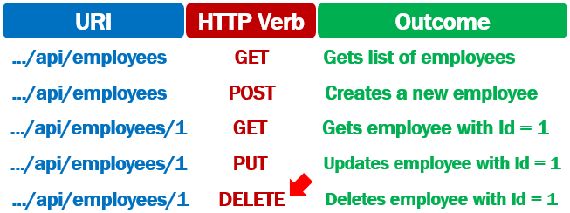

## ASP.NET Core REST API - HTTP DELETE Example

[Route("api/[controller]")]

[ApiController]

public class EmployeesController : ControllerBase

{

private readonly IEmployeeRepository employeeRepository;

public EmployeesController(IEmployeeRepository employeeRepository)

{

this.employeeRepository = employeeRepository;

}

[HttpDelete("{id:int}")]

public async Task<ActionResult<Employee>> DeleteEmployee(int id)

{

try

{

var employeeToDelete = await employeeRepository.GetEmployee(id);

if (employeeToDelete == null)

{

return NotFound($"Employee with Id = {id} not found");

}

return await employeeRepository.DeleteEmployee(id);

}

catch (Exception)

{

return StatusCode(StatusCodes.Status500InternalServerError,

"Error deleting data");

}

}

}

Copy

## Code Explanation

It is the DELETE request that is used to delete an existing employee. This is the reason DeleteEmployee() method is decorated with the HttpDelete attribute.

The id of the employee to delete is passed as a parameter to the HttpDelete attribute. This id will be appended to the URL /api/employees. So the URL becomes /api/employees/id

[HttpDelete("{id:int}")]

public async Task<ActionResult<Employee>> DeleteEmployee(int id)

Copy

The employee id value in the URL is automatically mapped to the id parameter on the DeleteEmployee(int id) method.

As we are using the int route constraint on the id route parameter, the id value in the URL is mapped to the method parameter, only if the value is an integer.

## ASP.NET Core Web API CRUD Operations Example

The following is the complete EmployeesController code. We have all the CRUD operations (i.e Create, Read, Update and Delete) implemented.

using EmployeeManagement.Api.Models;

using EmployeeManagement.Models;

using Microsoft.AspNetCore.Http;

using Microsoft.AspNetCore.Mvc;

using System;

using System.Threading.Tasks;

namespace EmployeeManagement.Api.Controllers

{

[Route("api/[controller]")]

[ApiController]

public class EmployeesController : ControllerBase

{

private readonly IEmployeeRepository employeeRepository;

public EmployeesController(IEmployeeRepository employeeRepository)

{

this.employeeRepository = employeeRepository;

}

[HttpGet]

public async Task<ActionResult> GetEmployees()

{

try

{

return Ok(await employeeRepository.GetEmployees());

}

catch (Exception)

{

return StatusCode(StatusCodes.Status500InternalServerError,

"Error retrieving data from the database");

}

}

[HttpGet("{id:int}")]

public async Task<ActionResult<Employee>> GetEmployee(int id)

{

try

{

var result = await employeeRepository.GetEmployee(id);

if (result == null)

{

return NotFound();

}

return result;

}

catch (Exception)

{

return StatusCode(StatusCodes.Status500InternalServerError,

"Error retrieving data from the database");

}

}

[HttpPost]

public async Task<ActionResult<Employee>> CreateEmployee(Employee employee)

{

try

{

if(employee == null)

{

return BadRequest();

}

var emp = employeeRepository.GetEmployeeByEmail(employee.Email);

if(emp != null)

{

ModelState.AddModelError("email", "Employee email already in use");

return BadRequest(ModelState);

}

var createdEmployee = await employeeRepository.AddEmployee(employee);

return CreatedAtAction(nameof(GetEmployee), new { id = createdEmployee.EmployeeId },

createdEmployee);

}

catch (Exception)

{

return StatusCode(StatusCodes.Status500InternalServerError,

"Error retrieving data from the database");

}

}

[HttpPut("{id:int}")]

public async Task<ActionResult<Employee>> UpdateEmployee(int id, Employee employee)

{

try

{

if(id != employee.EmployeeId)

{

return BadRequest("Employee ID mismatch");

}

var employeeToUpdate = await employeeRepository.GetEmployee(id);

if(employeeToUpdate == null)

{

return NotFound($"Employee with Id = {id} not found");

}

return await employeeRepository.UpdateEmployee(employee);

}

catch (Exception)

{

return StatusCode(StatusCodes.Status500InternalServerError,

"Error updating data");

}

}

[HttpDelete("{id:int}")]

public async Task<ActionResult<Employee>> DeleteEmployee(int id)

{

try

{

var employeeToDelete = await employeeRepository.GetEmployee(id);

if (employeeToDelete == null)

{

return NotFound($"Employee with Id = {id} not found");

}

return await employeeRepository.DeleteEmployee(id);

}

catch (Exception)

{

return StatusCode(StatusCodes.Status500InternalServerError,

"Error deleting data");

}

}

}

}

Copy

## EmployeeRepository

EmployeeRepository uses entity framework core to store and retrieve data from SQL Server database.

public class EmployeeRepository : IEmployeeRepository

{

private readonly AppDbContext appDbContext;

public EmployeeRepository(AppDbContext appDbContext)

{

this.appDbContext = appDbContext;

}

public async Task<Employee> AddEmployee(Employee employee)

{

var result = await appDbContext.Employees.AddAsync(employee);

await appDbContext.SaveChangesAsync();

return result.Entity;

}

public async Task<Employee> DeleteEmployee(int employeeId)

{

var result = await appDbContext.Employees

.FirstOrDefaultAsync(e => e.EmployeeId == employeeId);

if (result != null)

{

appDbContext.Employees.Remove(result);

await appDbContext.SaveChangesAsync();

return result;

}

return null;

}

public async Task<Employee> GetEmployee(int employeeId)

{

return await appDbContext.Employees

.FirstOrDefaultAsync(e => e.EmployeeId == employeeId);

}

public async Task<Employee> GetEmployeeByEmail(string email)

{

return await appDbContext.Employees

.FirstOrDefaultAsync(e => e.Email == email);

}

public async Task<IEnumerable<Employee>> GetEmployees()

{

return await appDbContext.Employees.ToListAsync();

}

public async Task<Employee> UpdateEmployee(Employee employee)

{

var result = await appDbContext.Employees

.FirstOrDefaultAsync(e => e.EmployeeId == employee.EmployeeId);

if (result != null)

{

result.FirstName = employee.FirstName;

result.LastName = employee.LastName;

result.Email = employee.Email;

result.DateOfBrith = employee.DateOfBrith;

result.Gender = employee.Gender;

result.DepartmentId = employee.DepartmentId;

result.PhotoPath = employee.PhotoPath;

await appDbContext.SaveChangesAsync();

return result;

}

return null;

}

}

Copy

# Search in ASP.NET Core REST API

In this video we will discuss, **how to implement search feature in ASP.NET Core REST API**.

[Route("api/[controller]")]

[ApiController]

public class EmployeesController : ControllerBase

{

private readonly IEmployeeRepository employeeRepository;

public EmployeesController(IEmployeeRepository employeeRepository)

{

this.employeeRepository = employeeRepository;

}

[HttpGet("{search}")]

public async Task<ActionResult<IEnumerable<Employee>>> Search(string name, Gender? gender)

{

try

{

var result = await employeeRepository.Search(name, gender);

if (result.Any())

{

return Ok(result);

}

return NotFound();

}

catch (Exception)

{

return StatusCode(StatusCodes.Status500InternalServerError,

"Error retrieving data from the database");

}

}

}

Copy

## Code Explanation

As per the [Route] attribute on the EmployeesController, the route to reach this controller is /api/employees

[Route("api/[controller]")]

[ApiController]

public class EmployeesController : ControllerBase

{

}

Copy

The following [HttpGet] attribute specified an extension to the base route /api/employees. So the route to reach this Search() method is /api/employees/search. The values for the two method parameters come from the query strings in the URL.

[HttpGet("{search}")]

public async Task<ActionResult<IEnumerable<Employee>>> Search(string name, Gender? gender)

{

}

Copy

If you want the search terms (name and gender) to be included as route parameters instead of query strings, change the route template on the HttpGet attribute as shown below. However, this approach is not recommended if you have many search parameters.

[HttpGet("{search}/{name}/{gender?}")]

public async Task<ActionResult<IEnumerable<Employee>>> Search(string name, Gender? gender)

{

}

Copy

Since the route parameters and method parameters are mapped by name, even if the order does not match, they will still be correctly mapped i.e the URL parameter name is mapped to the method parameter name and the gender URL parameter is mapped to the gender method parameter.

[HttpGet("{search}/{name}/{gender?}")]

public async Task<ActionResult<IEnumerable<Employee>>> Search(Gender? gender, string name)

{

}

Copy

## IEmployeeRepository Interface

public interface IEmployeeRepository

{

Task<IEnumerable<Employee>> Search(string name, Gender? gender);

}

Copy

## EmployeeRepository

public class EmployeeRepository : IEmployeeRepository

{

private readonly AppDbContext appDbContext;

public EmployeeRepository(AppDbContext appDbContext)

{

this.appDbContext = appDbContext;

}

public async Task<IEnumerable<Employee>> Search(string name, Gender? gender)

{

IQueryable<Employee> query = appDbContext.Employees;

if (!string.IsNullOrEmpty(name))

{

query = query.Where(e => e.FirstName.Contains(name)

|| e.LastName.Contains(name));

}

if(gender != null)

{

query = query.Where(e => e.Gender == gender);

}

return await query.ToListAsync();

}

}

# Call REST API from ASP.NET Core Blazor

In this video we will discuss **how to call and consume a REST API from ASP.NET Core Blazor application**.

## Can a Blazor component call REST API directly

Yes, a Blazor component can directly call a REST API. However, for separation of concerns and to keep the component code clean, it's a good practice to create a separate service that calls the REST API.

## Create a service to call REST API

Add a folder with name Services to the Blazor web application project. Add the following 2 class files to this folder.

1. IEmployeeService.cs
2. EmployeeService.cs

#### **IEmployeeService.cs**

public interface IEmployeeService

{

Task<IEnumerable<Employee>> GetEmployees();

}

Copy

#### **EmployeeService.cs**

* We are using HttpClient class to call the REST API service.
* This class is in System.Net.Http namespace.
* HttpClient is injected into the EmployeeService using dependency injection.
* We have not registered HttpClient service with the dependency injection container yet. We will do that in just a bit.
* We are using httpClient.GetJsonAsync to call the REST API. This method is in Microsoft.AspNetCore.Blazor.HttpClient Nuget package. Install this package and do not forget to include the namespace Microsoft.AspNetCore.Components.
* Pass the REST API endpoint (api/employees) to httpClient.GetJsonAsync method.

httpClient.GetJsonAsync<Employee[]>("api/employees")​

Copy

using EmployeeManagement.Models;

using Microsoft.AspNetCore.Components;

using System.Collections.Generic;

using System.Net.Http;

using System.Threading.Tasks;

namespace EmployeeManagement.Web.Services

{

public class EmployeeService : IEmployeeService

{

private readonly HttpClient httpClient;

public EmployeeService(HttpClient httpClient)

{

this.httpClient = httpClient;

}

public async Task<IEnumerable<Employee>> GetEmployees()

{

return await httpClient.GetJsonAsync<Employee[]>("api/employees");

}

}

}

Copy

## Register HttpClient Services

In ConfigureServices method of the Startup class register HttpClient Services using AddHttpClient method.

public void ConfigureServices(IServiceCollection services)

{

services.AddRazorPages();

services.AddServerSideBlazor();

services.AddHttpClient<IEmployeeService, EmployeeService>(client =>

{

client.BaseAddress = new Uri("https://localhost:44379/");

});

}

Copy

## Call Service from Blazor Component

* Finally call IEmployeeService from EmployeeList blazor component.
* We use [Inject] attribute to inject a service into a Blazor component. We cannot use a constructor for this.
* In the component OnInitializedAsync method, we call the EmployeeService.GetEmployees method.
* The data (list of employees) that this method returns is then used to initialise Employees property.
* The EmployeeList blazor component binds to this Employees property to display the list of employees.

using EmployeeManagement.Models;

using EmployeeManagement.Web.Services;

using Microsoft.AspNetCore.Components;

using System.Collections.Generic;

using System.Linq;

using System.Threading.Tasks;

namespace EmployeeManagement.Web.Pages

{

public class EmployeeListBase : ComponentBase

{

[Inject]

public IEmployeeService EmployeeService { get; set; }

public IEnumerable<Employee> Employees { get; set; }

protected override async Task OnInitializedAsync()

{

Employees = (await EmployeeService.GetEmployees()).ToList();

}

}

}

# Blazor route parameters

In this video we will discuss route parameters in blazor with an example. The following EmmployeeList component displays the list of all employees.

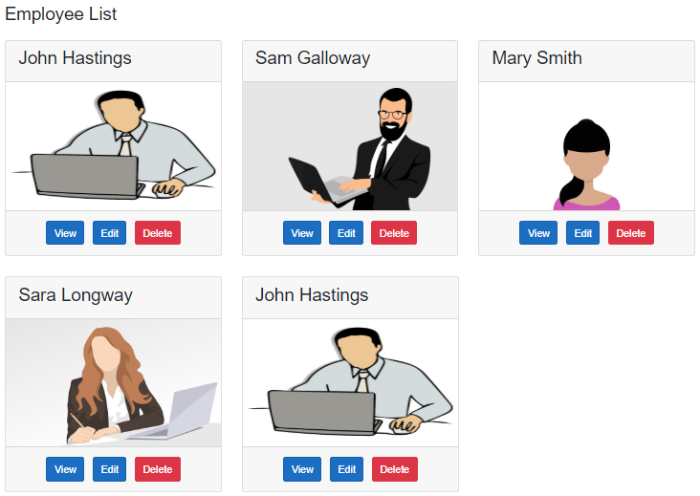

When we click the View button, the user should be redirected to the URL (/employeedetails/3). The value 3 in the URI is the employee id. The blazor component (EmployeeDetails) displays the details of the Employee.

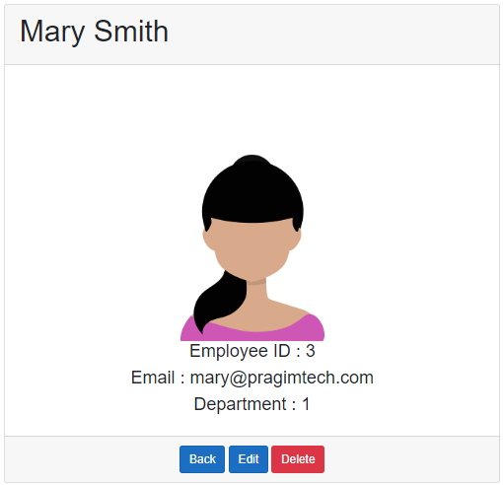

## EmployeeDetails.razor

@page "/employeedetails/{id}"

@inherits EmployeeDetailsBase

<div class="row justify-content-center m-3">

<div class="col-sm-8">

<div class="card">

<div class="card-header">

<h1>@Employee.FirstName @Employee.LastName</h1>

</div>

<div class="card-body text-center">

<img class="card-img-top" src="@Employee.PhotoPath" />

<h4>Employee ID : @Employee.EmployeeId</h4>

<h4>Email : @Employee.Email</h4>

<h4>Department : @Employee.DepartmentId</h4>

</div>

<div class="card-footer text-center">

<a href="/" class="btn btn-primary">Back</a>

<a href="#" class="btn btn-primary">Edit</a>

<a href="#" class="btn btn-danger">Delete</a>

</div>

</div>

</div>

</div>

Copy

To get to this component, employee Id must be passed in the URL as a route parameter. This is specified using the @page directive route template.

@page "/employeedetails/{Id}"

Copy

## EmployeeDetailsBase.cs

using EmployeeManagement.Models;

using EmployeeManagement.Web.Services;

using Microsoft.AspNetCore.Components;

using System.Threading.Tasks;

namespace EmployeeManagement.Web.Pages

{

public class EmployeeDetailsBase : ComponentBase

{

public Employee Employee { get; set; } = new Employee();

[Inject]

public IEmployeeService EmployeeService { get; set; }

[Parameter]

public string Id { get; set; }

protected async override Task OnInitializedAsync()

{

Id = Id ?? "1";

Employee = await EmployeeService.GetEmployee(int.Parse(Id));

}

}

}

Copy

* The Id public property is decorated with the [Parameter] attribute.
* The name of the property (Id) matches with the name of the route parameter in the @page directive (@page "/employeedetail/{Id}")
* The blazor router, uses the route parameter value in the URL to populate the Id property in the component class.
* The following 2 conditions must be true, for the router to be able to map the route parameter value in the URL to the public property in the component class
  1. The public property in the component class must be decorated with [Parameter] attribute.
  2. The name of the property in the component class and the name of the route parameter in the @page directive must be the same.

If the names are different you will get the following runtime exception

InvalidOperationException: Object of type 'EmployeeManagement.Web.Pages.EmployeeDetail' does not have a property matching the name 'Id'.

## Blazor optional route parameter

Optional parameters aren't supported. However, we can use two @page directives to get the effect of optional parameters.

@page "/employeedetails"

@page "/employeedetails/{Id}"

Copy

The first @page directive allows navigation to the component without a parameter. The second @page directive receives the {Id} route parameter and assigns the value to the Id public property on the component class.

public class EmployeeDetailsBase : ComponentBase

{

public Employee Employee { get; set; } = new Employee();

[Inject]

public IEmployeeService EmployeeService { get; set; }

[Parameter]

public string Id { get; set; }

protected override async Task OnInitializedAsync()

{

// If Id value is not supplied in the URL, use the value 1

Id = Id ?? "1";

Employee = await EmployeeService.GetEmployee(int.Parse(Id));

}

}

Copy

## Building URL with route parameter

On the list page when the View button is clicked we want to redirect the user to /employeedetail/id.

<a href="@($"employeedetails/{employee.EmployeeId}")"

class="btn btn-primary m-1">View</a>

Copy

## IEmployeeService.cs

public interface IEmployeeService

{

Task<IEnumerable<Employee>> GetEmployees();

Task<Employee> GetEmployee(int id);

}

Copy

## EmployeeService.cs

public class EmployeeService : IEmployeeService

{

private readonly HttpClient httpClient;

public EmployeeService(HttpClient httpClient)

{

this.httpClient = httpClient;

}

public async Task<Employee> GetEmployee(int id)

{

return await httpClient.GetJsonAsync<Employee>($"api/employees/{id}");

}

public async Task<IEnumerable<Employee>> GetEmployees()

{

return await httpClient.GetJsonAsync<Employee[]>("api/employees");

}

}

Copy

# Display data from two or more tables in Blazor

In this video we will discuss how to retrieve data from two or more related database tables and display them in a Blazor web application. There are several ways to do this. There is no right or wrong way. Which way you chose really depends on the architecture, complexity and the requirements of your application.

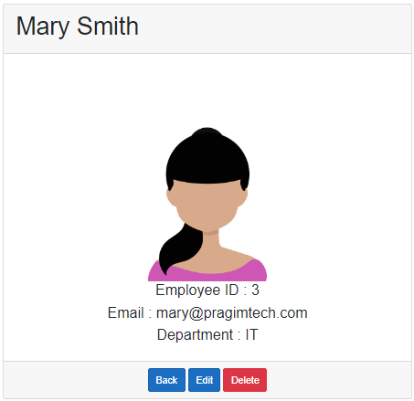

As you can see from the image, we are displaying the following employee details.

* Id
* Name
* Email
* Department Name

Id, Name, and Email come from the Employees database table and the Department Name comes from the Departments table. Here we are working with two database tables, but you can use the same technique to work with three or even more database tables.

## Employee Class

The Department property carries the employee Department data i.e DepartmentId and DepartmentName.

public class Employee

{

public int EmployeeId { get; set; }

[Required]

[MinLength(2)]

public string FirstName { get; set; }

[Required]

public string LastName { get; set; }

public string Email { get; set; }

public DateTime DateOfBrith { get; set; }

public Gender Gender { get; set; }

public int DepartmentId { get; set; }

public Department Department { get; set; }

public string PhotoPath { get; set; }

}

Copy

## EmployeeRepository

In the Employee entity, to include related entity data like Department, chain the Include() method. Chain ThenInclude() method if you want to include additional related entities like skills data, experience data etc.

public class EmployeeRepository : IEmployeeRepository

{

private readonly AppDbContext appDbContext;

public EmployeeRepository(AppDbContext appDbContext)

{

this.appDbContext = appDbContext;

}

public async Task<Employee> GetEmployee(int employeeId)

{

return await appDbContext.Employees

.Include(e => e.Department)

.FirstOrDefaultAsync(e => e.EmployeeId == employeeId);

}

}

Copy

## EmployeeDetails Component

@page "/employeedetails/{id}"

@page "/employeedetails"

@inherits EmployeeDetailsBase

@if (Employee == null || Employee.Department == null)

{

<div class="spinner"></div>

}

else

{

<div class="row justify-content-center m-3">

<div class="col-sm-8">

<div class="card">

<div class="card-header">

<h1>@Employee.FirstName @Employee.LastName</h1>

</div>

<div class="card-body text-center">

<img class="card-img-top" src="@Employee.PhotoPath" />

<h4>Employee ID : @Employee.EmployeeId</h4>

<h4>Email : @Employee.Email</h4>

<h4>Department : @Employee.Department.DepartmentName</h4>

</div>

<div class="card-footer text-center">

<a href="/" class="btn btn-primary">Back</a>

<a href="#" class="btn btn-primary">Edit</a>

<a href="#" class="btn btn-danger">Delete</a>

</div>

</div>

</div>

</div>

}

Copy

The following null check is required. Otherwise you will get a NullReferenceException, if either Employee or Department properties are not initialized by the time the view references those properties.

@if (Employee == null || Employee.Department == null)

{

<div class="spinner"></div>

}

Copy

# Blazor event handling

In this video we will learn event handling in Blazor with examples.

## Display X and Y mouse coordinates

As we hover the mouse over an image element, we want to display X and Y mouse coordinates. In the following example,

* mousemove event is handled.
* Mouse\_Move is the event handler method.
* The event handler stores the mouse X and Y coordinates in Coordinates property.
* The component view binds to this Coordinates property to display the X and Y coordinates.

## Component View

<img class="card-img-top" src="@Employee.PhotoPath"

@onmousemove="@Mouse\_Move" />

<h1>@Coordinates</h1>

Copy

## Component Class

protected string Coordinates { get; set; }

protected void Mouse\_Move(MouseEventArgs e)

{

Coordinates = $"X = {e.ClientX } Y = {e.ClientY}";

}

Copy

## Event handling using a lambda expression

Instead of creating a separate named method in the component class and then specifying that method as the event handler we can use a lambda expression as the event handler directly in the HTML. An example is shown below.

<img class="card-img-top" src="@Employee.PhotoPath"

@onmousemove="@(e => Coordinates = $"X = {e.ClientX} Y = {e.ClientY}")" />

Copy

## Show and Hide Employee Card Footer

We want to show and hide the card footer when a button is clicked. The text on the button should also change from Show Footer to Hide Footer and vice-versa depending on the visibility of the footer.

## Component View

In the example below

* onclick event is being handled
* Button\_Click is the event handler method
* The text on the button is bound to ButtonText property in the component class
* The class attribute of the card-footer <div> eletemt is bound to CssClass property in the component class

<button class="btn btn-primary" @onclick="@Button\_Click">@ButtonText</button>

<div class="card-footer text-center @CssClass">

<a href="/" class="btn btn-primary">Back</a>

<a href="#" class="btn btn-primary">Edit</a>

<a href="#" class="btn btn-danger">Delete</a>

</div>

Copy

## Component Class

ButtonText and CssClass properties are declared in the component class. In the Button\_Click event handler the values of these 2 properties (i.e ButtonText & CssClass) are being changed depending on thier current values.

protected string ButtonText { get; set; } = "Hide Footer";

protected string CssClass { get; set; } = null;

protected void Button\_Click()

{

if (ButtonText == "Hide Footer")

{

ButtonText = "Show Footer";

CssClass = "HideFooter";

}

else

{

CssClass = null;

ButtonText = "Hide Footer";

}

}

Copy

## CSS Class

.HideFooter{

display:none;

}

Copy

# Blazor data binding

In this video we will learn

1. One way data binding in Blazor
2. Two way data binding in Blazor

## One way data binding in Blazor

#### **Binding to a property**

In the following example, we have one way data binding i.e from the component class to the component view. The view binds to the Name property in the component class. Whenever the Name property value changes, the UI is automatically updated to reflect the change.

##### **Component class**

protected string Name { get; set; } = "Tom";

Copy

##### **Component view**

<b>Name :</b> @Name

Copy

#### **Binding to razor expression**

The following example display employee name with salutation depending on their gender.

##### **Component class**

protected string Name { get; set; } = "Tom";

protected string Gender { get; set; } = "Male";

Copy

##### **Component view**

<b>Name with salutation:</b> @(Gender == "Male" ? $"Mr. {Name}" : $"Miss. {Name}")

Copy

#### **Binding to input element**

In the following example, the html input element (text box) is bound to Name property. This is still one way binding i.e from the component class to the view. Whenever the Name property value in the class changes, the UI is automatically updated to reflect the change. However, when we change the value in the text box, the Name property in the component class is not changed. Data is flowing only in one direction i.e from the component class to the UI but not in the other direction i.e from the UI to the class.

In this example we are binding to an input element. In a similar way, we can bind to any HTML element, like radio button, checkbox etc.

##### **Component class**

protected string Name { get; set; } = "Tom";

Copy

##### **Component view**

<b>Name :</b> <input value="@Name" />

Copy

## Two way data binding in Blazor

* With two way data binding, data moves in both the directions i.e from the component class to the UI and from the UI to the component class.
* The following is one way to implement two way data binding in Blazor. The value attribute is bound to Name property, so the data flows from the component class to the UI.
* We are also binding to onchange event. The value for onchange attribute is a lambda expression which updates the Name property with the value in the text box. So with this event binding, the data flows from the UI to the component class property.
* Please note : We are using a lambda expression here, but you can also create a separate named method in the component class and then specify the name of that method as the value for onchange event.

##### **Component class**

protected string Name { get; set; } = "Tom";

Copy

##### **Component view**

<b>Name :</b> <input value="@Name" @onchange="@(e => { Name = e.Value.ToString(); })" />

Copy

#### **Making two way data binding easier**

The above example can be rewritten using the bind attribute as shown below. It simplifies two way data binding.

##### **Component class**

protected string Name { get; set; } = "Tom";

Copy

##### **Component view**

<b>Name :</b> <input @bind="Name" />

Copy

The change event is triggered, only when the input element loses focus and that's when the property in the component class is updated with the data in the input element.

#### **Event parameter with two way data binding**

* What if we do not want to wait, until the input element loses focus. As the value in the input element is being changed, we want the component class property to be updated.
* This can be achieved by specifying the event name in the two way data binding. To specify the event name we use the event parameter as shown in the example below. In this case we are binding to input event. This is raised as the value is being changed.

<b>Name :</b> <input @bind="Name" @bind:event="oninput" />

Copy

#### **Binding to element attributes other than value attribute**

@bind-{ATTRIBUTE} along with @bind-{ATTRIBUTE}:event syntax can be used to bind element attributes other than the value attribute. In the example below, the <div> element style is updated when the Colour property value changes:

##### **Component class**

protected string Colour { get; set; } = "background-color:white";

Copy

##### **Component view**

<b>Colour :</b> <input @bind="Colour" />

<div @bind-style="Colour" @bind-style:event="onchange">

<h3>The background colour of this text changes</h3>

</div>

Copy

# Blazor two way data binding example

In this video we will understand two way data binding in Blazor with a very simple but a real world example. As the user types in the Description textbox, we want to display the total number of characters typed so far as shown in the image below.



## Blazor component class

Create Description property in the component class. It's important you initialise the property to an empty string, otherwise you will get a null reference exception at runtime.

public string Description { get; set; } = string.Empty;

Copy

## Blazor component view

<div>

<textarea @bind="Description" @bind:event="oninput" />

</div>

<div>

Count : @Description.Length

</div>

Copy

#### **Code exaplanation**

* Bind the <textarea> element to the Description property using the bind attribute.
* With the bind attribute, we get two way data-binding i.e the <textarea> element displays the value of the Description property and if we change the text in the <textarea> element on the UI, the Description property in the component class is automatically updated.
* By default, the bind attribute binds data on change event. Change event is triggered when the element loses focus.
* However, we want the characters count as the user is typing in the <textarea> element. We do not want to wait until the element loses focus.
* This means we want to change the default event of data binding. We do this by using the event parameter of the bind attribute.
* In this example, we changed the default binding event from onchange to oninput.
* The input event is fired as we type in the <textarea> element and the Description property is updated with the new value.
* To display the count of characters the UI is bound to @Description.Length

# Blazor component parameters

In this video we will discuss **how to pass data from parent component to child component using parameters in Blazor**. Let's understand this with an example.

As you can see from the image below, when Show Footer checkbox is checked, the Card Footer should be displayed when it is unchecked it should be hidden.



On this page we have 2 blazor components

1. EmployeeList Component (Parent Component)
2. DisplayEmployee Component (Child Component)

## Child Component Class (DisplayEmployeeBase.cs)

* This class has just 2 properties (Employee and ShowFooter)
* Both of them are decorated with the Parameter attribute
* This attribute allows the values to be passed from the parent component

using EmployeeManagement.Models;

using Microsoft.AspNetCore.Components;

namespace EmployeeManagement.Web.Pages

{

public class DisplayEmployeeBase : ComponentBase

{

[Parameter]

public Employee Employee { get; set; }

[Parameter]

public bool ShowFooter { get; set; }

}

}

Copy

## Child Component View (DisplayEmployee.razor)

* This component does not have @page directive. We intentionally left it out, because we are going to use this component only as a child component. We don't want this to be a routable component i.e we don't want to be able to reach this component by using a URL in the browser.
* This component binds to the Employee property to display the employee details. It also uses the ShowFooter boolean property to show and hide the footer.
* The values for these 2 properties (Employee and ShowFooter) will be passed by the parent component (EmployeeList component)

@inherits DisplayEmployeeBase

<div class="card m-3" style="min-width: 18rem; max-width:30.5%;">

<div class="card-header">

<h3>@Employee.FirstName @Employee.LastName</h3>

</div>

<img class="card-img-top imageThumbnail" src="@Employee.PhotoPath" />

@if (ShowFooter)

{

<div class="card-footer text-center">

<a href="@($"employeedetails/{Employee.EmployeeId}")"

class="btn btn-primary m-1">View</a>

<a href="#" class="btn btn-primary m-1">Edit</a>

<a href="#" class="btn btn-danger m-1">Delete</a>

</div>

}

</div>

Copy

## Parent Component Class (EmployeeListBase.cs)

* The main responsibility of this parent component (EmployeeList) is to retrieve the list of employees by calling the REST API.
* It also has the ShowFooter boolean property. The Show Footer checkbox on the view is bound to this property.

using EmployeeManagement.Models;

using EmployeeManagement.Web.Services;

using Microsoft.AspNetCore.Components;

using System.Collections.Generic;

using System.Linq;

using System.Threading.Tasks;

namespace EmployeeManagement.Web.Pages

{

public class EmployeeListBase : ComponentBase

{

[Inject]

public IEmployeeService EmployeeService { get; set; }

public IEnumerable<Employee> Employees { get; set; }

public bool ShowFooter { get; set; } = true;

protected override async Task OnInitializedAsync()

{

Employees = (await EmployeeService.GetEmployees()).ToList();

}

}

}

Copy

## Parent Component View (EmployeeList.razor)

* As this parent component loops through the list of employees, it passes the employee object to the child component using the Employee property.
* A value for ShowFooter is also passed from the parent component to the child component.
* Remember both these properties (Employee and ShowFooter) are decorated with the [Parameter] attribute in the child component. This allows the parent component to pass values to those 2 properties.

@page "/"

@inherits EmployeeListBase

<h3>Employee List</h3>

<input type="checkbox" id="showFooter" @bind="ShowFooter" />

<label for="showFooter">Show Footer</label>

@if (Employees == null)

{

<div class="spinner"></div>

}

else

{

<div class="card-deck">

@foreach (var employee in Employees)

{

<DisplayEmployee Employee="employee" ShowFooter="ShowFooter">

</DisplayEmployee>

}

</div>

}

# Blazor EventCallback

In this video we will discuss **how to communicate from child component to parent component using EventCallBacks** with an example.

On this page we have 2 blazor components

1. EmployeeList Component (Parent Component)
2. DisplayEmployee Component (Child Component)

In our previous video, we discussed how to pass data from parent component to child component using parameters. In this video, we will discuss how to do the opposite i.e pass data from child component to parent component. Let's understand this with an example.

## Child to parent component communication



* As you can see from the image above, when an emmployee is selected by checking the checkbox, we want to display the Selected Employees Count.
* The Checkbox is in the child component (DisplayEmployee Component)
* The Selected Employees Count must be displayed in the parent component (EmployeeList Component)
* When the checkbox checked status changes in the child component, the selected employees count must be updated accordingly in the parent component. This means, we want to call the parent component method in response to the child component event.

## Expose an event using EventCallback

The parent component must be notified, when the checkbox checked status changes in the child component. For this the child component exposes an event. The parent component assigns a callback method to the child component's event. In Blazor, to expose an event we use EventCallback.

#### **Child Component Class (DisplayEmployeeBase.cs)**

* OnEmployeeSelection is the event this child component is exposing. It is of type EventCallback.
* EventCallback supports generics which we use to pass event data (also commonly called event payload).
* In our example, we are passing bool. A value of true or false depending on whether the checkbox is checked or not.
* Checkbox binds to IsSelected boolean property.
* CheckBoxChanged method is the event hanlder. It stores the checked state of the checkbox in IsSelected property. It also raises OnEmployeeSelection custom event.
* Checkbox checked state is passed as the event payload to OnEmployeeSelection event.

public class DisplayEmployeeBase : ComponentBase

{

protected bool IsSelected { get; set; }

[Parameter]

public EventCallback<bool> OnEmployeeSelection { get; set; }

protected async Task CheckBoxChanged(ChangeEventArgs e)

{

IsSelected = (bool)e.Value;

await OnEmployeeSelection.InvokeAsync(IsSelected);

}

}

Copy

#### **Child Component View (DisplayEmployee.razor)**

In the view, the checkbox is bound to IsSelected property and CheckBoxChanged() is specified as the event handler for onchange event. Remember change event is fired every time the checked state of the checkbox changes.

<input type="checkbox" checked="@IsSelected" @onchange="CheckBoxChanged" />

Copy

#### **Parent Component Class (EmployeeListBase.cs)**

* SelectedEmployeesCount property keeps track of the number of employees selected. This is the property that we increment of decrement depending on the checked state of the checkbox in the child component.
* EmployeeSelectionChanged is the callback method. This method will be called when the checked state of the checkbox in the child component changes.

public class EmployeeListBase : ComponentBase

{

protected int SelectedEmployeesCount { get; set; } = 0;

protected void EmployeeSelectionChanged(bool isSelected)

{

if(isSelected)

{

SelectedEmployeesCount++;

}

else

{

SelectedEmployeesCount--;

}

}

}

Copy

#### **Parent Component View (EmployeeList.razor)**

In the view assign EmployeeSelectionChanged as the Callback method to the child component custom event OnEmployeeSelection.

@foreach (var employee in Employees)

{

<DisplayEmployee OnEmployeeSelection="EmployeeSelectionChanged">

</DisplayEmployee>

}

# Building a blazor form

In this video we will discuss **how to build a form in Blazor with an example**.

* We can use the standard HTML form and input elements to create a blazor form.
* However, Blazor comes with several built-in form and input components that make the task of creating a form much easier.
* These built-in blazor form components also support form validation. We will discuss validation in our upcoming videos.

## Blazor form input components

The following are some of the available built-in blazor form components

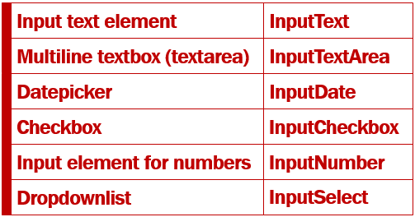

## Blazor EditForm Component

* In Blazor a form is defined using EditForm component.
* The @Model attribute specifies the data the form will bind to and work with.
* In this example Model attribute value is Employee, which is a property in the component class and carries the employee data the form will bind to and work with.
* The InputText component binds to Employee.FirstName using bind-value attribute.
* This attribute provides two way data-binding. This means, the value in the FirstName property of the Employee object is displayed in the input element. If we make a change to the firstname, by changing the value in the input element, Employee.FirstName property is automatcially updated with the changed value.

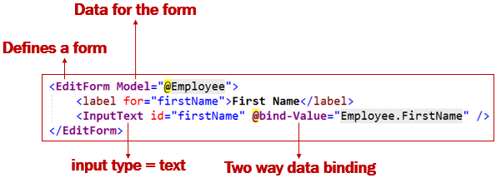

## Edit Employee Form Example

We want our Edit Employee Form to look as shown below.

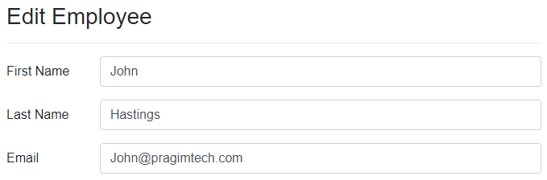

## Edit Employee View (EmployeeDetails.razor)

Id in the page directive is the route parameter. This is the Id of the employee that we want to edit.

@page "/editemployee/{id}"

@inherits EditEmployeeBase

<EditForm Model="@Employee">

<h3>Edit Employee</h3>

<hr />

<div class="form-group row">

<label for="firstName" class="col-sm-2 col-form-label">

First Name

</label>

<div class="col-sm-10">

<InputText id="firstName" class="form-control" placeholder="First Name"

@bind-Value="Employee.FirstName" />

</div>

</div>

<div class="form-group row">

<label for="lastName" class="col-sm-2 col-form-label">

Last Name

</label>

<div class="col-sm-10">

<InputText id="lastName" class="form-control" placeholder="Last Name"

@bind-Value="Employee.LastName" />

</div>

</div>

<div class="form-group row">

<label for="email" class="col-sm-2 col-form-label">

Email

</label>

<div class="col-sm-10">

<InputText id="email" class="form-control" placeholder="Email"

@bind-Value="Employee.Email" />

</div>

</div>

</EditForm>

Copy

## Edit Employee Component Class (EditEmployeeBase.cs)

* Employee property contains the employee data we want to edit.
* EmployeeService  retrieves the employee details by ID.
* The Id property receives the employee id from the URL.

public class EditEmployeeBase : ComponentBase

{

public Employee Employee { get; set; } = new Employee();

[Inject]

public IEmployeeService EmployeeService { get; set; }

[Parameter]

public string Id { get; set; }

protected async override Task OnInitializedAsync()

{

Employee = await EmployeeService.GetEmployee(int.Parse(Id));

}

}

Copy

## Redirect to EditEmployee component

When the Edit button on DisplayEmployee component is clicked, it redirects the user to EditEmployee component. The Id of the employee to edit is passed in the URL as a route parameter.

<a href="@($"editemployee/{Employee.EmployeeId}")"

class="btn btn-primary m-1">Edit</a>

Copy

# Binding select element with database data in Blazor

In this video we will discuss how to bind a select element with database data in Blazor. When the **Edit Employee** form loads, we want to retrieve the list of all departments from the database and bind them to the Department dropdownlist. In addition to binding the list of all departments, we also want the employee's department to be selected.

For example, if the employee's department is Payroll, in addition to displaying the list of all departments, we want the Payroll department to be selected.

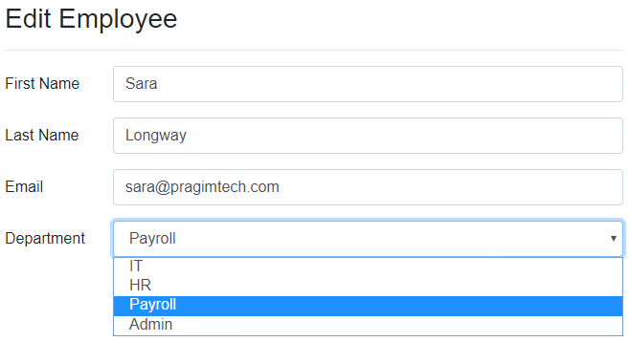

## Blazor input select example

<InputSelect id="department" @bind-Value="DepartmentId">

@foreach (var dept in Departments)

{

<option value="@dept.DepartmentId">@dept.DepartmentName</option>

}

</InputSelect>

Copy

## Code explanation

* We use the InputSelect component, to render an html select element
* Departments property in the component class carries the list of all departments to the view.
* The foreach loop, loops through the list and creates a select element option for each department.
* The value for the option is the department id and the display text is the department name.
* If the employee belongs to IT department, it should be selected. For this we use @bind-Value attribute. This attribute provides two-way data-binding i.e on the initial page load, the employee department is selected and if we change the selection, the newly selected department value is automatically passed to the DepartmentId property in the component class.
* Binding the select element to an integer is not supported and throws the following exception.  
  Microsoft.AspNetCore.Components.Forms.InputSelect`1[System.Int32] does not support the type 'System.Int32'

## Edit Employee Component View (EditEmployee.razor)

@page "/editemployee/{id}"

@inherits EditEmployeeBase

<EditForm Model="@Employee">

<h3>Edit Employee</h3>

<hr />

<div class="form-group row">

<label for="firstName" class="col-sm-2 col-form-label">

First Name

</label>

<div class="col-sm-10">

<InputText id="firstName" class="form-control" placeholder="First Name"

@bind-Value="Employee.FirstName" />

</div>

</div>

<div class="form-group row">

<label for="lastName" class="col-sm-2 col-form-label">

Last Name

</label>

<div class="col-sm-10">

<InputText id="lastName" class="form-control" placeholder="Last Name"

@bind-Value="Employee.LastName" />

</div>

</div>

<div class="form-group row">

<label for="email" class="col-sm-2 col-form-label">

Email

</label>

<div class="col-sm-10">

<InputText id="email" class="form-control" placeholder="Email"

@bind-Value="Employee.Email" />

</div>

</div>

<div class="form-group row">

<label for="department" class="col-sm-2 col-form-label">

Department

</label>

<div class="col-sm-10">

<InputSelect id="department" @bind-Value="DepartmentId" class="form-control">

@foreach (var dept in Departments)

{

<option value="@dept.DepartmentId">@dept.DepartmentName</option>

}

</InputSelect>

</div>

</div>

</EditForm>

Copy

## Edit Employee Component Class (EditEmployeeBase.cs)

using EmployeeManagement.Models;

using EmployeeManagement.Web.Services;

using Microsoft.AspNetCore.Components;

using System.Collections.Generic;

using System.Linq;

using System.Threading.Tasks;

namespace EmployeeManagement.Web.Pages

{

public class EditEmployeeBase : ComponentBase

{

[Inject]

public IEmployeeService EmployeeService { get; set; }

public Employee Employee { get; set; } = new Employee();

[Inject]

public IDepartmentService DepartmentService { get; set; }

public List<Department> Departments { get; set; } = new List<Department>();

public string DepartmentId { get; set; }

[Parameter]

public string Id { get; set; }

protected async override Task OnInitializedAsync()

{

Employee = await EmployeeService.GetEmployee(int.Parse(Id));

Departments = (await DepartmentService.GetDepartments()).ToList();

DepartmentId = Employee.DepartmentId.ToString();

}

}

}

Copy

The rest of the code in this article, explains how to retrieve Departments data from the database table using a REST API.

## REST API Project - IDepartmentRepository Interface

These 2 methods perform database operations and we want them to be executed asynchronously so they return a task.

public interface IDepartmentRepository

{

Task<IEnumerable<Department>> GetDepartments();

Task<Department> GetDepartment(int departmentId);

}

Copy

## REST API Project - DepartmentRepository Class

public class DepartmentRepository : IDepartmentRepository

{

private readonly AppDbContext appDbContext;

public DepartmentRepository(AppDbContext appDbContext)

{

this.appDbContext = appDbContext;

}

public async Task<Department> GetDepartment(int departmentId)

{

return await appDbContext.Departments

.FirstOrDefaultAsync(d => d.DepartmentId == departmentId);

}

public async Task<IEnumerable<Department>> GetDepartments()

{

return await appDbContext.Departments.ToListAsync();

}

}

Copy

## REST API Project - Departments REST API Controller

[Route("api/[controller]")]

[ApiController]

public class DepartmentsController : ControllerBase

{

private readonly IDepartmentRepository departmentRepository;

public DepartmentsController(IDepartmentRepository departmentRepository)

{

this.departmentRepository = departmentRepository;

}

[HttpGet]

public async Task<ActionResult> GetDepartments()

{

try

{

return Ok(await departmentRepository.GetDepartments());

}

catch (Exception)

{

return StatusCode(StatusCodes.Status500InternalServerError,

"Error retrieving data from the database");

}

}

[HttpGet("{id:int}")]

public async Task<ActionResult<Department>> GetDepartment(int id)

{

try

{

var result = await departmentRepository.GetDepartment(id);

if (result == null)

{

return NotFound();

}

return result;

}

catch (Exception)

{

return StatusCode(StatusCodes.Status500InternalServerError,

"Error retrieving data from the database");

}

}

}

Copy

## Blazor Web Project - IDepartmentService Interface

public interface IDepartmentService

{

Task<IEnumerable<Department>> GetDepartments();

Task<Department> GetDepartment(int id);

}

Copy

## Blazor Web Project - DepartmentService Class

public class DepartmentService : IDepartmentService

{

private readonly HttpClient httpClient;

public DepartmentService(HttpClient httpClient)

{

this.httpClient = httpClient;

}

public async Task<Department> GetDepartment(int id)

{

return await httpClient.GetJsonAsync<Department>($"api/departments/{id}");

}

public async Task<IEnumerable<Department>> GetDepartments()

{

return await httpClient.GetJsonAsync<Department[]>("api/departments");

}

}

Copy

## Blazor Web Project - Startup.cs

In ConfigureServices method of the Startup class register HttpClient Services using AddHttpClient method.

public void ConfigureServices(IServiceCollection services)

{

services.AddRazorPages();

services.AddServerSideBlazor();

services.AddHttpClient<IEmployeeService, EmployeeService>(client =>

{

client.BaseAddress = new Uri("https://localhost:44379/");

});

services.AddHttpClient<IDepartmentService, DepartmentService>(client =>

{

client.BaseAddress = new Uri("https://localhost:44379/");

});

}

Copy

# InputSelect does not support the type System.Int32

In this article we will discuss how to fix this error - InputSelect does not support the type System.Int32. This is one of the common error you will encounter when binding a select element to integer.

## Blazor Select Example

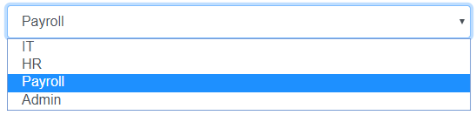

<InputSelect @bind-Value="Employee.DepartmentId">

@foreach (var dept in Departments)

{

<option value="@dept.DepartmentId">@dept.DepartmentName</option>

}

</InputSelect>

Copy

In this example, the InputSelect element, is bound to DepartmentId property of the Employee object. DepartmentId is of type integer, so we get the following exception.

InputSelect does not support the type System.Int32

Only String and Enum data types are supported. Out of the box, the built-in InputSelect component only supports String and Enum data types. Integer is not supported. Since ASP.NET core is open source, we can see the source code of InputSelect on the following page.

[InputSelect Component Source Code](https://github.com/dotnet/aspnetcore/blob/58c13c312eabfb00fdb56c7e0f69813359d2fa9a/src/Components/Web/src/Forms/InputSelect.cs)

## Inelegant Fix

In the component class create a string property and bind to it. The downside of this approach is we have to do the conversion twice. First from int to string while binding the value to the select element and from string to int after retrieving the selected value from the select element.

public string DepartmentId { get; set; }

Copy

## Custom InputSelect

The propery way to fix this is by creating a custom InputSelect element. The easiest way to do this by inheriting the built-in InputSelect component and overriding TryParseValueFromString() method.

In the example below, we have included a case for integer data type. String and Enum data types will still be supported, because in the ELSE block we are falling back to the base class implementation of TryParseValueFromString() method.

using Microsoft.AspNetCore.Components.Forms;

namespace EmployeeManagement.Web.Pages

{

public class CustomInputSelect<TValue> : InputSelect<TValue>

{

protected override bool TryParseValueFromString(string value, out TValue result,

out string validationErrorMessage)

{

if (typeof(TValue) == typeof(int))

{

if (int.TryParse(value, out var resultInt))

{

result = (TValue)(object)resultInt;

validationErrorMessage = null;

return true;

}

else

{

result = default;

validationErrorMessage =

$"The selected value {value} is not a valid number.";

return false;

}

}

else

{

return base.TryParseValueFromString(value, out result,

out validationErrorMessage);

}

}

}

}

Copy

In all our forms we can now use this CustomInputSelect component. It supports all the following types

* Int
* String and
* Enum

If you want another data type like GUID for example, just include another IF block for GUID conversion in the CustomInputSelect component class.

# Razor class library and reusable blazor components

Blazor is an excellent framework and allows us to create reusable Blazor components. We created the following CustomInputSelect component in our previous video. This component allows us to bind an integer property to an input select element.

using Microsoft.AspNetCore.Components.Forms;

namespace Pragim.Components

{

public class CustomInputSelect<TValue> : InputSelect<TValue>

{

protected override bool TryParseValueFromString(string value, out TValue result,

out string validationErrorMessage)

{

if (typeof(TValue) == typeof(int))

{

if (int.TryParse(value, out var resultInt))

{

result = (TValue)(object)resultInt;

validationErrorMessage = null;

return true;

}

else

{

result = default;

validationErrorMessage =

$"The selected value {value} is not a valid number.";

return false;

}

}

else

{

return base.TryParseValueFromString(value, out result,

out validationErrorMessage);

}

}

}

}

Copy

## Component reusability and project type

The project type determines the reusability of a blazor component. If the blazor component is created in a web project, we may not be able to reuse it in other projects.

To be able to reuse a blazor component in multiple projects, create it in a **razor class library project**. This project can then be referenced by any project and use the Blazor component. We can even package and ship them as a NuGet package.

## Reusing blazor components

To be able to use blazor components in your project, add a project reference to the razor class library project. We can then use the Blazor component as we normally use.

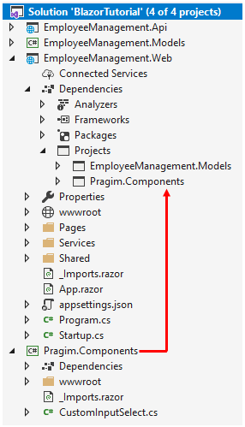

Do not forget to include the required namespace. If you plan to use the blazor component in multiple pages, you may include the namespace in \_Imports.razor file. This allows us to use the components in the namespace in all the pages across our project. There's no need to include the using declaration in each individual page.

# Bind input select element to enum in blazor

In this video we will discuss **how to bind input select element to enum type in Blazor**.

## Gender Enum

We want to bind the Gender enum to Input Select element.

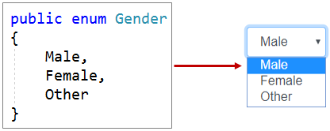

* Enum.GetValues() method returns the list of Enum memebers (i.e Male, Female, and Other).
* Foreach loop creates a select element option for each enum member.
* The built-in InputSelect component supports binding to an enum out of the box.

<InputSelect @bind-Value="Employee.Gender">

@foreach (var gender in Enum.GetValues(typeof(Gender)))

{

<option value="@gender">@gender</option>

}

</InputSelect>

# Blazor DatePicker

In this video we will discuss how to include a DatePicker in a Blazor app.

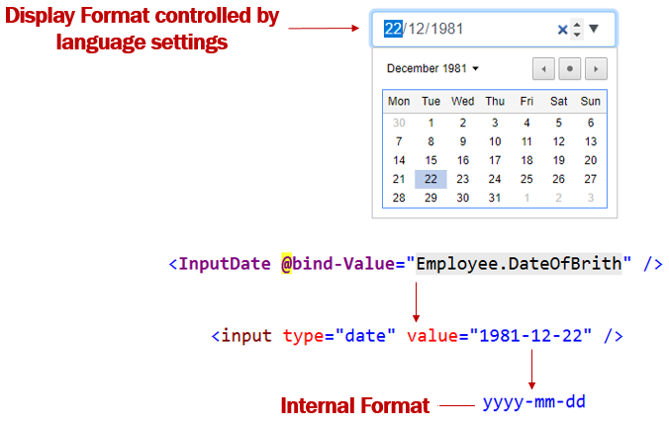

Including a DatePicker in a Blazor app is very simple. Use the built-in InputDate component and bind it to Date property on the Model object. That's it.

<InputDate @bind-Value="Employee.DateOfBrith" />

Copy

Please note : This is an HTML5 date input. This means the look and feel of the Datepicker depends on the browser you are using.

InputDate component is rendered as <input type=date>. This is a built-in HTML input type, and as per the HTML spec, the internal format must always be yyyy-mm-dd. Specifying a format for the date field type isn't recommended because Blazor has built-in support to format dates.

## Date display format in Blazor

What if I want to present the date to the user on the UI in mm/dd/yyyy instead of dd/mm/yyyy. Well, the display in the UI, is controlled by the browser. This means the Browser will present the data (i.e the date for example) according to the browser's language settings. So if you want the date to be displayed on the UI in mm/dd/yyyy instead of dd/mm/yyyy change the language settings accordingly.

#### **Change language settings on Google Chorme**

1. On your computer, open Chrome.
2. On Google chrome, at the top right, click the 3 vertial dots and then Settings.
3. In the Search Settings textbox, type language.
4. If the language isn't listed, add it by clicking Add languages.
5. Next to the language you'd like to use, click the 3 vertial dots and then check the checkbox (Display Google Chrome in this language)

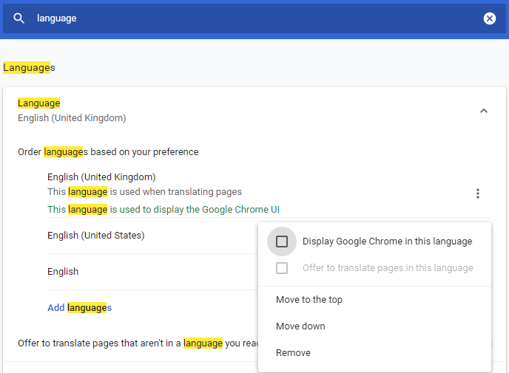

Restart Chrome to apply the changes. To restart Google chrome, type the following command in the address bar.

chrome://restrat

Copy

If this does not change the Date display format. Change the language settings on your operation system.

#### **Change language settings on Windows 10**

1. In the run window, type the command control and click OK
2. In the Control Panel, click on Date and Time option and then Change Date and time button.
3. Click on Change Calendar settings
4. Change the format from the dropdownlist. You can also change just the short or long date format.
5. Finally, restart your browser to apply the changes.

# Blazor form validation

In this article we will understand, how to **implement form validation in blazor**. Let's understand this with an example.

## Employee Edit Form Validation

The model for the Employee Edit Form is Employee class. We want to implement form validation as you can see in the image below.

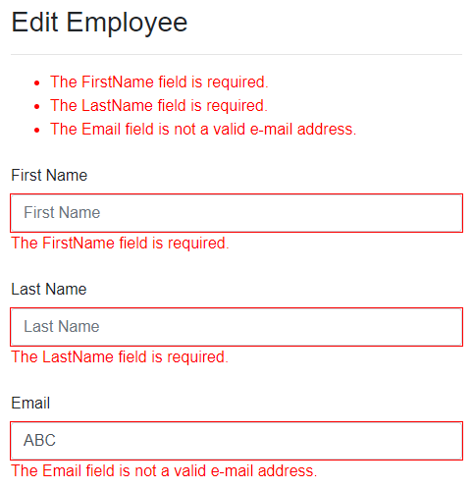

There are 2 simple steps.

## Step 1 : Decorate the model class with validation attributes

These validation attributes (Required, EmailAddress) are in System.ComponentModel.DataAnnotations namespace.

public class Employee

{

public int EmployeeId { get; set; }

[Required]

[MinLength(2)]

public string FirstName { get; set; }

[Required]

public string LastName { get; set; }

[EmailAddress]

public string Email { get; set; }

// Rest of the properties

}

Copy

## Step 2 : Attach Validation Support

* The DataAnnotationsValidator component attaches validation support to our form
* The ValidationSummary component displays a summary of all validation messages
* The ValidationMessage component displays validation messages for a specific field

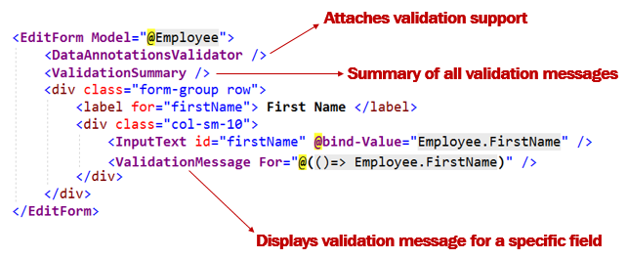

## Customize blazor validation messages

If you do not like the default validation error messages, you can change them using the ErrorMessage property.

public class Employee

{

[Required(ErrorMessage = "FirstName is mandatory")]

[MinLength(2)]

public string FirstName { get; set; }

// Other properties

}

Copy

## Edit Form Validation - Complete Code

@page "/editemployee/{id}"

@inherits EditEmployeeBase

<EditForm Model="@Employee">

<DataAnnotationsValidator />

<h3>Edit Employee</h3>

<hr />

<ValidationSummary />

<div class="form-group row">

<label for="firstName" class="col-sm-2 col-form-label">

First Name

</label>

<div class="col-sm-10">

<InputText id="firstName" class="form-control" placeholder="First Name"

@bind-Value="Employee.FirstName" />

<ValidationMessage For="@(() => Employee.FirstName)" />

</div>

</div>

<div class="form-group row">

<label for="lastName" class="col-sm-2 col-form-label">

Last Name

</label>

<div class="col-sm-10">

<InputText id="lastName" class="form-control" placeholder="Last Name"

@bind-Value="Employee.LastName" />

<ValidationMessage For="@(() => Employee.LastName)" />

</div>

</div>

<div class="form-group row">

<label for="email" class="col-sm-2 col-form-label">

Email

</label>

<div class="col-sm-10">

<InputText id="email" class="form-control" placeholder="Email"

@bind-Value="Employee.Email" />

<ValidationMessage For="@(() => Employee.Email)" />

</div>

</div>

<div class="form-group row">

<label for="department" class="col-sm-2 col-form-label">

Department

</label>

<div class="col-sm-10">

<CustomInputSelect @bind-Value="Employee.DepartmentId" class="form-control">

@foreach (var dept in Departments)

{

<option value="@dept.DepartmentId">@dept.DepartmentName</option>

}

</CustomInputSelect>

</div>

</div>

<div class="form-group row">

<label for="gender" class="col-sm-2 col-form-label">

Gender

</label>

<div class="col-sm-10">

<InputSelect @bind-Value="Employee.Gender" class="form-control">

@foreach (var gender in Enum.GetValues(typeof(Gender)))

{

<option value="@gender">@gender</option>

}

</InputSelect>

</div>

</div>

<div class="form-group row">

<label for="dateOfBirth" class="col-sm-2 col-form-label">

Date Of Birth

</label>

<div class="col-sm-10">

<InputDate @bind-Value="Employee.DateOfBrith" class="form-control" />

</div>

</div>

</EditForm>

# Blazor custom form validation

In this video we will discuss how to create a custom validation attribute and perform custom form validation in Blazor.

## Built-in attributes for validation in Blazor

For most use cases asp.net core has several built-in attributes for model validation. Some of the common built-in attributes are listed below.

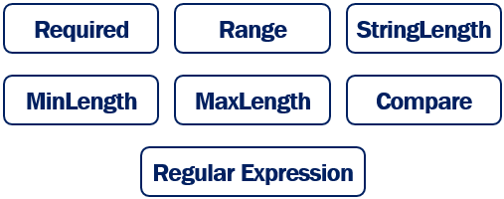

## Custom validation attribute example

If we have a validation requirement that cannot be implemented using the built-in attributes, we can create a custom validation attribute.

On the following Edit Employee page, the only allowed email domain is pragimtech.com. If any other domain name is used, we want to display a validation error. We could achieve this using the built-in regular expression validator, but let's create a custom validator.

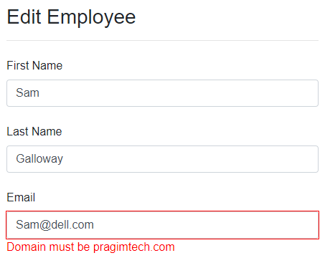

## Create custom validation attribute

To create a custom validation attribute

1. Create a class that derives from the built-in abstract ValidationAttribute class and override IsValid() method.
2. IsValid() method returns null if there are no validation errors, otherwise a ValidationResult object.
3. ValidationResult accepts 2 parameters - Validation error message and the property name with which this validation error message must be associated with.
4. The public property (AllowedDomain) allows to pass the domain name instead of hard-coding it in this EmailDomainValidator class. This approach makes this validator more reusable.

using System.ComponentModel.DataAnnotations;

namespace EmployeeManagement.Models.CustomValidators

{

public class EmailDomainValidator : ValidationAttribute

{

public string AllowedDomain { get; set; }

protected override ValidationResult IsValid(object value,

ValidationContext validationContext)

{

string[] strings = value.ToString().Split('@');

if (strings[1].ToUpper() == AllowedDomain.ToUpper())

{

return null;

}

return new ValidationResult($"Domain must be {AllowedDomain}",

new[] { validationContext.MemberName });

}

}

}

Copy

## Using Custom Validation Attribute in Blazor

public class Employee

{

[EmailDomainValidator(AllowedDomain = "pragimtech.com")]

public string Email { get; set; }

}

Copy

* Use the custom validation attribute just like any other built-in validation attribute.
* Email property is decorated with EmailDomainValidator attribute.
* AllowedDomain property specifies the email domain that we want to validate against.

# Compare validation in blazor

In this video we will learn implementing compare validation. The following are some of the common use cases.

* Email and Confirm Email Validation
* Password and Confirm Password Validation

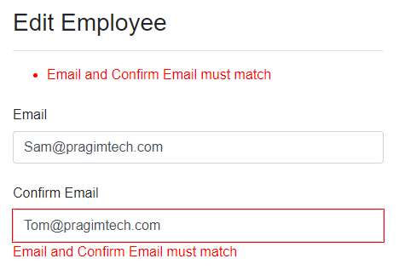

The standard [CompareAttribute] doesn't work well with the DataAnnotationsValidator component and can result in inconsistent behavior.

## CompareProperty attribute

* For this reason [CompareProperty] attribute is introduced in Blazor.
* This attribute is in Microsoft.AspNetCore.Components.DataAnnotations.Validation nuget package.
* As of May 2020, this is still an experimental package
* In a Blazor app, [CompareProperty] is a direct replacement for the [Compare] attribute.

## Blazor CompareProperty Example

* ConfirmEmail property is decorated with CompareProperty attribute
* Email is the other property to compare ConfirmEmail property

public class EditEmployeeModel

{

public string Email { get; set; }

[CompareProperty("Email",

ErrorMessage = "Email and Confirm Email must match")]

public string ConfirmEmail { get; set; }

// Other properties

}

Copy

In the view, use ValidationSummary and ValidationMessage components to display the validation error message.

@page "/editemployee/{id}"

@inherits EditEmployeeBase

<EditForm Model="@EditEmployeeModel" OnValidSubmit="HandleValidSubmit">

<DataAnnotationsValidator />

<ValidationSummary />

<div class="form-group row">

<label for="email" class="col-sm-2 col-form-label">

Email

</label>

<div class="col-sm-10">

<InputText id="email" class="form-control"

@bind-Value="EditEmployeeModel.Email" />

<ValidationMessage For="@(() => EditEmployeeModel.Email)" />

</div>

</div>

<div class="form-group row">

<label for="confirmEmail" class="col-sm-2 col-form-label">

Confirm Email

</label>

<div class="col-sm-10">

<InputText id="confirmEmail" class="form-control"

@bind-Value="EditEmployeeModel.ConfirmEmail" />

<ValidationMessage For="@(() => EditEmployeeModel.ConfirmEmail)" />

</div>

</div>

<button type="submit">Save</button>

</EditForm>

Copy

## Inconsistent behaviour

* + Even with the [CompareProperty] attribute, there is a bit of inconsistency.
  + A change to Confirm Email filed triggers the validation but not Email field.
* To trigger the validation when Email field is changed, click the Submit button.
* I think this is a gap and hopefully this will be fixed in the future releases.

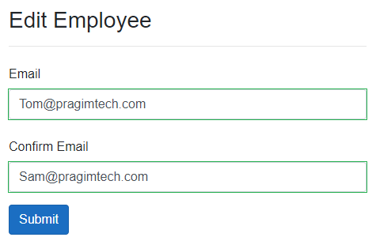

<EditForm Model="@EditEmployeeModel" OnValidSubmit="HandleValidSubmit">

<button class="btn btn-primary" type="submit">Submit</button>

</EditForm>

Copy

* + OnValidSubmit is set to HandleValidSubmit.
  + HandleValidSubmit is the method in the component class.
* This method is called when the form is valid (i.e when there are no validation errors).
* At the moment, this method does nothing. In our upcoming videos we will discuss saving the data in the underlying database.

protected void HandleValidSubmit()

{ }

Copy

# Validating nested complex models and collection types in Blazor

In this video we will discuss, **validating nested complex models and collection types in Blazor**.

## Validating top-level model properties in Blazor

public class Employee

{

[Required]

public string FirstName { get; set; }

[Required]

public string LastName { get; set; }

}

Copy

To validate the top-level properties (FirstName and LastName) of Employee class, we use DataAnnotationsValidator component.

<EditForm Model="@Employee">

<DataAnnotationsValidator />

<InputText id="firstName" @bind-Value="EditEmployeeModel.FirstName" />

<ValidationMessage For="@(() => EditEmployeeModel.FirstName)" />

</EditForm>

Copy

However, DataAnnotationsValidator component cannot be used to validate nested complex models and collection types.

public class Employee

{

[Required]

public string FirstName { get; set; }

[Required]

public string LastName { get; set; }

[ValidateComplexType]

public Department Department { get; set; }

}

public class Department

{

[Required]

public string DepartmentName { get; set; }

}

Copy

Department property in the Employee class is a complex type. To validate this use ObjectGraphDataAnnotationsValidator instead of DataAnnotationsValidator component. As the name implies, the ObjectGraphDataAnnotationsValidator validates the entire object graph, including collection and complex-type properties.

<EditForm Model="@Employee">

<ObjectGraphDataAnnotationsValidator />

<InputText id="firstName" @bind-Value="EditEmployeeModel.FirstName" />

<ValidationMessage For="@(() => EditEmployeeModel.FirstName)" />

</EditForm>

Copy

The complex types in the model should be decorated with [ValidateComplexType] attribute. In our example, Department property in the Employee class is decorated with this attribute.

Both ValidateComplexType and ObjectGraphDataAnnotationsValidator are in the nuget package Microsoft.AspNetCore.Components.DataAnnotations.Validation

# What is AutoMapper and using it in ASP.NET Core

AutoMapper is an object-object mapper i.e it maps an object of one type to another type.

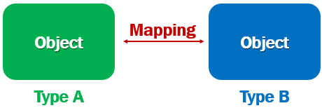

For example, consider the following 2 classes

public class Employee

{

public int EmployeeId { get; set; }

public string FirstName { get; set; }

public string LastName { get; set; }

public string Email { get; set; }

public DateTime DateOfBrith { get; set; }

public Gender Gender { get; set; }

public int DepartmentId { get; set; }

public string PhotoPath { get; set; }

public Department Department { get; set; }

}

public class EditEmployeeModel

{

public int EmployeeId { get; set; }

public string FirstName { get; set; }

public string LastName { get; set; }

public string Email { get; set; }

public string ConfirmEmail { get; set; }

public DateTime DateOfBrith { get; set; }

public Gender Gender { get; set; }

public int? DepartmentId { get; set; }

public string PhotoPath { get; set; }

public Department Department { get; set; } = new Department();

}

Copy

We want to map properties of the Employee class to EditEmployeeModel class. Without a tool like AutoMapper, we have to write the following boring mapping code.

EditEmployeeModel.EmployeeId = Employee.EmployeeId;

EditEmployeeModel.FirstName = Employee.FirstName;

EditEmployeeModel.LastName = Employee.LastName;

EditEmployeeModel.Email = Employee.Email;

EditEmployeeModel.ConfirmEmail = Employee.Email;

EditEmployeeModel.DateOfBrith = Employee.DateOfBrith;

EditEmployeeModel.Gender = Employee.Gender;

EditEmployeeModel.PhotoPath = Employee.PhotoPath;

EditEmployeeModel.DepartmentId = Employee.DepartmentId;

EditEmployeeModel.Department = Employee.Department;

Copy

If you are wondering why is there a need to map objects. Well, a mapping like this is required when we pass data between different layers of an application. For example, when we pass data between data access, business and presentation layers of our application.

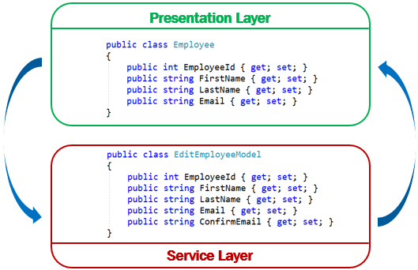

## Using AutoMapper in ASP.NET Core

To use AutoMapper in an ASP.NET Core project, install AutoMapper.Extensions.Microsoft.DependencyInjection nuget package. This package has a dependency on AutoMapper, so it will also be installed.

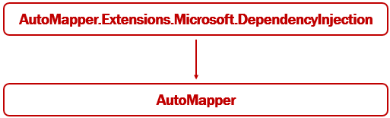

## Add AutoMapper Services

* + In ConfigureServices method of the Startup class, add AutoMapper services.
* AddAutoMapper method is in AutoMapper namespace.
* The class EmployeeProfile contains the mapping profiles for AutoMapper

public class Startup

{

public void ConfigureServices(IServiceCollection services)

{

services.AddAutoMapper(typeof(EmployeeProfile));

}

}

Copy

## AutoMapper Mapping Profile

using AutoMapper;

using EmployeeManagement.Models;

namespace EmployeeManagement.Web.Models

{

public class EmployeeProfile : Profile

{

public EmployeeProfile()

{

CreateMap<Employee, EditEmployeeModel>()

.ForMember(dest => dest.ConfirmEmail,

opt => opt.MapFrom(src => src.Email));

CreateMap<EditEmployeeModel, Employee>();

}

}

}

Copy

* When doing the mapping from one type to another, AutoMapper looks for mapping profiles.
* To create a mapping profile, create a class that derives from AutoMapper Profile class.
* Use CreateMap method to create a mapping from one type to another.
* CreateMap method is called twice to create 2 mappings. Employee to EditEmployeeModel and the reverse.
* Except for one property (ConfirmEmail), we do not need explicit property mappings, because the property names and their data types match. So the AutoMapper does the mapping for us automatically.

## Explicit AutoMapper Property Mapping

CreateMap<Employee, EditEmployeeModel>()

.ForMember(dest => dest.ConfirmEmail,

opt => opt.MapFrom(src => src.Email));

Copy

* For ConfirmEmail property in EditEmployeeModel class, we do not have a matching property in Employee class.
* We have an explicit mapping to map the Email property in Employee class to ConfirmEmail property in EditEmployeeModel class.

## Using AutoMapper IMapper Service

* + Just like any other service, inject AutoMapper IMapper service in to the blazor component class using thr [Inject] attribute.
  + If you have an ASP.NET Core MVC controller, use the standard constructor injection.
* Use the IMapper service Map method to do the object mapping.
* The first parameter is the source and the second parameter is the destination.

public class EditEmployeeBase : ComponentBase

{

[Inject]

public IMapper Mapper { get; set; }

protected async override Task OnInitializedAsync()

{

Mapper.Map(Employee, EditEmployeeModel);

}

}

Copy

# Edit and Update in Blazor

In this video we will discuss how to perform Edit and Update operation in Blazor.

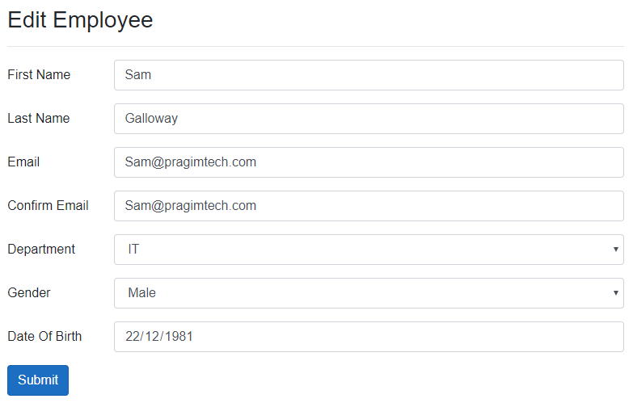

## EditEmployee Component Class

* + In HandleValidSubmit() method, EmployeeService.UpdateEmployee method updates the employee data in the underlying database by calling REST API.
* NavigationManager.NavigateTo("/") method redirects the user to the list page after a successful update.

using AutoMapper;

using EmployeeManagement.Models;

using EmployeeManagement.Web.Models;

using EmployeeManagement.Web.Services;

using Microsoft.AspNetCore.Components;

using System.Collections.Generic;

using System.Linq;

using System.Threading.Tasks;

namespace EmployeeManagement.Web.Pages

{

public class EditEmployeeBase : ComponentBase

{

[Inject]

public IEmployeeService EmployeeService { get; set; }

private Employee Employee { get; set; } = new Employee();

public EditEmployeeModel EditEmployeeModel { get; set; } = new EditEmployeeModel();

[Inject]

public IDepartmentService DepartmentService { get; set; }

public List<Department> Departments { get; set; } = new List<Department>();

[Parameter]

public string Id { get; set; }

[Inject]

public IMapper Mapper { get; set; }

[Inject]

public NavigationManager NavigationManager { get; set; }

protected async override Task OnInitializedAsync()

{

Employee = await EmployeeService.GetEmployee(int.Parse(Id));

Departments = (await DepartmentService.GetDepartments()).ToList();

Mapper.Map(Employee, EditEmployeeModel);

}

protected async Task HandleValidSubmit()

{

Mapper.Map(EditEmployeeModel, Employee);

var result = await EmployeeService.UpdateEmployee(Employee);

if (result != null)

{

NavigationManager.NavigateTo("/");

}

}

}

}

Copy

## EditEmployee Component - Blazor EditForm

@page "/editemployee/{id}"

@inherits EditEmployeeBase

<EditForm Model="@EditEmployeeModel" OnValidSubmit="HandleValidSubmit">

<ObjectGraphDataAnnotationsValidator />

<h3>Edit Employee</h3>

<hr />

<ValidationSummary />

<div class="form-group row">

<label for="firstName" class="col-sm-2 col-form-label">

First Name

</label>

<div class="col-sm-10">

<InputText id="firstName" class="form-control" placeholder="First Name"

@bind-Value="EditEmployeeModel.FirstName" />

<ValidationMessage For="@(() => EditEmployeeModel.FirstName)" />

</div>

</div>

<div class="form-group row">

<label for="lastName" class="col-sm-2 col-form-label">

Last Name

</label>

<div class="col-sm-10">

<InputText id="lastName" class="form-control" placeholder="Last Name"

@bind-Value="EditEmployeeModel.LastName" />

<ValidationMessage For="@(() => EditEmployeeModel.LastName)" />

</div>

</div>

<div class="form-group row">

<label for="email" class="col-sm-2 col-form-label">

Email

</label>

<div class="col-sm-10">

<InputText id="email" class="form-control" placeholder="Email"

@bind-Value="EditEmployeeModel.Email" />

<ValidationMessage For="@(() => EditEmployeeModel.Email)" />

</div>

</div>

<div class="form-group row">

<label for="confirmEmail" class="col-sm-2 col-form-label">

Confirm Email

</label>

<div class="col-sm-10">

<InputText id="confirmEmail" class="form-control"

@bind-Value="EditEmployeeModel.ConfirmEmail" />

<ValidationMessage For="@(() => EditEmployeeModel.ConfirmEmail)" />

</div>

</div>

<div class="form-group row">

<label for="department" class="col-sm-2 col-form-label">

Department

</label>

<div class="col-sm-10">

<CustomInputSelect @bind-Value="EditEmployeeModel.DepartmentId" class="form-control">

@foreach (var dept in Departments)

{

<option value="@dept.DepartmentId">@dept.DepartmentName</option>

}

</CustomInputSelect>

</div>

</div>

<div class="form-group row">

<label for="gender" class="col-sm-2 col-form-label">

Gender

</label>

<div class="col-sm-10">

<InputSelect @bind-Value="EditEmployeeModel.Gender" class="form-control">

@foreach (var gender in Enum.GetValues(typeof(Gender)))

{

<option value="@gender">@gender</option>

}

</InputSelect>

</div>

</div>

<div class="form-group row">

<label for="dateOfBirth" class="col-sm-2 col-form-label">

Date Of Birth

</label>

<div class="col-sm-10">

<InputDate @bind-Value="EditEmployeeModel.DateOfBrith" class="form-control" />

</div>

</div>

@\*<div class="form-group row">

Updating Department Name from this page does not make sense

This is only here to demonstrate complex model validation

<label for="deptName" class="col-sm-2 col-form-label">

Department Name

</label>

<div id="deptName" class="col-sm-10">

<InputText @bind-Value="EditEmployeeModel.Department.DepartmentName"

class="form-control" />

<ValidationMessage For="@(() => EditEmployeeModel.Department.DepartmentName)" />

</div>

</div>\*@

<button class="btn btn-primary" type="submit">Submit</button>

</EditForm>

Copy

## IEmployeeService

public interface IEmployeeService

{

Task<IEnumerable<Employee>> GetEmployees();

Task<Employee> GetEmployee(int id);

Task<Employee> UpdateEmployee(Employee updatedEmployee);

}

Copy

## EmployeeService

using EmployeeManagement.Models;

using Microsoft.AspNetCore.Components;

using System.Collections.Generic;

using System.Net.Http;

using System.Threading.Tasks;

namespace EmployeeManagement.Web.Services

{

public class EmployeeService : IEmployeeService

{

private readonly HttpClient httpClient;

public EmployeeService(HttpClient httpClient)

{

this.httpClient = httpClient;

}

public async Task<Employee> GetEmployee(int id)

{

return await httpClient.GetJsonAsync<Employee>($"api/employees/{id}");

}

public async Task<IEnumerable<Employee>> GetEmployees()

{

return await httpClient.GetJsonAsync<Employee[]>("api/employees");

}

public async Task<Employee> UpdateEmployee(Employee updatedEmployee)

{

return await httpClient.PutJsonAsync<Employee>("api/employees", updatedEmployee);

}

}

}

Copy

## REST API UpdateEmployee Method

public async Task<ActionResult<Employee>> UpdateEmployee(Employee employee)

{

try

{

var employeeToUpdate = await employeeRepository.GetEmployee(id);

if(employeeToUpdate == null)

{

return NotFound($"Employee with Id = {id} not found");

}

return await employeeRepository.UpdateEmployee(employee);

}

catch (Exception)

{

return StatusCode(StatusCodes.Status500InternalServerError,

"Error updating data");

}

}

# Create operation in Blazor

In this video we will implement Create operation in Blazor i.e add a new employee record to the Employees database table through a blazor web application.

## Edit Employee Component Class (EditEmployeeBase.cs)

using AutoMapper;

using EmployeeManagement.Models;

using EmployeeManagement.Web.Models;

using EmployeeManagement.Web.Services;

using Microsoft.AspNetCore.Components;

using System;

using System.Collections.Generic;

using System.Linq;

using System.Threading.Tasks;

namespace EmployeeManagement.Web.Pages

{

public class EditEmployeeBase : ComponentBase

{

[Inject]

public IEmployeeService EmployeeService { get; set; }

private Employee Employee { get; set; } = new Employee();

public EditEmployeeModel EditEmployeeModel { get; set; } =

new EditEmployeeModel();

[Inject]

public IDepartmentService DepartmentService { get; set; }

public List<Department> Departments { get; set; } =

new List<Department>();

[Parameter]

public string Id { get; set; }

[Inject]

public IMapper Mapper { get; set; }

[Inject]

public NavigationManager NavigationManager { get; set; }

protected async override Task OnInitializedAsync()

{

int.TryParse(Id, out int employeeId);

if (employeeId != 0)

{

Employee = await EmployeeService.GetEmployee(int.Parse(Id));

}

else

{

Employee = new Employee

{

DepartmentId = 1,

DateOfBrith = DateTime.Now,

PhotoPath = "images/nophoto.jpg"

};

}

Departments = (await DepartmentService.GetDepartments()).ToList();

Mapper.Map(Employee, EditEmployeeModel);

}

protected async Task HandleValidSubmit()

{

Mapper.Map(EditEmployeeModel, Employee);

Employee result = null;

if (Employee.EmployeeId != 0)

{

result = await EmployeeService.UpdateEmployee(Employee);

}

else

{

result = await EmployeeService.CreateEmployee(Employee);

}

if (result != null)

{

NavigationManager.NavigateTo("/");

}

}

}

}

Copy

## Edit Employee Component View (EditEmployee.razor)

@page "/editemployee/{id}"

@page "/editemployee"

@inherits EditEmployeeBase

<EditForm Model="@EditEmployeeModel" OnValidSubmit="HandleValidSubmit">

<ObjectGraphDataAnnotationsValidator />

<h3>Edit Employee</h3>

<hr />

<ValidationSummary />

<div class="form-group row">

<label for="firstName" class="col-sm-2 col-form-label">

First Name

</label>

<div class="col-sm-10">

<InputText id="firstName" class="form-control" placeholder="First Name"

@bind-Value="EditEmployeeModel.FirstName" />

<ValidationMessage For="@(() => EditEmployeeModel.FirstName)" />

</div>

</div>

<div class="form-group row">

<label for="lastName" class="col-sm-2 col-form-label">

Last Name

</label>

<div class="col-sm-10">

<InputText id="lastName" class="form-control" placeholder="Last Name"

@bind-Value="EditEmployeeModel.LastName" />

<ValidationMessage For="@(() => EditEmployeeModel.LastName)" />

</div>

</div>

<div class="form-group row">

<label for="email" class="col-sm-2 col-form-label">

Email

</label>

<div class="col-sm-10">

<InputText id="email" class="form-control" placeholder="Email"

@bind-Value="EditEmployeeModel.Email" />

<ValidationMessage For="@(() => EditEmployeeModel.Email)" />

</div>

</div>

<div class="form-group row">

<label for="confirmEmail" class="col-sm-2 col-form-label">

Confirm Email

</label>

<div class="col-sm-10">

<InputText id="confirmEmail" class="form-control"

@bind-Value="EditEmployeeModel.ConfirmEmail" />

<ValidationMessage For="@(() => EditEmployeeModel.ConfirmEmail)" />

</div>

</div>

<div class="form-group row">

<label for="department" class="col-sm-2 col-form-label">

Department

</label>

<div class="col-sm-10">

<CustomInputSelect @bind-Value="EditEmployeeModel.DepartmentId"

class="form-control">

@foreach (var dept in Departments)

{

<option value="@dept.DepartmentId">

@dept.DepartmentName

</option>

}

</CustomInputSelect>

</div>

</div>

<div class="form-group row">

<label for="gender" class="col-sm-2 col-form-label">

Gender

</label>

<div class="col-sm-10">

<InputSelect @bind-Value="EditEmployeeModel.Gender" class="form-control">

@foreach (var gender in Enum.GetValues(typeof(Gender)))

{

<option value="@gender">@gender</option>

}

</InputSelect>

</div>

</div>

<div class="form-group row">

<label for="dateOfBirth" class="col-sm-2 col-form-label">

Date Of Birth

</label>

<div class="col-sm-10">

<InputDate @bind-Value="EditEmployeeModel.DateOfBrith" class="form-control" />

</div>

</div>

@\*<div class="form-group row">

<label for="deptName" class="col-sm-2 col-form-label">

Department Name

</label>

<div id="deptName" class="col-sm-10">

<InputText @bind-Value="EditEmployeeModel.Department.DepartmentName"

class="form-control" />

<ValidationMessage For="@(() => EditEmployeeModel.Department.DepartmentName)" />

</div>

</div>\*@

<button class="btn btn-primary" type="submit">Submit</button>

</EditForm>

Copy

## NavMenu.razor

<li class="nav-item px-3">

<NavLink class="nav-link" href="/editemployee">

<span class="oi oi-file" aria-hidden="true"></span> Create

</NavLink>

</li>

Copy

## IEmployeeService

public interface IEmployeeService

{

Task<IEnumerable<Employee>> GetEmployees();

Task<Employee> GetEmployee(int id);

Task<Employee> UpdateEmployee(Employee updatedEmployee);

Task<Employee> CreateEmployee(Employee newEmployee);

}

Copy

## EmployeeService

public class EmployeeService : IEmployeeService

{

private readonly HttpClient httpClient;

public EmployeeService(HttpClient httpClient)

{

this.httpClient = httpClient;

}

public async Task<Employee> CreateEmployee(Employee newEmployee)

{

return await httpClient.PostJsonAsync<Employee>("api/employees", newEmployee);

}

}

Copy

## nophoto.jpg used in the demo



# Force reload blazor component

In this video we will discuss **how to force reload blazor component**. When a blazor component is used for multiple workflows, this feature allows us to refresh the component, so the user can see the elements that are changed dynamically.

## Uisng a blazor component for multiple workflows

For example, EditEmployee component is used for the following 2 workflows

* 1. Editing existing employee data
  2. Creating a new employee

In the following example, PageHeader is set to Create Employee if EmployeeId is 0, otherwise Edit Employee

[Parameter]

public string Id { get; set; }

public string PageHeader { get; set; }

protected async override Task OnInitializedAsync()

{

int.TryParse(Id, out int employeeId);

if (employeeId != 0)

{

PageHeader = "Edit Employee";

Employee = await EmployeeService.GetEmployee(int.Parse(Id));

}

else

{

PageHeader = "Create Employee";

Employee = new Employee

{

DepartmentId = 1,

DateOfBrith = DateTime.Now,

PhotoPath = "images/nophoto.jpg"

};

}

}

Copy

The view binds to the PageHeader property

<h3>@PageHeader</h3>

Copy

## Why force-reload blazor component

If your navigation flow is the following, then the PageHeader text changes from Edit Employee to Create Employee as expected.

* 1. Navigate to EditEmployee Component (for editing existing employee data).
  2. Navigate to a different component, for example ListEmployees component.

1. Navigate to EditEmployee Component (for creating a new employee).

However, if your navigation flow is the following, then the PageHeader text is not refreshed.

1. Navigate to EditEmployee Component (for editing existing employee data)
2. Navigate to EditEmployee Component (for creating a new employee).

## Force reload blazor nav link

When you are already on EditEmployee component, and when the <NavLink> element is clicked, it does not send the request to the server, the redirection happens on the client. Hence, nothing on the page updates.

<NavLink class="nav-link" href="/editemployee">

<span class="oi oi-file" aria-hidden="true"></span> Create

</NavLink>

Copy

To fix this

1. Include onclick event handler
2. NavigationManager.NavigateTo() method has a boolean forceLoad parameter.
3. The default value is false. Pass true to this parameter.
4. This will by-pass client-side routing and forces the browser to load the component from the server.

<NavLink class="nav-link" href="/editemployee" @onclick="HandleClick">

<span class="oi oi-file" aria-hidden="true"></span> Create

</NavLink>

Copy

@code {

@inject NavigationManager NavigationManager;

private void HandleClick()

{

NavigationManager.NavigateTo("editemployee", true);

}

}

Copy

## Blazor navigation menu selected style

The following are the 2 routes to get to EditEmployee component. When a value for employee id is passed in the URL, the component is used for editing else for creating a new employee.

@page "/editemployee/{id}"

@page "/editemployee"

Copy

The following are the 2 navigation menu items

<NavLink class="nav-link" href="/editemployee" @onclick="HandleClick">

<span class="oi oi-file" aria-hidden="true"></span> Create

</NavLink>

<NavLink class="nav-link" href="/editemployee/1">

<span class="oi oi-file" aria-hidden="true"></span> Edit

</NavLink>

Copy

The URL (/editemployee/1) matches both the navigation menu items (Create & Edit) and as a result, selected style is applied to both.

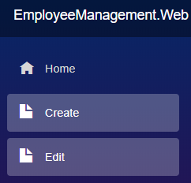

To fix this set Match="NavLinkMatch.All" on both the menu items

<NavLink class="nav-link" href="/editemployee" @onclick="HandleClick"

Match="NavLinkMatch.All">

<span class="oi oi-file" aria-hidden="true"></span> Create

</NavLink>

<NavLink class="nav-link" href="/editemployee/1"

Match="NavLinkMatch.All">

<span class="oi oi-file" aria-hidden="true"></span> Edit

</NavLink>

Copy

* NavLinkMatch.All, specifies that the selected style must be applied to the NavLink when it matches the entire current URL.
* NavLinkMatch.Prefix specifies that the selected style must be applied to the NavLink when it matches any prefix of the current URL.

# Delete database row from blazor

In this video we will implement **Delete operation in Blazor** i.e delete employee row from the Employees database table through a blazor web application.

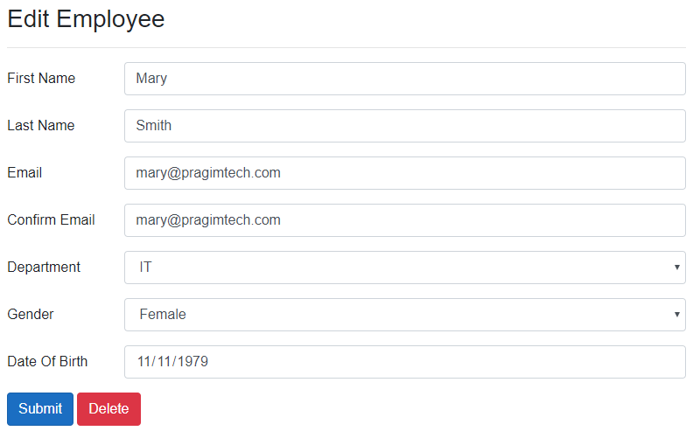

## EditEmployee.razor

EditEmployee component is used for both

* 1. Editing existing employee data and

1. Creating a new employee

Delete button must not be displayed when we are creating a new employee, hence we check if EditEmployeeModel.EmployeeId > 0

@if (EditEmployeeModel.EmployeeId > 0)

{

<button class="btn btn-danger" type="button" @onclick="Delete\_Click">

Delete

</button>

}

Copy

## EditEmployeeBase.cs

* After the Employee row is deleted, redirect to EmployeeList component.
* The URL path for EmployeeList component is "/"

protected async Task Delete\_Click()

{

await EmployeeService.DeleteEmployee(Employee.EmployeeId);

NavigationManager.NavigateTo("/");

}

Copy

## IEmployeeService.cs

public interface IEmployeeService

{

Task DeleteEmployee(int id);

}

Copy

## EmployeeService.cs

public class EmployeeService : IEmployeeService

{

private readonly HttpClient httpClient;

public EmployeeService(HttpClient httpClient)

{

this.httpClient = httpClient;

}

public async Task DeleteEmployee(int id)

{

await httpClient.DeleteAsync($"api/employees/{id}");

}

}

Copy

## EmployeesController.cs

[Route("api/[controller]")]

[ApiController]

public class EmployeesController : ControllerBase

{

private readonly IEmployeeRepository employeeRepository;

public EmployeesController(IEmployeeRepository employeeRepository)

{

this.employeeRepository = employeeRepository;

}

[HttpDelete("{id:int}")]

public async Task<ActionResult<Employee>> DeleteEmployee(int id)

{

try

{

var employeeToDelete = await employeeRepository.GetEmployee(id);

if (employeeToDelete == null)

{

return NotFound($"Employee with Id = {id} not found");

}

return await employeeRepository.DeleteEmployee(id);

}

catch (Exception)

{

return StatusCode(StatusCodes.Status500InternalServerError,

"Error deleting data");

}

}

}

Copy

# Pass data from child to parent component in blazor

In this video we will discuss implementing Delete CRUD operation on list component. Along the way we will understand, how to pass data from child component to parent component in Blazor.

On the following page we have 2 blazor components

1. EmployeeList Component (Parent Component)
2. DisplayEmployee Component (Child Component)

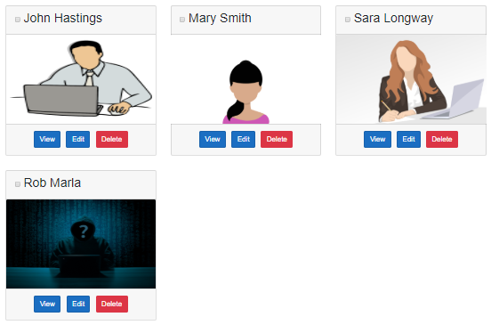

* + When the Delete button is clicked, the respective employee must be deleted and the employee card should dissappear.
  + The Delete button is in the child component (DisplayEmployee Component)
* It is the parent component (EmployeeList Component) that loops through the list of employees and renders each employee using the child component (DisplayEmployee Component)
* When the Delete button in the child component (DisplayEmployee Component) is clicked, it is the child component that is responsible for deleting the respective employee from the database.

## Child component to parent component communication

Child component (DisplayEmployee Component) should notify the parent component (EmployeeList Component) that a record is deleted so the parent component can remove the respective employee card from the list of employees. For this the child component exposes an event. The parent component assigns a callback method to the child component's event. In Blazor, to expose an event we use EventCallback.

#### **Child Component Class (DisplayEmployeeBase.cs)**

* OnEmployeeDeleted is the custom event.
* We use EventCallback to create a custom event. We discussed this in [Part 28](https://youtu.be/Kb5bWCuQ9bQ) of [Blazor tutorial](https://www.pragimtech.com/courses/blazor-tutorial-for-beginners/" \o "Blazor tutorial" \t "_blank).
* Delete\_Click event handler deletes the employee record and raises the custom event - OnEmployeeDeleted.

[Parameter]

public EventCallback<int> OnEmployeeDeleted { get; set; }

[Inject]

public IEmployeeService EmployeeService { get; set; }

[Inject]

public NavigationManager NavigationManager { get; set; }

protected async Task Delete\_Click()

{

await EmployeeService.DeleteEmployee(Employee.EmployeeId);

await OnEmployeeDeleted.InvokeAsync(Employee.EmployeeId);

//NavigationManager.NavigateTo("/", true);

}

Copy

#### **Child Component View (DisplayEmployee.razor)**

* + Bind the Delete button to Delete\_Click event handler method.
* Everytime the delete button is clicked, the respective employee is deleted and the custom event OnEmployeeDeleted is raised.

<button type="button" class="btn btn-danger m-1"

@onclick="Delete\_Click">

Delete

</button>

Copy

#### **Parent Component Class (EmployeeListBase.cs)**

EmployeeDeleted is the callback method. This method will be called when the delete button in the child component is clicked.

protected async Task EmployeeDeleted()

{

Employees = (await EmployeeService.GetEmployees()).ToList();

}

Copy

#### **Parent Component View (EmployeeList.razor)**

In the view assign EmployeeDeleted() as the Callback method to the child component custom event OnEmployeeDeleted.

@foreach (var employee in Employees)

{

<DisplayEmployee Employee="employee" ShowFooter="ShowFooter"

OnEmployeeSelection="EmployeeSelectionChanged"

OnEmployeeDeleted="EmployeeDeleted"></DisplayEmployee>

}

Copy

# Delete confirmation dialog in Blazor

Once a record is deleted from the database, there is no easy way to recover it. So it's always a good practice to display a confirmation on Delete. In this video we will discuss, how to implement delete confirmation in Blazor.



## Reusable Blazor Confirmation Dialog Component

We will create a reusable confirmation dialog component so it can be used for displaying a confirmation dialog for any requirement, not just delete confirmation.

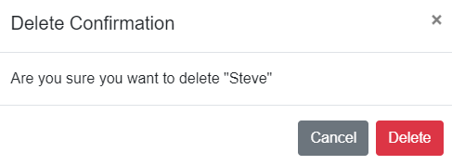

#### **Confirmation Component Class (ConfirmBase.cs)**

* We do not want to hard-code confirmation title and message.
* We want the calling component to be able to pass confirmation title and message.
* This makes this confirmation dialog component more reusable.
* This is the reason we created ConfirmationTitle and ConfirmationMessage properties.
* To make this component even more reusable, we can create additional properties that can be used by the calling component to pass the display text for both DELETE and CANCEL buttons.
* The custom event ConfirmationChanged is fired everytime Delete or Cancel button is clicked.
* The boolean property ShowConfirmation controls the visibility of the dialog on the UI.

using Microsoft.AspNetCore.Components;

using System.Threading.Tasks;

namespace PragimTech.Components

{

public class ConfirmBase : ComponentBase

{

protected bool ShowConfirmation { get; set; }

[Parameter]

public string ConfirmationTitle { get; set; } = "Confirm Delete";

[Parameter]

public string ConfirmationMessage { get; set; } = "Are you sure you want to delete";

public void Show()

{

ShowConfirmation = true;

StateHasChanged();

}

[Parameter]

public EventCallback<bool> ConfirmationChanged { get; set; }

protected async Task OnConfirmationChange(bool value)

{

ShowConfirmation = false;

await ConfirmationChanged.InvokeAsync(value);

}

}

}

Copy

#### **Confirmation Component View (Confirm.razor)**

* The view binds to ConfirmationTitle and ConfirmationMessage properties. The default values specified in the component class are used, if the calling component does not pass values explicitly.
* OnConfirmationChange method in the component class is specified as the event handler for the following 3 buttons
  + Delete
  + Cancel
  + Close
* When Cancel and Close buttons are clicked, false is passed as the event payload (i.e event data). The calling component can subscribe to the custom event ConfirmationChanged and will have access to this event data.
* When Delete button is clicked, true is passed as the event data.
* In the calling component, we can use the event data to determine if a confiramtion is given or not. True indicates confirmation given, false indicates confirmation not given.

@inherits ConfirmBase

@if (ShowConfirmation)

{

<div class="modal fade show d-block" id="exampleModal" tabindex="-1" role="dialog">

<div class="modal-dialog" role="document">

<div class="modal-content">

<div class="modal-header">

<h5 class="modal-title" id="exampleModalLabel">@ConfirmationTitle</h5>

<button type="button" class="close" data-dismiss="modal" aria-label="Close"

@onclick="() => OnConfirmationChange(false)">

<span aria-hidden="true">&times;</span>

</button>

</div>

<div class="modal-body">

@ConfirmationMessage

</div>

<div class="modal-footer">

<button type="button" class="btn btn-secondary" data-dismiss="modal"

@onclick="() => OnConfirmationChange(false)">Cancel</button>

<button type="button" class="btn btn-danger"

@onclick="() => OnConfirmationChange(true)">Delete</button>

</div>

</div>

</div>

</div>

}

Copy

## Using Confirmation Dialog Component

In our example, Delete confirmation must be displayed when Delete button on Employee card is clicked.

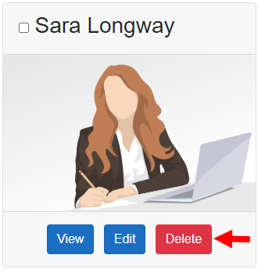

* @ref attribute creates a reference to the component instance
* The component reference (DeleteConfirmation) is used to call Show() method of the delete confirmation component which displays the dialog.
* ConfirmDelete\_Click is the event handler that handles the custom event ConfirmationChanged.

<Confirm @ref="DeleteConfirmation" ConfirmationChanged="ConfirmDelete\_Click"

ConfirmationMessage=@($"Are you sure you want to delete \"{Employee.FirstName}\"")>

</Confirm>

Copy

protected PragimTech.Components.ConfirmBase DeleteConfirmation { get; set; }

protected void Delete\_Click()

{

DeleteConfirmation.Show();

}

protected async Task ConfirmDelete\_Click(bool deleteConfirmed)

{

if(deleteConfirmed)

{

await EmployeeService.DeleteEmployee(Employee.EmployeeId);

await OnEmployeeDeleted.InvokeAsync(Employee.EmployeeId);

}

}

Copy

# Blazor Attribute Splatting

In this article we will discuss, what is Attribute Splatting in Blazor with an example.

## Passing data from parent component to child component

#### **Child Component (ChildComponent.razor)**

<input id="firstName" placeholder="Child Component Placeholder"/>

Copy

#### **Parent Component (ParentComponent.razor)**

<ChildComponent placeholder="Parent Component Placeholder"></ChildComponent>

Copy

This code throws the following InvalidOperationException at runtime.

Object of type 'ChildComponent' does not have a property matching the name 'placeholder'.

Copy

To be able to pass data from Parent Component to Child Component we use component parameters. We discussed component parameters in [Part 27](https://youtu.be/Ii7QwHdD0oU) of [Blazor tutorial](https://www.pragimtech.com/courses/blazor-tutorial-for-beginners/" \o "Blazor tutorial for beginners" \t "_blank).

To make the above example work modify the code in the child component

<input id="firstName" placeholder="@Placeholder"/>

@code {

[Parameter]

public string Placeholder { get; set; } = "Child Component Placeholder";

}

Copy

* We created Placeholder parameter.
* The <input> element binds to this Placeholder parameter.
* The parent component can now pass a value for this Placeholder parameter.

<ChildComponent placeholder="Parent Component Placeholder"></ChildComponent>

Copy

## Example without using attribute splatting

#### **Child Component**

This child component has several parameters. It is tedious to declare these parameters in code and then assign values in the HTML, especially if you have lot of parameters. Instead we could we use attribute splatting. In both the cases the generated HTML is the same. The benefit of attribute splatting is we write a lot less code.

<input id="firstName" required="@Required" maxlength="@Maxlength" size="@Size"

placeholder="@Placeholder" />

@code {

[Parameter]

public string Required { get; set; } = "required";

[Parameter]

public string Maxlength { get; set; } = "15";

[Parameter]

public string Size { get; set; } = "25";

[Parameter]

public string Placeholder { get; set; } = "Child Component Placeholder";

}

Copy

#### **Parent Component**

<ChildComponent required="required" maxlength="100" size="50"

placeholder="Parent Component Placeholder">

</ChildComponent>

Copy

## Example with attribute splatting

#### **Child Component**

* With Attribute Splatting, a dictionary is used to capture attributes.
* The dictionary key is of type string and value is of type object.
* These attributes are then splatted onto an HTML element using  @attributes Razor directive.

<input id="firstName" @attributes="InputAttributes" />

@code {

[Parameter]

public Dictionary<string, object> InputAttributes { get; set; } =

new Dictionary<string, object>()

{

{ "required", "required" },

{ "placeholder", "Child Component Placeholder" },

{ "size", "100" },

{ "maxlength", "15" }

};

}

Copy

#### **Parent Component**

<ChildComponent InputAttributes="attributesFromParent">

</ChildComponent>

@code {

public Dictionary<string, object> attributesFromParent { get; set; } =

new Dictionary<string, object>()

{

{ "required", "required" },

{ "placeholder", "Parent Component Placeholder" },

{ "size", "50" },

{ "maxlength", "5" }

};

}

Copy

## Declared Properties and Attribute splatting

* A component can have both explicitly declared parameters and attribute splatting.
* In general, attribute splatting is used to capture and render additional attributes in addition to the component's explicitly declared parameters.
* In the following example, Value is explicitly declared parameter.

#### **Child Component**

<input id="firstName" @attributes="InputAttributes" value="@Value"/>

@code {

[Parameter]

public Dictionary<string, object> InputAttributes { get; set; } =

new Dictionary<string, object>()

{

{ "required", "required" },

{ "placeholder", "Child Component Placeholder" },

{ "size", "100" },

{ "maxlength", "15" }

};

[Parameter]

public string Value { get; set; } = "Child Value";

}

Copy

#### **Parent Component**

The parent component passes the value (Parent Value) to the child component's explicitly declared Value parameter.

<ChildComponent InputAttributes="attributesFromParent" Value="Parent Value">

</ChildComponent>

@code {

[Parameter]

public Dictionary<string, object> attributesFromParent { get; set; } =

new Dictionary<string, object>()

{

{ "required", "required" },

{ "placeholder", "Parent Component Placeholder" },

{ "size", "50" },

{ "maxlength", "5" }

};

}

# Arbitrary attributes and parameters in Blazor

In this article we will discuss **how a component can accept arbitrary attributes**. This is continuation to our previous article [Attribute Splatting](https://www.pragimtech.com/blog/blazor/blazor-attribute-splatting/).

### Child Component (ChildComponent.razor)

Dictionary parameter InputAttributes is applied to the <input> element using @attributes razor directive. This InputAttributes parameter allows a parent component to be able to pass arbitrary attributes.

<input id="firstName" @attributes="InputAttributes" />

@code {

[Parameter]

public Dictionary<string, object> InputAttributes { get; set; } =

new Dictionary<string, object>()

{

{ "placeholder", "Child Component Placeholder" }

};

}

Copy

### Parent Component (ParentComponent.razor)

The parent component is passing 2 attributes (required and placeholder) to the child component using the dictionary parameter InputAttributes. Using this technique, you can pass any number of arbitrary attributes from the parent component to child component.

<ChildComponent InputAttributes="attributesFromParent">

</ChildComponent>

@code {

public Dictionary<string, object> attributesFromParent { get; set; } =

new Dictionary<string, object>()

{

{ "required", "required" },

{ "placeholder", "Parent Component Placeholder" }

};

}

Copy

However, what you cannot do is specify the arbitrary attributes in the HTML. In this example maxlength attribute is included in the HTML. This causes InvalidOperationException: Object of type 'EmployeeManagement.Web.Pages.ChildComponent' does not have a property matching the name 'maxlength'. One way to fix this is to include a corresponding parameter in the child component. It's tedious to include a parameter for every attribute especially if we want to support large number of attributes.

<ChildComponent InputAttributes="attributesFromParent" maxlength="15">

</ChildComponent>

@code {

public Dictionary<string, object> attributesFromParent { get; set; } =

new Dictionary<string, object>()

{

{ "required", "required" },

{ "placeholder", "Parent Component Placeholder" }

};

}

Copy

### CaptureUnmatchedValues Property

To be able to capture attribute values that do not have matching parameters, simply set CaptureUnmatchedValues property of the dictionary parameter to true.

#### **Child Component (ChildComponent.razor)**

<input id="firstName" @attributes="InputAttributes" />

@code {

[Parameter(CaptureUnmatchedValues = true)]

public Dictionary<string, object> InputAttributes { get; set; } =

new Dictionary<string, object>()

{

{ "placeholder", "Child Component Placeholder" }

};

}

Copy

#### **Parent Component (ParentComponent.razor)**

The parent component is passing 3 arbitrary attributes - maxlength, placeholder and required.

<ChildComponent maxlength="15" placeholder="Parent Component Placeholder" required>

</ChildComponent>

Copy

When CaptureUnmatchedValues property is set to true, we cannot explicitly set the value for the dictionary property in the parent component. If we try to do that, we get the following exception.

InvalidOperationException: The property 'InputAttributes' on component type 'EmployeeManagement.Web.Pages.ChildComponent' cannot be set explicitly when also used to capture unmatched values.

### Default attribute values

If required, the child component can specify default values. However, the order in which the default values and @attributes directive are applied matters.

#### **Child Component (ChildComponent.razor)**

In this example, a default value for the placeholder attribute is specified by the child component. This default value is present on the left hand side of the @attributes directive.

<input id="firstName" placeholder="Default Placeholder" @attributes="InputAttributes" />

@code {

[Parameter(CaptureUnmatchedValues = true)]

public Dictionary<string, object> InputAttributes { get; set; } =

new Dictionary<string, object>();

}

Copy

### Parent Component (ParentComponent.razor)

Parent component did not explicitly pass a value for the placeholder attribute, so the child component default placeholder value will be used.

<ChildComponent></ChildComponent>

Copy

In the example below, parent component is passing a value for the placeholder attribute, so this will override the child component default placeholder value as expected.

<ChildComponent placeholder="Parent Component Placeholder">

</ChildComponent>

Copy

Now, in the child component, reverse the @attributes directive and the placeholder default value.

#### **Child Component (ChildComponent.razor)**

The attributes are always processed from right to left, so the default placeholder attribute value specified in the child component is always used, even if the parent component passes an explicit value for the placeholder attribute.

<input id="firstName" @attributes="InputAttributes" placeholder="Default Placeholder"/>

@code {

[Parameter(CaptureUnmatchedValues = true)]

public Dictionary<string, object> InputAttributes { get; set; } =

new Dictionary<string, object>();

}

Copy

#### **Parent Component (ParentComponent.razor)**

Parent Component has specified an explicit value for the placeholder attribute, but this will be overriden by the child component.

<ChildComponent placeholder="Parent Component Placeholder">

</ChildComponent>

# Blazor cascading values and parameters

One way to pass data from Parent component to child component is by using component parameters. We discussed component parameters in detail in [Part 27](https://youtu.be/Ii7QwHdD0oU) of [Blazor tutorial](https://www.pragimtech.com/courses/blazor-tutorial-for-beginners/" \o "Learn Blazor from Scratch" \t "_blank).

## Cascading values and parameters

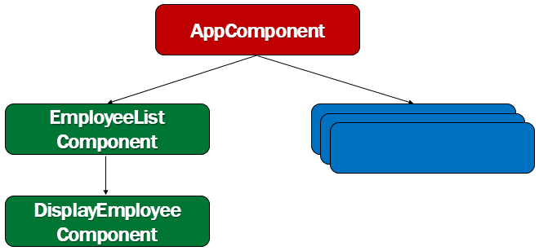

A blazor application is a set of components. We create individual components and put them together to create a working blazor application. Components can also be nested. A component can be nested in another component. That component can be nested in yet another component and this can go on.

However, when there are several component layers in the component hierarchy, it's tedious to pass data from an ancestor component to a descendent component using component parameters. This is when we use cascading values and parameters. They provide a convenient way for an ancestor component to pass a value to all of its descendent components.

## Blazor CascadingValue Component

Blazor has a built-in component called CascadingValue. We can pass a value to this component. This value is then cascaded down its component tree to all of its descendants.

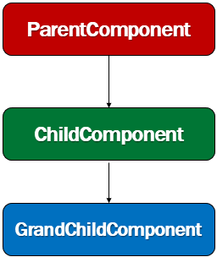

In the following example, ParentComponent Style property value is passed to the CascadingValue component.

#### **ParentComponent.razor**

@page "/pc"

<h1 style="@Color">Parent Component Text</h1>

<CascadingValue Value="@Style">

<ChildComponent>

</ChildComponent>

</CascadingValue>

@code {

public string Style { get; set; } = "color:red";

}

Copy

## Accessing Cascading Value

The child component can access the cascading value by declaring a property of the same type, decorated with the [CascadingParameter] attribute. In fact, any of the descendant components in the component tree can access the cascading value. They simply have to declare a property of the same type, decorated with the [CascadingParameter] attribute.

#### **ChildComponent.razor**

<h1 style="@ElementStyle">-Child Component</h1>

<GrandChildComponent></GrandChildComponent>

@code {

[CascadingParameter]

public string ElementStyle { get; set; }

}

Copy

Along the samelines, even the GrandChildComponent can access the Cascading Value

#### **GrandChildComponent.razor**

<h1 style="@ElementStyle">--Grand Child Component Text</h1>

@code {

[CascadingParameter]

public string ElementStyle { get; set; }

}

Copy

Next : Multiple Cascading Parameters

# Blazor multiple cascading parameters

In this video we will discuss **multiple cascading parameters in Blazor**. This is continuation to our previous video [Part 48](https://youtu.be/ZmDMKp1Q8kA). Please watch [Part 48](https://youtu.be/ZmDMKp1Q8kA) from [Blazor tutorial](https://www.youtube.com/playlist?list=PL6n9fhu94yhVowClAs8-6nYnfsOTma14P" \o "Blazor tutorial for beginners" \t "_blank) before proceeding.

Any of the descendant components in the component tree can access the cascading value. The descendant component, that wants to access the cascading value simply declares a property of the same type, decorated with the [CascadingParameter] attribute.

There are 2 ways to cascade values from the parent component to a child component (in fact any child component) in the component tree.

## Cascading values by type

#### **ParentComponent.razor**

This parent component is passing 2 cascading values

* Style (Value is of type string)
* EmployeeAge (Value is of type int)

<CascadingValue Value="@Style">

<CascadingValue Value="@EmployeeAge">

<ChildComponent></ChildComponent>

</CascadingValue>

</CascadingValue>

@code {

public string Style { get; set; } = "color:red";

public int EmployeeAge { get; set; } = 25;

}

Copy

#### **ChildComponent.razor**

* Since the cascaded values are of different type, this child component has to simply create a property of the same type and decorate with [CascadingParameter] attribute.
* ElementStyle property is of type string so it receives the Style cascaded value from the parent component.
* Along the same lines, EmpAge property in the child component receives the EmployeeAge cascaded value from the parent component.

<h1 style="@ElementStyle">-Child Component Text. Employee Age = @EmpAge</h1>

@code {

[CascadingParameter]

public string ElementStyle { get; set; }

[CascadingParameter]

public int EmpAge { get; set; }

}

Copy

## Multiple cascading values of the same type

What if we have multiple cascading values of the same type.

#### **ParentComponent.razor**

Both the cascading values (Style and BorderStyle) are of type string.

<CascadingValue Value="@Style">

<CascadingValue Value="@BorderStyle">

<ChildComponent></ChildComponent>

</CascadingValue>

</CascadingValue>

@code {

public string Style { get; set; } = "color:red";

public string BorderStyle { get; set; } = "border:1px solid red";

}

Copy

#### **ChildComponent.razor**

* ElementStyle property in this child component receives BorderStyle cascaded values from the parent component.
* This is because both Style and BorderStyle are of type string and it is the BorderStyle cascaded value that is nearest to the child component so it wins.

<h1 style="@ElementStyle">-Child Component Text.</h1>

@code {

[CascadingParameter]

public string ElementStyle { get; set; }

}

Copy

#### **ChildComponent.razor**

* Both the cascading parameters in this example receives the Style cascading value from the parent component and the reasoning is the same.
* If multiple cascaded values of the same type are passed by the parent component to the child component, by default the cascaded value that is nearest to the child component in the hierarchy wins.

<h1 style="@ElementStyle; @H1Border">-Child Component Text.</h1>

@code {

[CascadingParameter]

public string ElementStyle { get; set; }

[CascadingParameter]

public string H1Border { get; set; }

}

Copy

## Cascading values by name

* Another way to access cascading values is by Name.
* Since a unique name is provided to each of the values, these values are now cascaded to the descendant components by Name.

#### **ParentComponent.razor**

<CascadingValue Value="@Style" Name="ColorStyle">

<CascadingValue Value="@BorderStyle" Name="BorderStyle">

<ChildComponent></ChildComponent>

</CascadingValue>

</CascadingValue>

@code {

public string Style { get; set; } = "color:red";

public string BorderStyle { get; set; } = "border:1px solid red";

}

Copy

#### **ChildComponent.razor**

* The child component can now decide which cascading value it wants by using the Name.
* ElementStyle cascading parameter receives the ColorStyle cascading value and
* H1Border cascading parameter receives the BorderStyle cascading value

# Blazor cascading values performance

In this video we will discuss the performance aspect of Blazor cascading values.

CascadingValue component has IsFixed boolean property. The default value of this property is false. This means the value that is cascaded down the component tree is constantly monitored by Blazor. When the cascaded value changes all the components in the entire component tree, that use the cascaded value are automatically updated. However, this constant monitoring requires resources and it is better to turn of this active monitoring when it is not required to avoid performance issues.

## When to turn off monitoring cascading values

1. To turn off monitoring cascading values set IsFixed boolean property to true.
2. In this example the color is set to red and it never changes again.
3. So, it makes sense to turn off monitoring the cascading value.

#### **ParentComponent.razor**

<h1 style="@Style">Parent Component Text</h1>

<CascadingValue Value="@Style" Name="ColorStyle" IsFixed="true">

<ChildComponent></ChildComponent>

</CascadingValue>

@code {

public string Style { get; set; } = "color:red";

}

Copy

#### **ChildComponent.razor**

<h1 style="@ElementStyle">-Child Component Text</h1>

@code {

[CascadingParameter(Name = "ColorStyle")]

public string ElementStyle { get; set; }

}

Copy

## When not to turn off monitoring cascading values

1. The Counter value is cascaded down the component tree.
2. The Counter value is increased by 1, everytime Increment Counter button is clicked.
3. If IsFixed property is set to true, the changed value will not be cascaded down the component tree.
4. So in this example, it does not make sense to turn off monitoring cascading values.

#### **ParentComponent.razor**

<button class="btn btn-primary" @onclick="IncrementCounter">

Increment Counter

</button>

<h1>Parent Component Text - @Counter</h1>

<CascadingValue Value="@Counter" Name="Counter" IsFixed="false">

<ChildComponent></ChildComponent>

</CascadingValue>

@code {

public int Counter { get; set; } = 0;

private void IncrementCounter()

{

Counter = Counter + 1;

}

}

Copy

#### **ChildComponent.razor**

<h1>Child Component Text - @Counter</h1>

@code {

[CascadingParameter(Name = "Counter")]

public int Counter { get; set; }

}

# ASP.NET core identity setup in blazor application

In this video we will discuss how to install and set up ASP.NET core identity in an existing blazor application. In our upcoming videos we will implement authentication using the identity API.

## What is ASP.NET Core Identity

ASP.NET Core Identity is a membership system. It allows us to create, read, update and delete user accounts. Supports account confirmation, authentication, authorisation, password recovery, two-factor authentication. It also supports external login providers like Microsoft, Facebook, Google etc.

We discussed ASP.NET Core Identity in detail in our [ASP.NET Core tutorial](https://www.youtube.com/playlist?list=PL6n9fhu94yhVkdrusLaQsfERmL_Jh4XmU). If you are new to it, please check out videos from [Part 65](https://youtu.be/egITMrwMOPU) from our [ASP.NET Core tutorial](https://www.youtube.com/playlist?list=PL6n9fhu94yhVkdrusLaQsfERmL_Jh4XmU).

## ASP.NET core identity setup in blazor

We will use Visual Studio Scaffolder to add identity support. Right click on the Blazor web project and select Add - New Scaffolded Item...

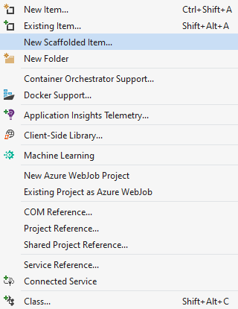

Select Identity from both the left and middle panes in Add New Scaffolded Item dialog.

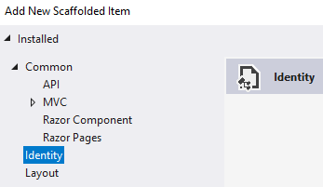

## On Add Identity dialog

1. Check  Override all files - This adds all the Identity views and classes to our project, so we can modify them to meet our application specific requirements.
2. Data context class - If your project already has a data context class, select it from the dropdown list. Otherwise, click the plus sign to have it generated.
3. Click Add

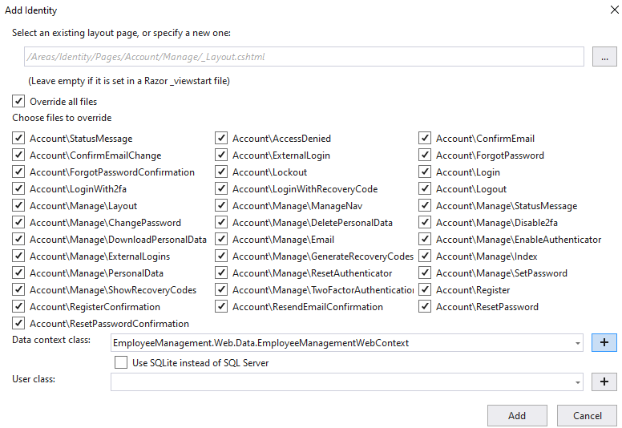

The generated identity files are stored in Areas/Identity folder.

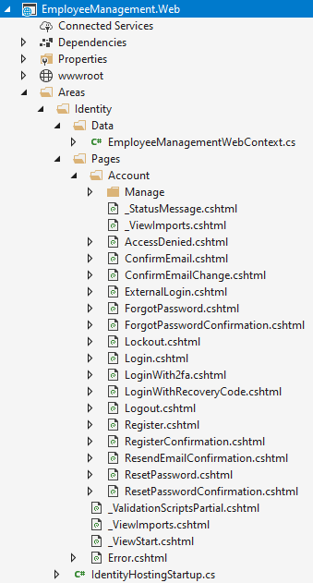

## Add and execute identity migrations

Open Package Manager Console and execute the following command add a migration

Add-Migration IdentitySupport

Copy

Execute the migration

Update-Database

Copy

## Generated Identity Tables

You can see the  generated Identity tables using the SQL Server Object Explorer in Visual Studio. The database connection string is in appsettings.json.

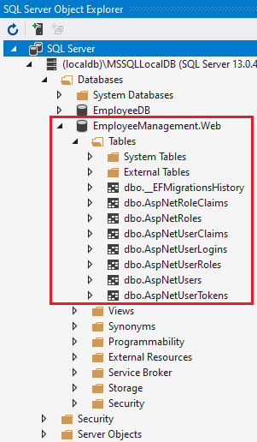

# How cookie authentication works

In this video we will discuss how cookie authentication works in general. In our upcoming videos we will implement it in Blazor web application.

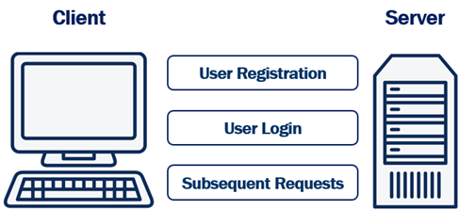

## User Registration

To be able to login a user needs a user account with our system. So the user fills a registration form with their preferred username and password and posts the form to the server. The server then hashes the password and stores stores it in the database. Hashing prevents password theft. Even if an attacker cracks and gains access to your system, they won't be able to steal passwords because they are hashed. Hashing is different from encryption.

#### **Encryption vs Hashing**

Encryption is reversible, i.e what is encrypted can also be decrypted. Hashing, is one-way. It is irreversible. Hashing scrambles plain text to produce a unique message digest. If implemented using a strong algorithm, there is no way to reverse the hashing process to reveal the original password.

#### **Hashing without Salt**

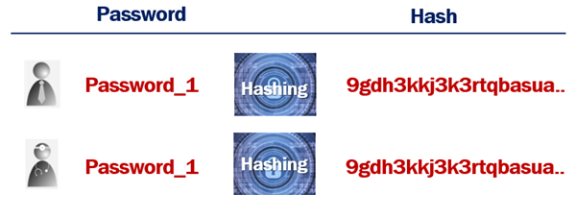

An attacker can hash random passwords and then compare the hashes to crack the password.

#### **Hashing with Salt**

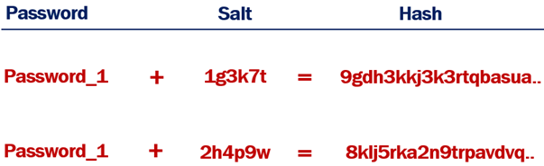

When a random salt is added to the hashing process, the generated hash will not be the same, even if the plain text passwords are.

## User Login

The registered username and password can then be used on the login form. The login form is posted to the server. The server looks up the username in the database. Hashes the supplied password, and compares it to the already hashed password in the database. If they match, then the system knows, the user is who he claims to be, otherwise access is denied by sending HTTP status code 401.

If the supplied username and password matches, the server creates an access token which uniquely identifies the user's session. This access token is stored in the database and is also attached to the response cookie. This cookie is then returned to the client. The user is now logged in.

## Subsequent Requests

On every subsequent request, the browser automatically sends the cookie to the server. The server reads the access token from the cookie and checks it against the one in the database associated with that user. If they match, access is granted.

Once the user logs out of the application, both, the authentication cookie and the access token in the database are deleted.

## Cookie authentication or token authentication

The following is our Blazor application architecture. We have a Blazor web application and a Web API. Blazor web application calls WEB API.

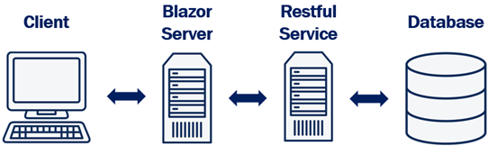

* Depending on how you want your application to scale you may have both blazor web app and web api deployed on same server or different servers. Depending on the demand, if you want to be able to independently scale up and down these 2 applications, then you may have to deploy them on different servers.
* If they are deployed on different servers, we cannot use the same cookie authentication to authenticate both the Blazor web application and web api. This is because a cookie created by one domain cannot be accessed by another domain.
* Although it is possible to share cookies between sub-domains, it is a standard practice to use cookie based authentication for web applications and token based authentication for web apis.

In our upcoming videos, we will implement cookie authentication to protect our blazor web application and token authentication to protect our Web API.

# Blazor cookie authentication - Login page

ASP.NET Core Identity provides cookie authentication out of the box. In this video we will discuss how to integrate this cookie authentication in a Blazor application.

## Scaffold ASP.NET Core Identity

The first step is to scaffold ASP.NET Core Identity into our existing Blazor application. ASP.NET Core Identity provides user registration, login, logout, two factor authentication etc out of the box. We discussed scaffolding ASP.NET Core Identity in [Part 51](https://youtu.be/FZzwhivKrtU) of [Blazor tutorial](https://www.pragimtech.com/courses/blazor-tutorial-for-beginners/" \o "Blazor Tutorial" \t "_blank).

## Configure cookie authentication services

In ConfigureServices() method of the Startup class

* AddAuthentication() - Adds cookie authentication services. ASP.NET Core Idenity writes a cookie with scheme "Identity.Application" which is specified as the default scheme.
* AddCookie() - As the name implies, adds the cookie services.

public void ConfigureServices(IServiceCollection services)

{

services.AddAuthentication("Identity.Application")

.AddCookie();

// Rest of the code

}

Copy

In Configure() method of the Startup class, UseAuthentication() and UseAuthorization() methods add authentication and authorization middleware components to the request processing pipeline.

public void Configure(IApplicationBuilder app, IWebHostEnvironment env)

{

// Rest of the code

app.UseRouting();

app.UseAuthentication();

app.UseAuthorization();

app.UseEndpoints(endpoints =>

{

endpoints.MapBlazorHub();

endpoints.MapFallbackToPage("/\_Host");

});

}

Copy

## Login navigation menu

Navigation menu is in Shared\NavMenu.razor file. Include the following NavLink element.

ASP.NET core identity login page is in Areas\Identity\Pages\Account\Login.cshtml. Areas and Pages folders are not required in the URL, so the URL path to get to the login page is /identity/account/login.

<li class="nav-item px-3">

<NavLink class="nav-link" href="/identity/account/login" Match="NavLinkMatch.All">

<span class="oi oi-lock-locked" aria-hidden="true"></span> Login

</NavLink>

</li>

Copy

## ASP.NET Core Identity Services

Areas\Identity\IdentityHostingStartup.cs is added by the identity scaffolder. The class in this file adds

* Identity Services.
* Entity Framework Services.
* Specifies the DbContext and the database connection string to use.

public class IdentityHostingStartup : IHostingStartup

{

public void Configure(IWebHostBuilder builder)

{

builder.ConfigureServices((context, services) => {

services.AddDbContext<EmployeeManagementWebContext>(options =>

options.UseSqlServer(

context.Configuration.GetConnectionString("EmployeeManagementWebContextConnection")));

services.AddDefaultIdentity<IdentityUser>(options => options.SignIn.RequireConfirmedAccount = true)

.AddEntityFrameworkStores<EmployeeManagementWebContext>();

});

}

}

Copy

## Registering a new user

At this point, navigate to the root application URL and click on the Longin link.

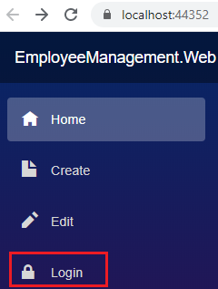

On the login page. Click on Register as a new user link. Provide Email, Password and Confirm Password.

On the subsequent page click on the link - Click here to confirm your account.

You can now use the registered username and password to login. The registered user details are stored in the Identity database table AspNetUsers.

Launch browser developer tools by pressing F12, and login. Under the Application tab, you will find authentication cookie with the scheme Identity.Application. This is same as the default scheme we specified in ConfigureServices() method of the Startup class.

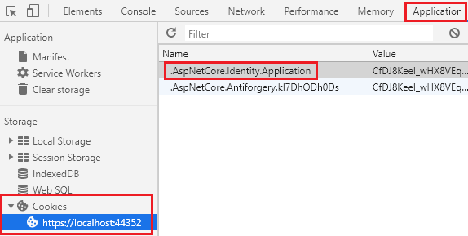

In our next video we will implement Logout functionality.

# Blazor cookie authentication - Logout page

In this video we will discuss implementing logout functionality in Blazor. For this we will use ASP.NET Core Identity logout page.

## Logout link in the navigation manu

The path to get to ASP.NET Core Identity logout page is /identity/account/logout

<li class="nav-item px-3">

<NavLink class="nav-link" href="/identity/account/logout" Match="NavLinkMatch.All">

<span class="oi oi-power-standby" aria-hidden="true"></span> Logout

</NavLink>

</li>

Copy

## ASP.NET Core Identity logout page

* ASP.NET Core Identity logout page is in Areas/Identity/Pages/Account/Logout.cshtml.
* ASP.NET Core Identity scaffolder provided the implementation of the Logout page.

#### **Logout.cshtml**

@page

@model LogoutModel

@{

ViewData["Title"] = "Log out";

}

<header>

<h1>@ViewData["Title"]</h1>

<p>You have successfully logged out of the application.</p>

</header>

Copy

#### **Logout.cshtml.cs**

using Microsoft.AspNetCore.Authorization;

using Microsoft.AspNetCore.Identity;

using Microsoft.AspNetCore.Mvc;

using Microsoft.AspNetCore.Mvc.RazorPages;

using Microsoft.Extensions.Logging;

using System.Threading.Tasks;

namespace EmployeeManagement.Web.Areas.Identity.Pages.Account

{

[AllowAnonymous]

public class LogoutModel : PageModel

{

private readonly SignInManager<IdentityUser> \_signInManager;

private readonly ILogger<LogoutModel> \_logger;

public LogoutModel(SignInManager<IdentityUser> signInManager, ILogger<LogoutModel> logger)

{

\_signInManager = signInManager;

\_logger = logger;

}

public void OnGet()

{

}

public async Task<IActionResult> OnPost(string returnUrl = null)

{

await \_signInManager.SignOutAsync();

\_logger.LogInformation("User logged out.");

if (returnUrl != null)

{

return LocalRedirect(returnUrl);

}

else

{

return RedirectToPage();

}

}

}

}

Copy

* To signout the user, SignInManager.SignOutAsync() method is used. This method removes the authentication cookie.
* SignOutAsync() method is called on the form POST. When we click the Logout navigation link, a GET request is issued to the logout page.
* OnGet() method in Logout page is empty. Nothing happens. It just displays the static text - You have successfully logged out of the application.
* To delete the autentication cookie and log out the user a POST request must be issued to the Logout page.
* You can do this by clicking the Logout link on the top right hand corner of the Logout page.

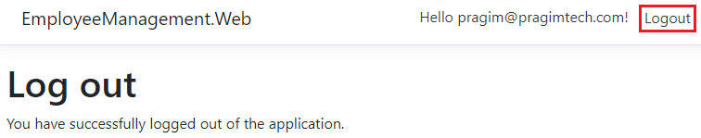

The logoutForm and the logout submit button are in Pages/Shared/\_LoginPartial.cshtml file.

## Submit logout form automatically

Include the following JavaScript code to automatically submit the logout form. We are using an IIFE here. IIFE stands for Immediately Invoked Function Expression. It is also called as a Self-Executing Anonymous Function. In simple terms it is a JavaScript function that runs as soon as it is defined.

<script>

(() => {

document.getElementById('logoutForm').submit();

})()

</script>

Copy

## Redirect to the application root

If you do not want to stay on the ASP.NET Core Identity Logout page, you can redirect the user to the application root URL by modifying the code in OnPost() method of Logout.cshtml.

public async Task<IActionResult> OnPost(string returnUrl = null)

{

await \_signInManager.SignOutAsync();

\_logger.LogInformation("User logged out.");

if (returnUrl != null)

{

return LocalRedirect(returnUrl);

}

else

{

// Redirect the user to application root

return LocalRedirect("~/");

}

}

Copy

We discussed ASP.NET Core Identity concepts like registering users, login, logout etc in our ASP.NET Core tutorial. If you are new to ASP.NET Core identity, please check out videos from Part 65 from [ASP.NET Core tutorial](https://www.pragimtech.com/courses/asp-net-core-mvc-tutorial-for-beginners/).

# Authorization in Blazor

In this video we will discuss Authorization in Blazor, specifically how to show and hide UI elements depending on the authentication state of the user.

## Authorization in ASP.NET Core

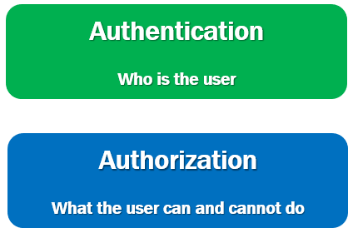

* Authentication is the process of identifying who the user is.
* Authorization is the process of identifying what the user can and cannot do.
* For example, if the logged in user, is an administrator, he may be able to Create, Read, Update and Delete orders, where as a normal user may only view orders but not Create, Update or Delete orders.

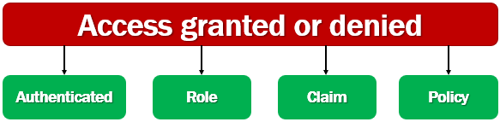

Access is typically granted or denied based on whether:

* A user is authenticated (logged in).
* A user is in a role.
* A user has a claim.
* A policy is satisfied.

We discussed all these concepts i.e authorization using roles, claims and policies in detail in [ASP.NET Core tutorial for beginners course](https://www.pragimtech.com/courses/asp-net-core-mvc-tutorial-for-beginners/). We use roles, claims and policies the same way in ASP.NET Core MVC apps, razor pages and Blazor. If you are new to these concepts please check out videos starting at [Part 77](https://youtu.be/NV734cJdZts) from [ASP.NET Core tutorial for beginners](https://www.youtube.com/playlist?list=PL6n9fhu94yhVkdrusLaQsfERmL_Jh4XmU) course.

## Blazor AuthorizeView component

* In Blazor we use AuthorizeView component to show or hide UI elements depending on whether the user is authorized to see it.
* In this example, AuthorizeView component is used in it's simplest form, without any parameters (i.e roles or policies), so, it only checks if the user is authenticated.
* If the user is authenticated, then the content in <Authorized> component is displayed, otherwise,  the content in <NotAuthorized> component is displayed.

<AuthorizeView>

<Authorized>

This content is displayed only if the user is Authorized

</Authorized>

<NotAuthorized>

This content is displayed if the user is Not Authorized

</NotAuthorized>

</AuthorizeView>

Copy

## CascadingAuthenticationState component

If you get the following error

InvalidOperationException: Authorization requires a cascading parameter of type Task<AuthenticationState>. Consider using CascadingAuthenticationState to supply this.

The error message is pretty good. It clearly tells us what needs to be done. Authentication state must be provided to the application and we do this by wrapping by the <Router> component with <CascadingAuthenticationState> component. The <Router> component is in App.razor file.

<CascadingAuthenticationState>

<Router AppAssembly="@typeof(Program).Assembly">

<Found Context="routeData">

<RouteView RouteData="@routeData" DefaultLayout="@typeof(MainLayout)" />

</Found>

<NotFound>

<LayoutView Layout="@typeof(MainLayout)">

<p>Sorry, there's nothing at this address.</p>

</LayoutView>

</NotFound>

</Router>

</CascadingAuthenticationState>

Copy

## Role or policy based authorization in Blazor

Both role-based and policy-based authorization is supported in Blazor. For role-based authorization, use the Roles parameter.

<AuthorizeView Roles="administrator, manager">

<p>Displayed if the logged in user is in administrator or manager role</p>

</AuthorizeView>

Copy

For policy-based authorization, use the Policy parameter:.

<AuthorizeView Policy="admin-policy">

<p>Displayed if the logged in user staisfies admin-policy</p>

</AuthorizeView>

Copy

## AuthorizeView component context variable

* AuthorizeView component exposes a context variable.
* The variable type is AuthenticationState.
* Use it to access autneticated user information.

In the following example, we are using the context variable to displayed the logged-in username.

<AuthorizeView>

<Authorized>

<li class="nav-item px-3">

<NavLink class="nav-link" href="/identity/account/logout" Match="NavLinkMatch.All">

<span class="oi oi-power-standby" aria-hidden="true"></span>

Logout (@context.User.Identity.)

</NavLink>

</li>

</Authorized>

</AuthorizeView>

Copy

## AuthenticationStateProvider service

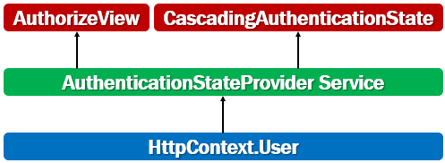

* Blazor has a built-in service called AuthenticationStateProvider service.
* This service obtains authentication state data from ASP.NET Core's HttpContext.User.
* This is how authentication state integrates with existing ASP.NET Core authentication mechanisms.
* It is this service that is used by AuthorizeView component and CascadingAuthenticationState component to get the authentication state.
* Don't use AuthenticationStateProvider directly. Use the AuthorizeView component.
* The main drawback to using AuthenticationStateProvider directly is that the component isn't notified automatically if the underlying authentication state data changes.

# Blazor authorize attribute

In our previous video we discussed AuthorizeView component. This component is used to authorize the display of specific parts within a page, including child components.

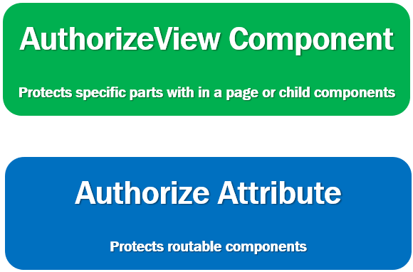

We use [Authorize] attribute to protect routable components (i.e components with @page directive). We reach these components via the router and authorization is performed while being routed to these components.

So this means, [Authorize] attribute cannot be used to protect parts of a page or child components. For that we use AuthorizeView component and for routable components we use [Authorize] attribute.

## Authorize attribute in Blazor and AuthorizeRouteView component

In the following example, [Authorize] attribute is used in it's simplest form, without any parameters (i.e roles or policies), so, it only checks if the user is authenticated.

If the user is authenticated, then the authorization is granted otherwise not.

@page "/"

@inherits EmployeeListBase

@attribute [Authorize]

@\*Rest of the component code\*@

Copy

## Blazor authorize attribute not working

* For the authorization to work as expected, along with the [Authorize] attribute we must also use AuthorizeRouteView component instead of RouteView component.
* In App.razor file, use AuthorizeRouteView component instead of RouteView component.

<AuthorizeRouteView RouteData="@routeData" DefaultLayout="@typeof(MainLayout)" />

Copy

## Role-based or Policy-based authorization

The [Authorize] attribute also supports role-based and policy-based authorization. For role-based authorization, use the Roles parameter:

@page "/"

@attribute [Authorize(Roles = "administrator, manager")]

<p>Only users in administrator or manager role are allowed access</p>

Copy

For policy-based authorization, use the Policy parameter:

@page "/"

@attribute [Authorize(Policy = "admin-policy")]

<p>Only users who satisfy admin-policy are allowed access</p>

Copy

## Customize unauthorized content

If access is not allowed, "Not authorized" is the content that is displayed by default. However, we can customize this unauthorized content.

<CascadingAuthenticationState>

<Router AppAssembly="@typeof(Program).Assembly">

<Found Context="routeData">

<AuthorizeRouteView RouteData="@routeData" DefaultLayout="@typeof(MainLayout)">

<NotAuthorized>

<p>Sorry, you're not authorized to reach this page.</p>

<p>You may need to log in as a different user.</p>

</NotAuthorized>

</AuthorizeRouteView>

</Found>

<NotFound>

<LayoutView Layout="@typeof(MainLayout)">

<p>Sorry, there's nothing at this address.</p>

</LayoutView>

</NotFound>

</Router>

</CascadingAuthenticationState>

# Authentication and authorization state data in code in blazor

In our previous video we discussed, how to use [Authorize] attribute to authorize access to routable components (i.e components with @page directive). We did this in the component html.

In this video we will discuss, how to obtain authentication and authorization state data in code in blazor.

## Cascading AuthenticationState parameter

* Cascading AuthenticationState parameter (Task<AuthenticationState>) provides authentication and authorization state data.
* If the user is not authenticated, the request is redirected to the login page.
* The return url is also passed as the query string parameter to the login page.
* Upon successful login, the user will be redirected to the page he was trying to access.

public class EditEmployeeBase : ComponentBase

{

[CascadingParameter]

private Task<AuthenticationState> authenticationStateTask { get; set; }

[Inject]

public NavigationManager NavigationManager { get; set; }

protected async override Task OnInitializedAsync()

{

var authenticationState = await authenticationStateTask;

if (!authenticationState.User.Identity.IsAuthenticated)

{

string returnUrl = WebUtility.UrlEncode($"/editEmployee/{Id}");

NavigationManager.NavigateTo($"/identity/account/login?returnUrl={returnUrl}");

}

// rest of the code

}

}

Copy

## Check if authenticated user is in a specific role

if (authenticationState.User.IsInRole("Administrator"))

{

// Execute Admin logic

}

Copy

## Check if authenticated user satisfies a specific policy

Task<AuthenticationState> can be combined with IAuthorizationService, to check if a specific aothorization policy is satisfied.

public class EditEmployeeBase : ComponentBase

{

[CascadingParameter]

private Task<AuthenticationState> authenticationStateTask { get; set; }

[Inject]

private IAuthorizationService AuthorizationService { get; set; }

protected async override Task OnInitializedAsync()

{

var user = (await authenticationStateTask).User;

if ((await AuthorizationService.AuthorizeAsync(user, "admin-policy"))

.Succeeded)

{

// Execute code specific to admin-policy

}

}

}

# Blazor course wrap up

In this video we will wrap up this asp.net core blazor tutorial.

This course is around 7 hours and consists of 58 clips. We have covered most of the blazor concepts that help you build real-world blazor applications.

There are few more important asp.net core security concepts to cover. This course is already 7 hours long. The rest of the security concepts are going to take at least another 3 hours, so it makes sense to cover them in a separate asp.net core security course.

## Machine setup for Blazor development

* [Install .NET Core SDK 3.1 or later](https://dotnet.microsoft.com/download/)
* [Download and install visual studio 2019](https://visualstudio.microsoft.com/downloads/)

We discussed installing these softwares in detail in [Part 1](https://youtu.be/uuzi3SmCLVo) of this [Blazor tutorial](https://www.pragimtech.com/courses/blazor-tutorial-for-beginners/" \o "Blazor tutorial for beginners" \t "_blank).

## Setup and run Blazor application

You can find the complete source code of the project that we have built as part of this course at the following link.

[Blazor Project Source Code](https://drive.google.com/drive/folders/1z49q-8xkKu8N8VjdemYKTs_4IbzBeLWM)

The following are the steps to setup and run Blazor application on your local machine.

Download the project source code. BlazorTutorial.zip contains the source code.

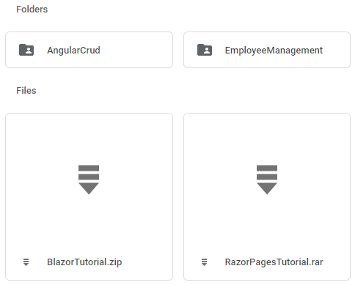

Extract all the files.

Double click on the solution file - BlazorTutorial.sln file. You will find this file in the BlazorTutorial folder.

Once you have the solution open. Execute the following command from Package Manager Console. Make sure EmployeeManagement.Web project is set as the Default project.

Update-Database

Copy

This will create the required asp.net core identity database tables.

Execute the Update-Database one more time. This time set EmployeeManagement.Api as the Default project. This migration creates the Employee database and the required tables.

Run the project using CTRL+F5

You can find all the videos, slides and notes in sequence on the following page.

[Blazor tutorial notes, slides and videos](https://www.pragimtech.com/courses/blazor-tutorial-for-beginners/)

If you have couple of minutes, please leave your rating and valuable feedback on our course page on the Feedback tab at the following URL.

[Submit your rating and review](https://www.pragimtech.com/courses/blazor-tutorial-for-beginners/)